|  |  |
| --- | --- |
| **Logo_FPT_University_doc** | **MINISTRY OF EDUCATION AND TRAINING** |

|  |
| --- |
| FPT UNIVERSITY |
| Capstone Project Document |
| Build a web provide service  For loading product to container |
|  |
| |  |  | | --- | --- | | **Group 10** | | | **Group Members** | Nguyễn Đinh Bảo Tú Team leader 60530  Võ Ngọc Luyến Team member 60521  Phan Duy Khánh Team member 60396  Hồ Đỗ Minh Trung Team member 60173 | | **Supervisor** | Lâm Hữu Khánh Phương | | **Ext Supervisor** |  | | **Capstone Project code** | CLS | |
|  |

|  |
| --- |
| - Ho Chi Minh City, 09/2013 - |

Table of Contents

[1 Introduction 5](#_Toc364447064)

[2 Project Management Plan 6](#_Toc364447065)

[2.1 Problem definition 6](#_Toc364447066)

[2.1.1 Name of This Capstone Project 6](#_Toc364447067)

[2.1.2 Problem Abstract 6](#_Toc364447068)

[2.1.3 Project Overview 6](#_Toc364447069)

[2.2 Project Organization 8](#_Toc364447070)

[2.2.1 Software Process Model 8](#_Toc364447071)

[2.2.2 Roles and Responsibility 9](#_Toc364447072)

[2.2.3 Tools and Techniques 9](#_Toc364447073)

[2.3 Project Management Plan 10](#_Toc364447074)

[2.3.1 Tasks 10](#_Toc364447075)

[2.3.2 Task Sheet: Assignments and Timetables 11](#_Toc364447076)

[2.3.3 All Meeting Minutes 12](#_Toc364447077)

[2.4 Convention Rules 12](#_Toc364447078)

[2.5 Other material (if any) 12](#_Toc364447079)

[3 Software Requirements Specifications (SRS) 12](#_Toc364447080)

[3.1 User Requirement Specification 12](#_Toc364447081)

[3.2 System Requirement Specification (Specific Requirements) 12](#_Toc364447082)

[3.2.1 External Interface Requirement 12](#_Toc364447083)

[3.2.2 Functional Requirements 14](#_Toc364447084)

[3.2.3 Non-functional Requirements 99](#_Toc364447085)

[3.3 Entity Relationship Diagram 100](#_Toc364447086)

[3.4 Other material (if any) 100](#_Toc364447087)

[4 Software Design Description (SDD) 100](#_Toc364447088)

[4.1 Design Overview 100](#_Toc364447089)

[4.2 System Architechure Design 101](#_Toc364447090)

[4.2.1 Choice of System Architecture 101](#_Toc364447091)

[4.2.2 Discussion of Aternative Designs 102](#_Toc364447092)

[4.2.3 Description of System Interface 103](#_Toc364447093)

[4.3 Component Diagram 103](#_Toc364447094)

[4.4 Detail Description of Components 105](#_Toc364447095)

[4.4.1 Model 105](#_Toc364447096)

[4.4.2 Controller 106](#_Toc364447097)

[4.4.3 Service 108](#_Toc364447098)

[4.4.4 AlgorithmAPI 112](#_Toc364447099)

[4.4.5 RenderAPI 117](#_Toc364447100)

[4.5 Sequence Diagram 118](#_Toc364447101)

[4.5.1 Guest Features 119](#_Toc364447102)

[4.5.2 User Features 120](#_Toc364447103)

[4.5.3 Admin Features 131](#_Toc364447104)

[4.6 User Interface Design 137](#_Toc364447105)

[4.6.1 Module User 137](#_Toc364447106)

[4.6.2 Module ManageProduct/Container/ContainerTemplate 139](#_Toc364447107)

[4.6.3 Module ManageSolution 140](#_Toc364447108)

[4.6.4 Module ManagePayment 144](#_Toc364447109)

[4.6.5 Module Manage Charge Usage 147](#_Toc364447110)

[4.6.6 Module ManageCharge Package 148](#_Toc364447111)

[4.7 Database Design 151](#_Toc364447112)

[4.8 Other material (if any) 152](#_Toc364447113)

[5 Software Test Documentation (STD) 152](#_Toc364447114)

[5.1 Introduction 152](#_Toc364447115)

[5.1.1 System Overview 152](#_Toc364447116)

[5.1.2 Test Approach 152](#_Toc364447117)

[5.2 Database Relationship Diagrams 152](#_Toc364447118)

[5.3 Screen shots 152](#_Toc364447119)

[5.4 Test Plan 152](#_Toc364447120)

[5.4.1 Features to be test 153](#_Toc364447121)

[5.4.2 Features not to be test 153](#_Toc364447122)

[5.4.3 Test Tool and Environment 154](#_Toc364447123)

[5.5 Test Cases 155](#_Toc364447124)

[5.5.1 Module User 155](#_Toc364447125)

[5.5.2 Module Manage Product/Container/ContainerTemplate 158](#_Toc364447126)

[5.5.3 Module Solution 162](#_Toc364447127)

[5.5.4 Module Charge Usage 164](#_Toc364447128)

[5.6 Checklists 173](#_Toc364447129)

[5.6.1 Checklist of validation 173](#_Toc364447130)

[5.6.2 Submission Checklist 174](#_Toc364447131)

[5.7 Other material (if any) 176](#_Toc364447132)

[6 Software User’s Manual (SUM) 176](#_Toc364447133)

[6.1 Installation Guide 176](#_Toc364447134)

[6.1.1 Server Side Setting up environment at server side 176](#_Toc364447135)

[6.1.2 Deployment at server sites 176](#_Toc364447136)

[6.2 User Guide 176](#_Toc364447137)

[6.2.1 Minimum System Requirements 176](#_Toc364447138)

[6.2.2 Introduction of Container Loading System 176](#_Toc364447139)

[6.2.3 Features and How to Use 177](#_Toc364447140)

[6.2.4 Others 200](#_Toc364447141)

# Introduction

According to the announcement of Vietnam Seaports Association in 21st August 2012, Viet Nam currently has around 159 million tons of importing and exporting products each year. There was around 7.1 million TEU (twenty-foot equivalent unit) of container which is used for loading and transportation purpose. And this numbers are increasing each year by 15%. So that it is also carried out the huge need of optimizing current logistic process into a more effective one.

As can be seen from our research about the process of using container to transport, the current process include several steps that is could be optimized by technology, one of them is the part of choosing the best way to load product into container. Currently in Viet Nam, the front-line people, who have responsibility for deciding and providing shipping note, is mostly based on their experience to organize the product. The process is keep track by using Excel sheet, which lead to the low level of effectiveness and causing miscommunication between the front-line people and the manager.

In order to solve this problem, various types of services and software solutions is introduced. However those services and solutions are mostly targeting the high profile customers. They are usually provided with high cost and increase complexity due to the need of serving the large firm. Besides, because they are software solutions so they need to be installed on personal computer and being licensed, so then it increased the cost and is not suitable for medium logistic company.

That has brought us to the idea of building up a service for container loading and exporting the shipping note using 3D technology and targeting SaaS (Software as a Service). This service would overcome the disadvantages of the current system is the field of user experience, portability and suitable cost for medium size company.

Besides providing the solutions for user from various type of company could effective load product into container with algorithm, we designed the system with the first-time user in mind, so that our guiding principal is quickest to learn and easiest to use. Our load planner is meant for front-line people and manager from various type of company, and because it is a service so it doesn’t need to be installed and with the monthly payment method which is effective used in domain and hosting service. It solved the problem of high cost for medium size company. Furthermore, the user can use the service anytime, anywhere, no matter where they are or what their working environment might be.

# Project Management Plan

## Problem definition

### Name of This Capstone Project

* Project full name: Build a web provide service for loading product to container.
* Project shore name: Container Loading System.
* Vietnamese name: Hệ thống sắp xếp hàng hóa vào container.
* Project code: CLS (Container Loading System).

### Problem Abstract

* According to the case of VinaCosmo, we can see the problem of the front-line people. As the customer from Japan, he can change the requirement very fast, so then the warehouse manager is just screw up with organizing the product in container to fulfill the need of customer.
* So CLS is going to bring “an online container loading service for logistic owner and front-line people who want to save cost and time for loading product to container by deeply using algorithm to loading, 3D display and manage loading process into container in a low cost and convenient way”.
* Loaded plan result is displayed in real-time 3D visualization. It can be viewed anywhere and anytime as long as accessing to website. A load plan result can be printed as a report or provided online to your customers as a demonstration of how their product is loaded into container.

### Project Overview

#### The Current System

Currently there are several company serve for logistic firm as a software provider. They provide service for create a container loading and managing system for whole company. However, these company mainly focus on the customer from oversea company, not for Viet Nam’s company.

The current process in loading product to container is still very simple. According to the case of VinaCosmo, the front-line people, he has to manually calculate and provide solution for loading product to container by his own experience only.

So when every things changes, customer has new requirement or prefer another way to load their product. Then the front-line people have to make it again. With these lack of productivity, VinaCosmo lost time and money for this particular jobs:

* Money: cost 1 person only to do this jobs.
* Productivity: Each time the orders comes, he has to take 2 hours for calculating and providing result, then its decrease the productivity by just take 4 orders at the same time.
* Time: cost hours for him to recalculate the product.

The fact is not just happen in VinaCosmo but also another firm at the save field logistic.

#### The Proposed System

EasyLoader is an online container loading service for logistic owner and front-line people who want to save cost and time for loading product to container by deeply using algorithm to loading, 3D display and manage loading process into container in a low cost and convenient way.

Problem, it solved:

* Currently, front-line people calculate by experience.
* There are many changes during the loading process.
* The calculating people and the end-line people, who directly load product not the same.
* Input data cause time-consuming.
* The current SCM and other software is expensive

For:

* Front-line people who directly calculate how to loading product into container.
* Logistic business owner, who want to improve their company productivity and decrease HR cost by investing in low cost IT service.

By:

* Smart algorithm will give front-line people usable results.
* Modern 3D display technology which is ready on browsers.
* Low cost and increase logistic business performance
* No need to install.
* Easy for importing data and exporting result.
* Support as close as reality business as possible

#### Boundaries of the System

The system under development of this Capstone Project will include:

* The complete website. Service for loading product to single container.
* All the process involved documents

#### Development Environment

Below is the list of hardware and software requirements needed for development environment:

##### Hardware requirements:

* N/A

##### Software requirements:

* Operating system: Windows 7
* IDE: Visual Studio 2012
* DBMS: SQL Server 2012
* Source Control: Git and Team Foundation Service.

## Project Organization

### Software Process Model

**SCRUM MODEL**

In order to fast delivery in the system, the Waterfall model was not working well for our project and we decided to use Scrum as the framework to move over to the agile process.

**OVERVIEW DIAGRAM**

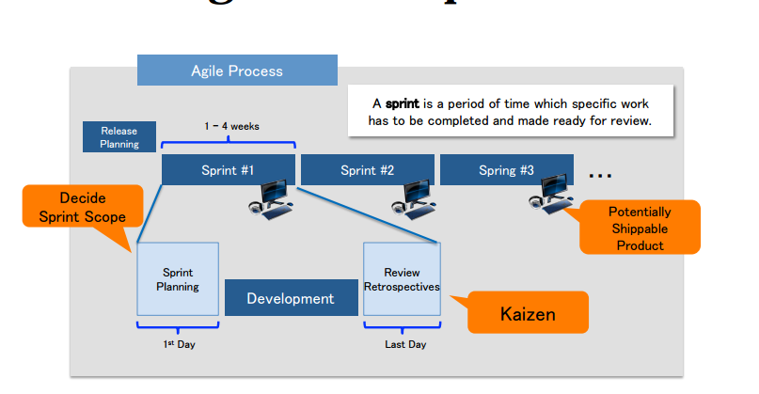

Figure 2-1 – Member of Project

The Scrum framework consists of Scrum Teams and their associated roles, events, artifacts, and rules. Each component within the framework serve for a specific purpose and it essential to Scrum’s success and usage.

Normally, a sprint’s duration is about 2 – 4 weeks. However, in case of the project characteristics, we decided to make progress in series of sprints which are time boxed interactions in one week. At the beginning of one sprint, through sprint planning meeting, all of team members will discuss to define sprint backlog which is suitable to be completed on that sprint. Daily meeting is not operated; instead we use daily report, task management by Redmine and Skype conference to conduct all activities.

Basically, we define some definition of “Done” for each user story, and they are listed as below:

On task level, a user story is being set as “Done”, if:

It is clearly explained by Product Owner

It is documented on Redmine in the field of Description (expected flow)

* The function is working
* The code has been self-tested
* The code is committed on SVN at the end of the day
* The code has been review by team lead

On Sprint level, a user story is set as “Done”, if:

* The code is demo to stake holder
* The user story is marked as “Done” by Product Owner and stake holder.
* On Release level
* The user stories is deployed on test server and test database
* System test on server

### Roles and Responsibility

|  |  |  |  |  |
| --- | --- | --- | --- | --- |
| No. | Full name | Team Role | Scrum Team Role | Responsibilities |
| 1 | Lâm Hữu Khánh Phương | Supervisor | Stake Holder | * Define business of our product * Give advice on tech * Review delivery at the end of Sprint |
| 2 | Nguyễn Đinh Bảo Tú | Team Leader | Product Owner | * Outline work in **scrum backlog** * Prioritize work * Answer question and deliver direction |
| 3. | Phan Duy Khánh | Team Member | Scrum Master | * Facilitate productivity – maximize team performance * Complete all individual work |
| 4. | Võ Ngọc Luyến | Team Member | Scrum Team Member | * Commit individual product on time * Support each other to complete team work |
| 5 | Hồ Đỗ Minh Trung | Team Member | Scrum Team Member | * Commit individual product on time * Support each other to complete team work |

Table 1-1 – Member of Project

### Tools and Techniques

For Development:

* Visual Studio 2012 Update 3: Use to code software modules.
* Visual Studio for Git extension: Use to access team foundation server with git support.
* SQL Server 2012: Use to create database for application.
* IIS: Use as web server.
* Design Patterns: MVC4, Entity Framework.

For Management:

* Microsoft Project: Task tracking.
* Tortoise SVN: Source version control.
* Team foundation server with git support Code: Manage project resources (document, design, meeting minutes …).

For Communication:

* Gmail for daily report and meeting minutes.
* Skype for online meeting.

## Project Management Plan

### Tasks

|  |  |
| --- | --- |
| 2.3.1.1 Scope Determination & Planning: | |
| Description | Determine project scope and planning |
| Deliverables |  |
| Resources Needed | 2 days |
| Dependencies and Constrains | The project must be feasible. |
| Risks | Project scope too large for 4 people in 4 month. |
| 2.3.1.2 Software Requirements Analysis: | |
| Description | Conduct needs analysis. |
| Deliverables |  |
| Resources Needed | 2 days |
| Dependencies and Constrains | **Scope Determination & Planning** must be done before doing this task. |
| Risks |  |
| 2.3.1.3 Design: | |
| Description | Design User Interface |
| Deliverables |  |
| Resources Needed | 15 days |
| Dependencies and Constrains | **Software Requirements Analysis** must be done before doing this task |
| Risks |  |
| 2.3.1.4 Development: | |
| Description | Develop project |
| Deliverables |  |
| Resources Needed | 21 days |
| Dependencies and Constrains | **Design** must be done before doing this task. |
| Risks |  |
| 2.3.1.5 Testing: | |
| Description | Includes Unit Testing and Integration Testing |
| Deliverables |  |
| Resources Needed | 9 days |
| Dependencies and Constrains | **Development** must be done before doing this task. |
| Risks |  |
| 2.3.1.6 Documentation: | |
| Description | Write document for submitting reports. |
| Deliverables | Report 1, Report 2, Report 3, Report 4, Report 5, Report6 |
| Resources Needed | 15 days |
| Dependencies and Constrains | * **Scope Determination & Planning** must be done before write document for submitting Report 1 & Report 2. * **Software Requirement Analysis** must be done before write document for submitting Report 3. * **Development** and **Testing** must be done before write document for submitting Report 4. |
| Risks |  |

Table 2-2 – Main Tasks of Project

### Task Sheet: Assignments and Timetables

|  |  |  |  |  |
| --- | --- | --- | --- | --- |
| Task Name | Duration | Star Date | End Date | Resource |
| Scope Determination & Planning | 2 days | Mon 15/04/2013 | Tue  16/04/2013 | TuNDB, KhanhPD, LuyenVN, TrungHDM |
| Software Requirements Analysis | 2 days | Wed  17/04/2013 | Thu 18/04/2013 | TuNDB, KhanhPD, LuyenVN, TrungHDM |
| Design | 17.89 days | Thu  18/04/2013 | Tue 14/05/2013 | TuNDB, KhanhPD, LuyenVN, TrungHDM |
| Development | 37.48 days | Mon  27/05/2013 | Wed 17/07/2013 | TuNDB, KhanhPD, LuyenVN, TrungHDM |
| Testing | 17.53 days | Wed 17/07/2013 | Mon 12/08/2013 | TuNDB, KhanhPD, LuyenVN, TrungHDM |
| Documentation | 85.5 days | Fri 19/04/2013 | Fri 16/08/2013 | TuNDB, KhanhPD, LuyenVN, TrungHDM |

Table 2-3 – Task Sheet

Detail Plan is put in CD with path: <root>\Plan\MasterSchedule.mpp.

### All Meeting Minutes

All Meeting Minutes are put in CD with path: <root>\Meeting Minutes\.

## Convention Rules

Reference coding convention statement at <http://msdn.microsoft.com/en-us/library/vstudio/ff926074.aspx>

## Other material (if any)

# Software Requirements Specifications (SRS)

## User Requirement Specification

Container Loading System has three main role:

* “Guest” can register to become “User” in the system. “Guest” can see some introduction about system and register to create an account to use.
* “User” can login into the system to manage product, manage container, manage solution, view usage, edit their profile, and see some analysis number (Usage histories, the number of products, container, solutions, recent solutions they use) in home page. User can create new solution, choose their products which save in stores and loading in their container. They can save solution to use later and export the results in excel format. Moreover, they can send requests for joining into clubs which they want. Besides, user also can retrieve their password when they forget it.
* “Admin” can login into the system to manage user. User can be activated or deactivated by admin. Admin can also manage common container, manage charge package, and manage transaction of user. Admin also see summary analysis number in home page.

## System Requirement Specification (Specific Requirements)

### External Interface Requirement

#### User Interfaces

* User can interact with the system and other users through the user interface. Below are screens available for users:

|  |  |
| --- | --- |
| Screen Name | Function |
| Sign up CLS Account | Allow actor (Guest) to signup |
| Login by CLS Account | Allow actor (Guest) to login with CLS account |
| Login by Facebook Account | Allow actor (Guest) to login via Facebook |
| Login by Google Account | Allow actor (Guest) to login via Google |
| View User Profile | Allow actors (Admin, User) to view profile |
| Update User Profile | Allow actors (Admin, User) to update profile |
| View Charge Usage | Allow actor (User) to view their usage |
| View Charge History | Allow actor (User) to view their history added charge package. |
| View Product List | Allow actor (User) to manage product |
| Search Product | Allow actor (User) to search product |
| Import Product List by Excel file | Allow actor (User) to import product by Excel file |
| Create Product | Allow actor (User) to create product |
| Update Product | Allow actor (User) to update product |
| Delete Product | Allow actor (User) to delete product |
| View Container List | Allow actor (User) to manage container |
| Search Container | Allow actor (User) to search container |
| Import Container List by Excel file | Allow actor (User) to import container by Excel file |
| Create Container | Allow actor (User) to create container |
| Update Container | Allow actor (User) to update container |
| Delete Container | Allow actor (User) to delete container |
| View Solution List | Allow actor (User) to view a list of solutions (if any). |
| Create Solution | Allow actor (User) to create a new solution. |
| Update Solution | Allow actor (User) to update information and save to database. |
| Delete Solution | Allow actor (User) to remove solution out of the database. |
| Clone Solution | Allow actor (User) to create a new solution with the same contents (include the product list and result of main solution) with selected solution. |
| Search Solution | Allow actor (User) to search solutions in user’s solutions list, the desired result is displayed (if any). |
| View Solution Detail | Allow actor (User) to view solution detail of particular solution. |
| View Solution Result (3D result) | Allow actor (User) to view the result in 3D cube, rotate cube to see all sides of that cube and view all details about loading result. |
| Export Solution Result (Excel result) | Allow actor (User) to export the solution result details to an excel file. |
| View User List | Allow actor (Admin) to manage account |
| Create User | Allow actor (Admin) to create account for user |
| Update User | Allow actor (Admin) to update user |
| Activate/ Deactivate User | Allow actor (Admin) to activate/deactivate user |
| View Common Container List | Allow actor (Admin) to manage common container |
| Search Common Container | Allow actor (Admin) to search common container |
| Create Common Container | Allow actor (Admin) to create common container |
| Update Common Container | Allow actor (Admin) to update common container |
| Delete Common Container | Allow actor (Admin) to delete common container |
| View Charge Package List | Allow actor (Admin) to manage Charge Package |
| Create Charge Package | Allow actor (Admin) to create Charge Package |
| Update Charge Package | Allow actor (Admin) to update Charge Package |
| Activate/Deactivate Charge Package | Allow actor (Admin) to activate/deactivate Charge Package |
| View Transaction | Allow actor (Admin) to manage transaction |
| View Usage | Allow actor (Admin) to view particular user’s usage |
| Create main charge package for user | Allow actor (Admin) to create main charge package account. |
| Create additional charge package for user | Allow actor (Admin) to create extra charge package account. |

Table 3-1 – User Interfaces

#### Hardware Interfaces (if any)

* N/A

#### Software Interfaces (if any)

* N/A

#### Communication Pools

* N/A

### Functional Requirements

* Actors:

|  |  |
| --- | --- |
| Actor | Description |
| Guest | Guest is person who didn’t logged into the CLS Website? |
| User | User is person who is logged into the CLS Website with role “User”. They can manage product, manage container, manage solution, and view usage. |
| Admin | Admin is person who is logged into the CLS Website with role “Admin”. They can manage user, manage common container, manage charge package, and manage payment. |

Table 3-2 – Functional Requirements

* Overall Use Case Diagram:

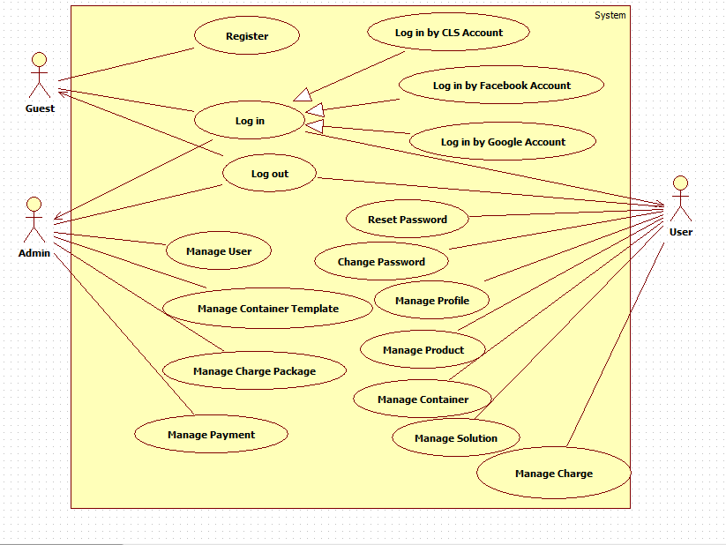

Figure 3‑1 Overall use case diagram

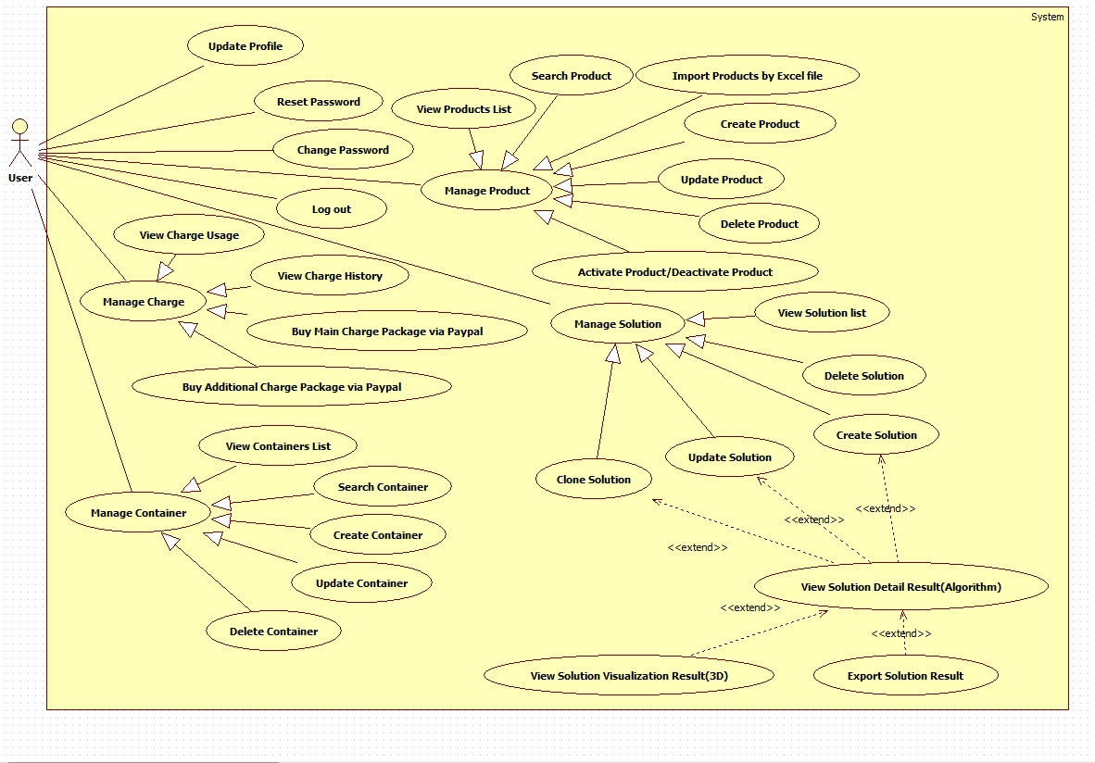

Figure 3‑2 User’s use case diagram

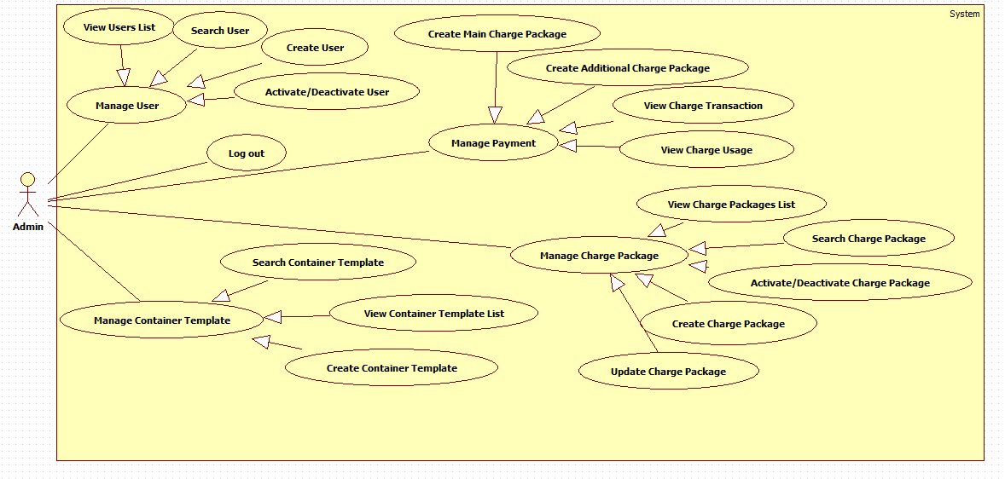

Figure 3‑3 Admin’s use case diagram

#### Guest Features

##### <Guest> Register CLS Account

###### Use case diagram

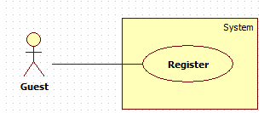

Figure 3‑4 Register CLS Account use case diagram

###### Use case specification

|  |  |  |  |  |
| --- | --- | --- | --- | --- |
| **USE CASE – CLS001** | | | | |
| **Use case No.** | CLS001 | **Use case version** | | 2.0 |
| **Use case name** | Register | | | |
| **Author** | Hồ Đỗ Minh Trung | | | |
| **Date** | 13/08/2013 | **Priority** | High | |
| **Actor:** Guest  **Summary:**   * Guest uses this use case to register account.   **Goal:**   * Allow guest to register account.   **Triggers:**   * On header page, click on “Đăng Ký” link and “Đăng Ký” page will be showed, then input information and then click “Đăng Ký” button to finish.   **Preconditions:**  **Post Conditions:**   * Guest can register an account successfully. System will transfer to “Trang Chủ” page.   **Main Success Scenario:**   |  |  | | --- | --- | | Actors action:   1. Click on “Đăng Ký” link to request “Đăng Ký” page. | System Response: | |  | 1. System will response “Đăng Ký” page (Please view Page Description below for more information of this page). | | 1. Enter information into text fields. Click on “Đăng Ký” button to finish. [Alternative 1] |  | |  | 1. System will create new account in database, user will be login automatically and system will transfer to “Trang Chủ” page of User. [Exception 1, 2, 3, 4]. |   **Alternative Scenario:**   |  |  | | --- | --- | | Actors action:   1. Click on “Đăng Nhập” link to finish. | System Response: | |  | 1. System will transfer to “Đăng Nhập” page. |   **Exceptions:**   |  |  |  | | --- | --- | --- | | No. | Actor Action | System Response | | 1 | Email has existed in database. | Display error message: “Email đã tồn tại. Xin sử dụng một email khác.” | | 2 | Input not a valid information in Email’s textbox. | Display error message: “Email không hợp lệ”. | | 3 | Password’s length is not in range: [6, 50]. | Display error message: “Mật khẩu phải từ 6 ký tự”. | | 4 | Input confirm password information different with password. | Display error message: “Xác nhận mật khẩu sai. Xin nhập lại”. | | 5 | Input wrong sum of 2 number in captcha image. | Display error message: “Tổng 2 số không đúng, xin nhập lại”. |   **Relationships:**   * Login by CLS Account.   **Business Rules:**  **Page Description:**   |  |  |  | | --- | --- | --- | | Field Name | Data Type and Constraints | Required | | Name | Textbox.  Min length: 1.  Max length: 50. | No | | Email | Textbox.  Min length: 1.  Max length: 50. | Yes | | Password | Textbox.  Min length: 6.  Max length: 50. | Yes | | Confirm Password | Textbox.  Min length: 6.  Max length: 50. | Yes | | Gender | Radio button. | Yes | | Captcha | Textbox.  Min length: 1.  Max length: 50. | Yes | | Register | Button |  | | | | | |
|  | | | | |

##### <Guest> Login by CLS Account

###### Use case diagram

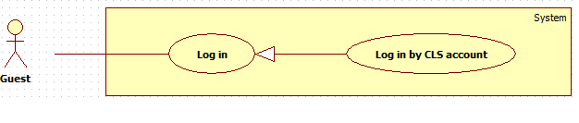

Figure 3‑5 Login by CLS Account use case diagram

###### Use case specification

|  |  |  |  |  |
| --- | --- | --- | --- | --- |
| **USE CASE – CLS002** | | | | |
| **Use case No.** | CLS002 | **Use case version** | | 2.0 |
| **Use case name** | Login | | | |
| **Author** | Hồ Đỗ Minh Trung | | | |
| **Date** | 13/08/2013 | **Priority** | High | |
| **Actor:** Guest  **Summary:**   * This use case is about allowing all people who have an account can login into the system.   **Goal:**   * Allow user can login into the system.   **Triggers:**   * Click on “Đăng Nhập” button on “Trang Chủ”.   **Preconditions:**   * Guest must have an Easy Loader account with User role.   **Post Conditions:**   * User can login into the system with power suitable for their account’s types.   **Main Success Scenario:**   |  |  | | --- | --- | | Actors action:   1. Click on “Đăng Nhập” link to request “Đăng Ký” page. | System Response: | |  | 1. System will response “Đăng Nhập” page (Please view Page Description below for more information of this page). | | 1. Enter information into text fields. Click on “Đăng Nhập” button to finish. [Alternative 1] |  | |  | 1. System response: Login successfully and system will transfer to “Trang Chủ” page of User. [Exception 1] |   **Alternative Scenario:**   |  |  | | --- | --- | | Actors action:   1. Click on Login by Google Plus. | System Response: | |  | 1. System will login via Google Plus. | | 1. Click on Login by Facebook. |  | |  | 1. System will login via Facebook. | | 1. Click on “Quên Mật Khẩu” link. | 1. System will response “Quên Mật Khẩu” page. | | 1. Click on “Đăng Ký” link. | 1. System will response “Đăng Ký” page. |   **Exceptions:**   |  |  |  | | --- | --- | --- | | No. | Actor Action | System Response | | 1 | Enters invalid (not registered username, wrong password) data and clicks “Đăng Nhập” | Shows “Email hoặc mật khẩu không chính xác” message. |   **Relationships:**  **Business Rules:**  **Page Description:**   |  |  |  | | --- | --- | --- | | Field Name | Data Type and Constraints | Required | | Email | Textbox.  Min length: 1.  Max length: 50 | Yes | | Password | Textbox.  Min length: 6.  Max length: 50. | Yes | | Login by Google+ | Button |  | | Login by Facebook | Button |  | | Forget Password | Link |  | | Keep Login | Checkbox |  | | Register | Link |  | | Login | Button |  | | | | | |

##### <Guest> Login by Facebook Account

###### Use case diagram

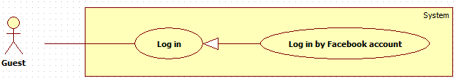

Figure 3‑6 Login by Facebook use case diagram

###### Use case specification

|  |  |  |  |  |
| --- | --- | --- | --- | --- |
| **USE CASE – CLS002** | | | | |
| **Use case No.** | CLS003 | **Use case version** | | 2.0 |
| **Use case name** | Login by Facebook Account | | | |
| **Author** | Hồ Đỗ Minh Trung | | | |
| **Date** | 13/08/2013 | **Priority** | High | |
| **Actor:** Guest  **Summary:**   * This use case is about allowing all people who have a Facebook account can login into the system.   **Goal:**   * Allow guest to login to the system with their Facebook account.   **Triggers:**   * Click on “Facebook” in “Đăng Nhập” form.   **Preconditions:**  **Post Conditions:**   * Guest can login successfully. System will transfer to user “Trang Chủ” page. * System save email and Facebook token into Database for further authentication.   **Main Success Scenario:**   |  |  | | --- | --- | | Actor Action | System Response | | 1. Click on “Facebook” button. | 1. System verify if Facebook token is access successfully yet. Otherwise system will prompt a window for user to enter their Facebook account. | | 1. User types their Facebook account and password and then click on “Login” button. | 1. System response: Login successfully and system will transfer to “Trang chủ” page.   [Exception 1] |   **Alternative Scenario:**  **Exceptions:**   |  |  |  | | --- | --- | --- | | No. | Actor Action | System Response | | 1 | Invalid Facebook account | Display error message: “Cannot access the Facebook token. Please try again” |   **Relationships:**  **Business Rules:**  **Page Description:** | | | | |

##### <Guest> Login by Google Account

###### Use case diagram

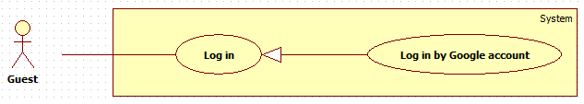

Figure 3‑7 Login by Google use case diagram

###### Use case specification

|  |  |  |  |  |
| --- | --- | --- | --- | --- |
| **USE CASE – CLS004** | | | | |
| **Use case No.** | CLS004 | **Use case version** | | 2.0 |
| **Use case name** | Register | | | |
| **Author** | Hồ Đỗ Minh Trung | | | |
| **Date** | 13/08/2013 | **Priority** | Medium | |
| **Actor:** Guest.  **Summary:**   * This use case is about allowing all people who have a Google Plus account can login into the system.   **Goal:**   * Allow guest to login to the system with their Google account.   **Triggers:**   * Click on “Google” on “Đăng Nhập” form.   **Preconditions:**  **Post Conditions:**   * Guest can login successfully. System will transfer to user “Trang Chủ” page.   **Main Success Scenario:**   |  |  | | --- | --- | | Actor Action | System Response | | 1. Click on “Google” button to finish. | 1. System verify if Google token is access successfully yet. Otherwise system will prompt a window for user to enter their google account. | | 1. User types their Google account and password and then click on “Đăng Nhập” button. | 1. System response: Login successfully and system will transfer to “Trang Chủ” page.   [Exception 1] |   **Alternative Scenario:**  **Exceptions:**   |  |  |  | | --- | --- | --- | | No. | Actor Action | System Response | | 1 | Invalid Google account | Display error message: “Cannot authorize your Google Account. Please try again” |   **Relationships:**  **Business Rules:**  **Page Description:** | | | | |

#### User Features

##### <User> Log out

###### Use case diagram



Figure 3‑8 Log out use case diagram

###### Use case specification

|  |  |  |  |  |
| --- | --- | --- | --- | --- |
| **USE CASE – CLS005** | | | | |
| **Use case No.** | CLS005 | **Use case version** | | 2.0 |
| **Use case name** | Log out | | | |
| **Author** | Hồ Đỗ Minh Trung | | | |
| **Date** | 16/08/2013 | **Priority** | High | |
| **Actor:** User  **Summary:**   * User want to log out, they use this function.   **Goal:**   * Allow user log out of system.   **Triggers:**   * On header page, click on User name title, choose “Thoát” from drop down list.   **Preconditions:**   * Guest must log in as the role “User”.   **Post Conditions:**  **Main Success Scenario:**   |  |  | | --- | --- | | Actors action:   1. Click on User name title. Choose “Thoát” from drop down list. | System Response: | |  | 1. User will be log out of system. System will response to Index page. |   **Alternative Scenario:**  **Exceptions:**  **Relationships:** Register, Login, Edit User Profile.  **Business Rules:**  **Page Description:** | | | | |

##### <User> View User Profile

###### Use case diagram

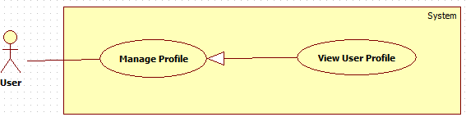

Figure 3‑9 View User profile use case diagram

###### Use case specification

|  |  |  |  |  |
| --- | --- | --- | --- | --- |
| **USE CASE – CLS005** | | | | |
| **Use case No.** | CLS006 | **Use case version** | | 2.0 |
| **Use case name** | View User Profile | | | |
| **Author** | Hồ Đỗ Minh Trung | | | |
| **Date** | 16/08/2013 | **Priority** | High | |
| **Actor:** User  **Summary:**   * User want to view their profile, they use this function.   **Goal:**   * Allow user view their profile.   **Triggers:**   * On header page, click on User name title, choose “Thông Tin Cá Nhân” from drop down list.   **Preconditions:**   * Guest must log in as the role “User”.   **Post Conditions:**  **Main Success Scenario:**   |  |  | | --- | --- | | Actors action:   1. Click on User name title. Choose “Thông Tin Cá Nhân” from drop down list. | System Response: | |  | 1. System will response to “Thông Tin Cá Nhân”page (Please view Page Description below for more information of this page). |   **Alternative Scenario:**  **Exceptions:**  **Relationships:** Register, Login, Edit User Profile.  **Business Rules:**  **Page Description:**   |  |  |  | | --- | --- | --- | | Field Name | Data Type and Constraints | Required | | “Tên” | Text.  Min length: 1.  Max length: 20. | Yes | | Email | Email.  Max length: 20. | Yes | | “Giới Tính” | Radio Button  Max length: 3. | Yes | | Birthday | Daytime Picker. |  | | Image | Image Picker Control. | Yes | | | | | |
|  | | | | |

##### <User> Update User Profile

###### Use case diagram

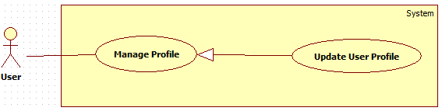

Figure 3‑10 Update User Profile use case diagram

###### Use case specification

|  |  |  |  |  |
| --- | --- | --- | --- | --- |
| **USE CASE – CLS006** | | | | |
| **Use case No.** | CLS007 | **Use case version** | | 2.0 |
| **Use case name** | Update User Profile | | | |
| **Author** | Hồ Đỗ Minh Trung | | | |
| **Date** | 13/08/2013 | **Priority** | High | |
| **Actor:** User.  **Summary:**   * User want to update their profile, they use this function.   **Goal:**   * Allow user edit their profile.   **Triggers:**   * Change information in “Thông Tin Cá Nhân” page, then click “Đồng Ý” button.   **Preconditions:**   * Guest must log in as the role “User”. * User is at “Thông Tin Cá Nhân” page.   **Post Conditions:**   * Profile User is updated to database.   **Main Success Scenario:**   |  |  | | --- | --- | | Actors action:   1. Change User’s information. Then click “Đồng Ý” button. | System Response: | |  | 1. System response: Update successfully and new information will be updated to database. |   **Alternative Scenario:**  **Exceptions:**  **Relationships:** Register, Login, View User Profile.  **Business Rules:**  **Page Description:**   |  |  |  | | --- | --- | --- | | Field Name | Data Type and Constraints | Required | | Name | Textbox.  Min length: 1.  Max length: 20. | Yes | | Email | Email.  Max length: 20 | Yes | | Gender | Radio Button. | Yes | | Birthday | Date time picker. | No | | Image | Image Picker Control. | Yes | | Update | Button |  | | | | | |
|  | | | | |

##### <User> Change Password

###### Use case diagram



Figure 3‑11 Change Password use case diagram

###### Use case specification

|  |  |  |  |  |
| --- | --- | --- | --- | --- |
| **USE CASE – CLS006** | | | | |
| **Use case No.** | CLS008 | **Use case version** | | 2.0 |
| **Use case name** | Change Password | | | |
| **Author** | Hồ Đỗ Minh Trung | | | |
| **Date** | 13/08/2013 | **Priority** | High | |
| **Actor:** User.  **Summary:**   * User want to update their password, they use this function.   **Goal:**   * Allow user change their password.   **Triggers:**   * On header page, click on User name title, choose “Đổi Mật Khẩu” link from drop down list.   **Preconditions:**   * Guest must log in as the role “User”.   **Post Conditions:**   * New User Password is updated to database.   **Main Success Scenario:**   |  |  | | --- | --- | | Actors action:   1. Click on “Đổi Mật Khẩu”. | System Response: | |  | 1. System will response “Đổi Mật Khẩu” page (Please view Page Description below for more information of this page). | | 1. Input current password and new password. Click on “Đồng Ý” button to finish. | 1. System response: Change password successfully and new password will replace the older in database. [Exception 1, 2]. |   **Alternative Scenario:**  **Exceptions:**   |  |  |  | | --- | --- | --- | | No. | Actor Action | System Response | | 1 | New Password similar with Curent Password. | Display error message: “Mật Khẩu mới phải khác mật khẩu cũ”. | | 2 | Current pass word is wrong. | Display error message: “Mật Khẩu hiện tại không đúng”. | | 3 | New Password and Confirm New Password not match. | Display error message: “Xác nhận mật khẩu sai”. |   **Relationships:** Register, Login, View User Profile.  **Business Rules:**  **Page Description:**   |  |  |  | | --- | --- | --- | | Field Name | Data Type and Constraints | Required | | Current Password | Password.  Min length: 6.  Max length: 50. | Yes | | New Password | Password.  Min length: 6.  Max length: 50. | Yes | | Confirm Password | Password.  Min length: 6.  Max length: 50. | Yes | | OK | Button. |  | | | | | |

##### <User> Reset Password

###### Use case diagram



Figure 3‑12 Reset Password use case diagram

###### Use case specification

|  |  |  |  |  |
| --- | --- | --- | --- | --- |
| **USE CASE – CLS006** | | | | |
| **Use case No.** | CLS009 | **Use case version** | | 2.0 |
| **Use case name** | Reset Password | | | |
| **Author** | Hồ Đỗ Minh Trung | | | |
| **Date** | 13/08/2013 | **Priority** | High | |
| **Actor:** User.  **Summary:**   * User forget password, they want to reset their password, and they use this function. Then check email to get reset link. Input new password.   **Goal:**   * Allow user reset their password.   **Triggers:**   * In “Đăng Nhập” page, click on “Quên Mật Khẩu” link. Then input email of their account.   **Preconditions:**   * Guest has a system’s account but they forgot password. * “Đăng Nhập” Page has load successful.   **Post Conditions:**   * System will send recovery password link to user’s email. User use that link to set a new password.   **Main Success Scenario:**   |  |  | | --- | --- | | Actors action:   1. Click on “Quên Mật Khẩu”. | System Response: | |  | 1. System will response “Lấy lại mật khẩu” page (Please view Page Description below for more information of this page). | | 1. Input email, then click “Đồng Ý” | 1. System response: Send an email to User’s email. | | 1. User check email. After that click on the link which system has send. | 1. System will response “Đặt lại mật khẩu” page. | | 1. User input new password and confirm new password, then click “Đồng Ý”. | 1. System response: New password has been updated to database. |   **Alternative Scenario:**  **Exceptions:**  **Relationships:** Register, Login, View User Profile.  **Business Rules:**  **Page Description:**   |  |  |  | | --- | --- | --- | | Field Name | Data Type and Constraints | Required | | Email | Email.  Max length: 50. | Yes | | Ok | Button. |  | | | | | |

##### <User> View Product List

###### Use case diagram

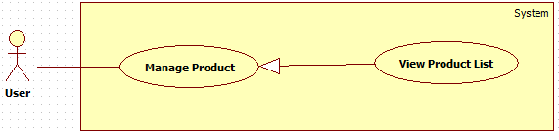

Figure 3‑13 View Product List use case diagram

###### Use case specification

|  |  |  |  |  |
| --- | --- | --- | --- | --- |
| **USE CASE – CLS007** | | | | |
| **Use case No.** | CLS010 | **Use case version** | | 2.0 |
| **Use case name** | View Product List | | | |
| **Author** | Võ Ngọc Luyến | | | |
| **Date** | 06/03/2013 | **Priority** | High | |
| **Actor:** User.  **Summary:**   * User wants to view their product list, they use this function   **Goal:**   * Allow user to view all the products they created.   **Triggers:**   * On header page, click on “Quản lý loại hàng” link and Manage Product page will be showed.   **Preconditions:**   * Guest must log in as the role “User”.   **Post Conditions:**  **Main Success Scenario:**   |  |  | | --- | --- | | Actor Action | System Response | | 1. Click on “Quản lý loại hàng” to request Manage Product page. | 1. System will response by loading all products of user and show in a datatable (Please view Page Description below for more information of this page). |   **Alternative Scenario:**  **Exceptions:**  **Relationships:**   * Search Product, Create Product, Update Product and Delete Product.   **Business Rules:**  **Page Description:**   |  |  |  |  | | --- | --- | --- | --- | | Field Name | Data Type and Constraints | | Required | | Manage Product Table | Table includes:   * “Tên loại hàng” column. * “Hình ảnh” column. * “Chiều dài” column. * “Chiều rộng” column. * “Chiều cao” column. | * “Khối lượng” column. * “Chiều cao cho phép” column. * “Kích hoạt” column. * Edit button * Delete button |  | | | | | |

##### <User> Search Product

###### Use case diagram

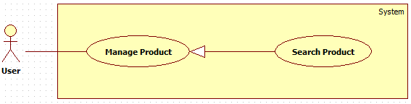

Figure 3‑14 Search Product use case diagram

###### Use case specification

|  |  |  |  |  |
| --- | --- | --- | --- | --- |
| **USE CASE – CLS008** | | | | |
| **Use case No.** | CLS011 | **Use case version** | | 2.0 |
| **Use case name** | Search Product | | | |
| **Author** | Võ Ngọc Luyến | | | |
| **Date** | 04/06/2013 | **Priority** | High | |
| **Actor:** User.  **Summary:**   * User wants to search products, they use this function.   **Goal:**   * Allow user to search their product.   **Triggers:**   * In Manage Product page, input keyword in search textbox such as product’s name. If it matches with any product of that user, the system will list them into Product List table.   **Preconditions:**   * Guest must log in as the role “User”. * Manage product page has loaded successfully.   **Post Conditions:**  **Main Success Scenario:**   |  |  | | --- | --- | | Actor Action | System Response | | 1. Input keyword in search text box. | 1. System will list items which match with keyword in Product List table. |   **Alternative Scenario:**   |  |  | | --- | --- | | Actor Action | System Response | | 1. User input product information which isn’t match with any user product information. | 1. Product List table has no row. |   **Exceptions:**  **Relationships:**  **Business Rules:**  **Page Description:**   |  |  |  | | --- | --- | --- | | Field Name | Data Type and Constraints | Required | | Text-Search | Textbox | Yes | | | | | |

##### <User> Create Product

###### Use case diagram

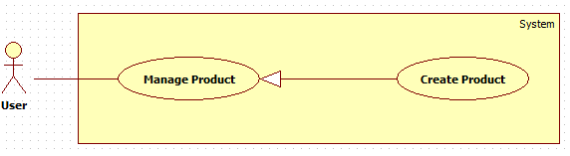

Figure 3‑15 Creat Product use case diagram

###### Use case specification

|  |  |  |  |  |
| --- | --- | --- | --- | --- |
| **USE CASE – CLS009** | | | | |
| **Use case No.** | CLS012 | **Use case version** | | 2.0 |
| **Use case name** | Create Product | | | |
| **Author** | Võ Ngọc Luyến | | | |
| **Date** | 04/06/2013 | **Priority** | High | |
| **Actor:** User  **Summary:**   * User wants to insert a new product, they use this function.   **Goal:**   * Allow user to create new product.   **Triggers:**   * On Manage Product page, click on “Thêm loại hàng mới” button and a form will be shown for user to input required information and then click “Tạo mới” button to finish.   **Preconditions:**   * Guest must log in as the role “User”. * Manage Product page has loaded successfully.   **Post Conditions:**   * User can create a new product successfully. The form is closed and user will return the product list view without reloading page. The new one is displayed as the first row in manage product data table. It will be also saved into database.   **Main Success Scenario:**   |  |  | | --- | --- | | Actor Action | System Response | | 1. Click on “Thêm loại hàng mớ**i”**. | 1. System will show a pop-up “Thêm hàng hóa mới”.   (Please view Page Description below for more information of this page) | | 1. Enter information into text fields, choose active or deactive status and choose an image for product.   Click on “Tạo mới” button to finish. [Alternative 1] | 1. System will return to Manage Product Page, then display a notification message “Tạo loại hàng mới thành công”.   [Exception 1,2,3,4,5,6,7] |   **Alternative Scenario:**   |  |  | | --- | --- | | Actor Action | System Response | | 1. Click on “Hủy bỏ” button to finish. | 1. System will return Manage Product Page, the pop-up is closed. |   **Exceptions:**   |  |  |  | | --- | --- | --- | | No. | Actor Action | System Response | | 1 | Product Name existed in user’s warehouse. | Display error message: “Loại hàng này đã tồn tại trong kho hàng của bạn. Vui lòng đổi tên khác.” | | 2 | Product Name is blank. | Display error message: “Tên loại hàng không thể để trống” | | 3 | Product Length is not numberic or negative number or blank. | Display error message: “Chiều dài phải là một số không âm” or “Chiều dài loại hàng không thể để trống” | | 4 | Product Width is not numberic or negative number or blank. | Display error message: “Chiều rộng phải là một số không âm” or “Chiều rộng loại hàng không thể để trống” | | 5 | Product Height is not numberic or negative number or blank. | Display error message: “Chiều cao phải là một số không âm” or “Chiều cao loại hàng không thể để trống” | | 6 | Product Weight is not numberic or negative number or blank. | Display error message: “Khối lượng phải là một số không âm” or “Khối lượng loại hàng không thể để trống” | | 7 | Maximum High is not numberic or negative number or blank. | Display error message: “Chiều cao cho phép phải là một số không âm” or “Chiều cao cho phép không thể để trống” |   **Relationships:**   * View Product List, Search product, Update Product, Delete Product.   **Business Rules:**   * The Name of new Product must be different from products which existed in database.   **Page Description:**   |  |  |  | | --- | --- | --- | | Field Name | Data Type and Constraints | Required | | Tên loại hàng | Textbox, Min length: 1, Max length: 50. | Yes | | Chiều dài | Textbox, Min length: 1 | Yes | | Chiều rộng | Textbox, Min length: 1 | Yes | | Chiều cao | Textbox, Min length: 1 | Yes | | Khối lượng | Textbox, Min length: 1 | Yes | | Chiều cao cho phép | Textbox, Min length: 1 | Yes | | Kích hoạt | Checkbox |  | | Danh sách ảnh | Dropdownlist |  | | Tạo mới, Xóa hết, Hủy bỏ. | Button |  | | Tạo mới, Xóa hết, Hủy bỏ. | Button |  | | | | | |

##### <User> Import Product List by Excel file

###### Use case diagram

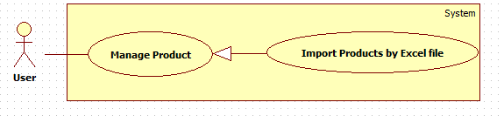

Figure 3‑16 Import Product List by Excel use case diagram

###### Use case specification

|  |  |  |  |  |
| --- | --- | --- | --- | --- |
| **USE CASE – CLS010** | | | | |
| **Use case No.** | CLS013 | **Use case version** | | 2.0 |
| **Use case name** | Import Products by Excel file | | | |
| **Author** | Võ Ngọc Luyến | | | |
| **Date** | 15/05/2013 | **Priority** | Low | |
| **Actor:** User  **Summary:**   * When there are many too products, user can import a product list from an excel file. The column in file can be any order provided that the name of the columns are correct. System will analyses product information fields, display for user review before uploading and save into database.   **Goal:**   * Give user the option to import a product list from an excel file with without creating one by one.   **Triggers:**   * On manage product page, click on “Nhập danh sách loại hàng từ file” link.   **Preconditions:**  **Post Conditions:**   * If the records are correct and full of essential information, it is added to product table as new record(s) and save into database.   **Main Success Scenario:**   |  |  | | --- | --- | | Actor Action | System Response | | 1. Click on “Nhập danh sách loại hàng từ file” button | 1. A form will pop up for user to choose the upload file. | | 1. Click “+” to choose the excel file which contains a product list to review in table. [Alternative 1] | 1. System will check the format of excel file and validate data in file. Then system will show all data content of that file in a datatable for user to review before uploading.   [Exception 1,2] | | 1. Click “Tải lên” to insert all new products. | 1. All new products (valid row) are inserted into database and displayed in manage product table. |   **Alternative Scenario:**   |  |  | | --- | --- | | Actor Action | System Response | | * User upload an excel file contains some products with data is incorrect format or blank. | * System will check and displayed as a red row in table | | * User upload an excel file which has duplicate product name, user can choose the new product or old product. (existed in their warehouse) | * If user choose the new product with its old product using in other solution. System will show a warning message for user: “Loại hàng này đang được sử dụng, nếu bạn cập nhật thông tin mới, các giải pháp liên quan sẽ bị xóa”. |   **Exceptions:**   |  |  |  | | --- | --- | --- | | No. | Actor Action | System Response | | 1 | User choose file which is not correct file type. | Display error message: “Tập tin của bạn không phải là .xls hoặc xlsx” | | 2 | The column name is incorrect format. | Display error message: “Tên cột không đúng. Tên cột phải là Tên loại hàng, Chiều dài, Chiều rộng, Chiều cao, Khối lượng.” |   **Relationships:** Create Product, Update Product, Delete Solution.  **Business Rules:**   * If the excel file user uploads, if there is any row which has the name is the same with any product name in user’s warehouse. System will allow user to choose the product with new data or keep the old product. If user choose new product, the old one is deleted and if user keep the old, that new product is ignored.   **Page Description:**   |  |  |  |  | | --- | --- | --- | --- | | Field Name | Data Type and Constraints | | Required | | Excel product table | Table includes columns:   * “Tên loại hang” * “Chiều dài” * “Chiều rộng” * “Chiều cao” * "Khối lượng” | * “Tải lên” button * “Hủy bỏ” button |  | | | | | |

##### <User> Update Product

###### Use case diagram

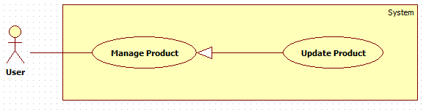

Figure 3‑17 Update Product use case diagram

###### Use case specification

|  |  |  |  |  |
| --- | --- | --- | --- | --- |
| **USE CASE – CLS011** | | | | |
| **Use case No.** | CLS014 | **Use case version** | | 2.0 |
| **Use case name** | Update Product | | | |
| **Author** | Võ Ngọc Luyến | | | |
| **Date** | 04/06/2013 | **Priority** | High | |
| **Actor:**   * User   **Summary:**   * User want to update their own product, they use this function.   **Goal:**   * Allow user change some information of the product.   **Triggers:**   * In manage product table, click on Edit button and “Cập nhật thông tin loại hàng” pop-up will be showed, then input information in which filed user want to change, then click “Cập nhật” button to finish.   **Preconditions:**   * Guest must log in as the role “User”. * Manage product page is load successful. * User has at least one product which show in product table.   **Post Conditions:**   * New product information is updated to database.   **Main Success Scenario:**   |  |  | | --- | --- | | Actor Action | System Response | | 1. Click on “Edit” button to request “Cập nhật thông tin loại hàng” pop-up. | 1. System will response by displaying an Edit Product pop-up (Please view Page Description below for more information of this page) | | 1. Change information into text fields.   Click on “Cập nhật” button to finish. [Alternative 1] [Alternative 2] | 1. The pop up is closed and system will return to manage product page and display message: “Cập nhật thông tin thành công”.[Exception 1,2,3,4,5,6,7] |   **Alternative Scenario:**  [Alternative 1]   |  |  | | --- | --- | | Actor Action | System Response | | 1. Click on “Hủy bỏ” button to finish | 1. System will return to manage product page. |   [Alternative 2]   |  |  | | --- | --- | | Actor Action | System Response | | 1. Change information into text fields. Click on “Cập nhật” button to finish. | 1. System will check and show a warning message to notify user”Loại hàng này đang được sử dụng trong một số giải pháp. Nếu bạn cập nhật sản phẩm này. Giải pháp liên quan sẽ bị xóa”. | | 1. Click on “Đồng ý” | 1. Product will be updated with new information and relational solution is deleted. |   **Exceptions:**   |  |  |  | | --- | --- | --- | | No. | Actor Action | System Response | | 1 | Product Name existed in user’s warehouse. | Display error message: “Loại hàng này đã tồn tại trong kho hàng của bạn. Vui lòng đổi tên khác.” | | 2 | Product Name is blank. | Display error message: “Tên loại hàng không thể để trống” | | 3 | Product Length is not numberic or negative number or blank. | Display error message: “Chiều dài phải là một số không âm” or “Chiều dài loại hàng không thể để trống” | | 4 | Product Width is not numeric or negative number or blank. | Display error message: “Chiều rộng phải là một số không âm” or “Chiều rộng loại hàng không thể để trống” | | 5 | Product Height is not numeric or negative number or blank. | Display error message: “Chiều cao phải là một số không âm” or “Chiều cao loại hàng không thể để trống” | | 6 | Product Weight is not numberic or negative number or blank. | Display error message: “Khối lượng phải là một số không âm” or “Khối lượng loại hàng không thể để trống” | | 7 | Maximum High is not numeric or negative number or blank. | Display error message: “Chiều cao cho phép phải là một số không âm” or “Chiều cao cho phép không thể để trống” |   **Relationships:**   * View Product List, Search Product and Delete Solution.   **Business Rules:**   * If user edit the product and that product is using in the other solution. System will check and show a warning message to notify ”Loại hàng này đang được sử dụng trong một số giải pháp. Nếu bạn cập nhật sản phẩm này. Giải pháp liên quan sẽ bị xóa”. User can choose “Đồng ý” or “Hủy bỏ”.   **Page Description:**   |  |  |  | | --- | --- | --- | | Field Name | Data Type and Constraints | Required | | “Tên loại hang” | Textbox, Min length: 1, Max length: 50. | Yes | | “Chiều dài” | Textbox, Min length: 1 | Yes | | Chiều rộng | Textbox, Min length: 1 | Yes | | Chiều cao | Textbox, Min length: 1 | Yes | | Khối lượng | Textbox, Min length: 1 | Yes | | Chiều cao cho phép | Textbox, Min length: 1 | Yes | | Kích hoạt | Checkbox |  | | Danh sách ảnh | Dropdownlist |  | | Tạo mới, Xóa hết, Hủy bỏ. | Button |  | | | | | |

##### <User> Delete Product

###### Use case diagram

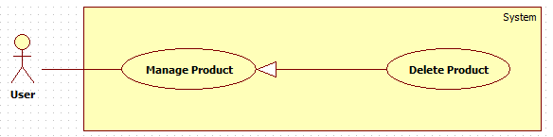

Figure 3‑18 Delete Product use case diagram

###### Use case specification

|  |  |  |  |  |
| --- | --- | --- | --- | --- |
| **USE CASE – CLS012** | | | | |
| **Use case No.** | CLS015 | **Use case version** | | 2.0 |
| **Use case name** | Delete Product | | | |
| **Author** | Võ Ngọc Luyến | | | |
| **Date** | 04/06/2013 | **Priority** | High | |
| **Actor:**   * User   **Summary:**   * User want to delete their own product, they use this function.   **Goal:**   * Allow user to remove their Product.   **Triggers:**   * In manage product table, click on “x” button   **Preconditions:**   * Manage Product page is load successful. * User has at least one product in manage product table.   **Post Conditions:**   * User can delete product successfully.   **Main Success Scenario:**   |  |  | | --- | --- | | Actor Action | System Response | | 1. Click on “x” button to delete product. | 1. System will response by showing “Xóa loại hàng” confirm pop-up with the message “Bạn chắc là muốn xóa loại hàng này”(Please view Page Description below for more information of this page) | | 1. Click on “Xóa” button to finish. [Alternative 1], [Alternative 2] | 1. System will remove that product from database datatable, pop up is closed and system will return to manage product page and show a notification”Xóa thành công”. |   **Alternative Scenario:**   |  |  | | --- | --- | | Actor Action | System Response | | 1. Click on “Hủy bỏ” button to finish | 1. System will return to manage product page. |   Alternative 2:   |  |  | | --- | --- | | Actor Action | System Response | | 1. Click on “Xóa” button to finish. | 1. System will check and show a warning message to notify user”Loại hàng này đang được sử dụng trong một số giải pháp. Nếu bạn xóa sản phẩm này. Giải pháp liên quan sẽ bị xóa”. | | 1. Click on “Đồng ý” | 1. Product will be removed from database and datatable. |   **Exceptions:**  **Relationships:**   * View Product List, Delete Solution   **Business Rules:**   * If user delete the product and that product is using in the other solution. System will check and show a warning message to notify user”Loại hàng này đang được sử dụng trong một số giải pháp. Nếu bạn xóa sản phẩm này. Giải pháp liên quan sẽ bị xóa”. User can choose “Đồng ý” or “Hủy bỏ”.   **Page Description:**  **Page Description:**   |  |  |  | | --- | --- | --- | | Field Name | Data Type and Constraints | Required | | Confirm message | Text:”Bạn có chắc muốn xóa loại hàng này” |  | | Xóa | Button |  | | Hủy bỏ | Button |  | | | | | |

##### <User> Activate/Deactivate Product

###### Use case diagram

****

Figure 3‑19 Search Product use case diagram

###### Use case specification

* This feature is same with Active/Deactive User

##### <User> View Container List

###### Use case diagram

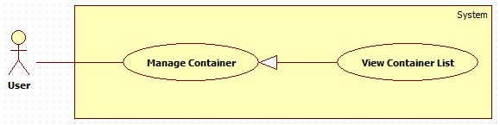

Figure 3‑20 View Container List use case diagram

###### Use case specification

|  |  |  |  |  |
| --- | --- | --- | --- | --- |
| **USE CASE – CLS013** | | | | |
| **Use case No.** | CLS016 | **Use case version** | | 2.0 |
| **Use case name** | View Container List | | | |
| **Author** | Võ Ngọc Luyến | | | |
| **Date** | 02/06/2013 | **Priority** | High | |
| **Actor:** User  **Summary:**   * User uses this use case to view their list of containers.   **Goal:**   * Allow user to view all containers in their warehouse.   **Triggers:**   * On header page, click on “Quản lý Container” link and Manage Container page will be showed.   **Preconditions:**   * Guest must log in as the role “User”.   **Post Conditions:**  **Main Success Scenario:**   |  |  | | --- | --- | | Actor Action | System Response | | 1. Click on “Quản lý Container” to request Manage Container page. | 1. System will response by loading all containers of user and show in a datatable (Please view Page Description below for more information of this page). |   **Relationships:**   * Search Container, Create Container, Update Container and Delete Container.   **Business Rules:**  **Page Description:**   |  |  |  | | --- | --- | --- | | Field Name | Data Type and Constraints | Required | | Mange Container Table | Table includes:   * “Tên Container” column. * “Hình ảnh” column. * “Chiều dài” column. * “Chiều rộng” column. * “Chiều cao” column. * “Khối lượng” * Edit button * Delete button |  | | | | | |

##### <User> Search Container

###### Use case diagram

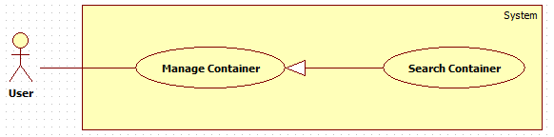

Figure 3‑21 Search Container use case diagram

###### Use case specification

|  |  |  |  |  |
| --- | --- | --- | --- | --- |
| **USE CASE – CLS014** | | | | |
| **Use case No.** | CLS017 | **Use case version** | | 2.0 |
| **Use case name** | Search Container | | | |
| **Author** | Võ Ngọc Luyến | | | |
| **Date** | 02/06/2013 | **Priority** | High | |
| **Actor:** User.  **Summary:**   * User wants to search containers, they use this function.   **Goal:**   * Allow user to search their containers.   **Triggers:**   * In Manage Container page, input keyword in search textbox such as container’s name. If it matches with any container of that user, the system will list them into Container List table.   **Preconditions:**   * Guest must log in as the role “User”. * Manage container page has loaded successfully.   **Post Conditions:**  **Main Success Scenario:**   |  |  | | --- | --- | | Actor Action | System Response | | 1. Input keyword in search text box. | 1. System will list items which match with keyword in Container List table. |   **Alternative Scenario:**   |  |  | | --- | --- | | Actor Action | System Response | | 1. User input container information which isn’t match with any user container information. | 1. Container List table has no row. |   **Relationships:**   * View Container List, Create Container, Update Container.   **Business Rules:**  **Page Description:**   |  |  |  | | --- | --- | --- | | Field Name | Data Type and Constraints | Required | | Text-Search | Textbox | Yes | | | | | |

##### <User> Create Container

###### Use case diagram

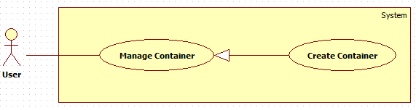

Figure 3‑22 Create Container use case diagram

###### Use case specification

|  |  |  |  |  |
| --- | --- | --- | --- | --- |
| **USE CASE – CLS015** | | | | |
| **Use case No.** | CLS018 | **Use case version** | | 2.0 |
| **Use case name** | Create Container | | | |
| **Author** | Võ Ngọc Luyến | | | |
| **Date** | 02/06/2013 | **Priority** | High | |
| **Actor:** User  **Summary:**   * User wants to insert a new container, they use this function.   **Goal:**   * Allow user to create new container.   **Triggers:**   * On Manage Container page, click on “Thêm Container mới” button and a form will be shown for user to input required information and then click “Tạo mới” button to finish.   **Preconditions:**   * Guest must log in as the role “User”. * Manage Container page has loaded successfully.   **Post Conditions:**   * User can create a new container successfully. The form is closed and user will return the container list view without reloading page. The new one is displayed as the first row in manage container datatable. It will be also saved into database.   **Main Success Scenario:**   |  |  | | --- | --- | | Actor Action | System Response | | 1. Click on “**Thêm Container mới”**. | 1. System will show a pop-up “Thêm container mới”.   (Please view Page Description below for more information of this page) | | 1. Enter information into text fields, choose an image for container.   Click on “Tạo mới” button to finish. [Alternative 1] | 1. System will return to Manage Container Page, then display a notification message “Tạo container mới thành công”.   [Exception 1,2,3,4,5,6,7] |   **Alternative Scenario:**   |  |  | | --- | --- | | Actor Action | System Response | | 1. Click on “Hủy bỏ” button to finish | 1. System will return Manage Container Page, the pop-up is closed. |   **Exceptions:**   |  |  |  | | --- | --- | --- | | No. | Actor Action | System Response | | 1 | Container Name existed in user’s warehouse. | Display error message: “Container này đã tồn tại trong kho hàng của bạn. Vui lòng đổi tên khác.” | | 2 | Container Name is blank. | Display error message: “Tên Container không thể để trống” | | 3 | Container Length is not numberic or negative number or blank. | Display error message: “Chiều dài phải là một số không âm” or “Chiều dài container không thể để trống” | | 4 | Container Width is not numberic or negative number or blank. | Display error message: “Chiều rộng phải là một số không âm” or “Chiều container không thể để trống” | | 5 | Container Height is not numberic or negative number or blank. | Display error message: “Chiều cao phải là một số không âm” or “Chiều cao container không thể để trống” | | 6 | Container Weight is not numberic or negative number or blank. | Display error message: “Khối lượng phải là một số không âm” or “Khối lượng container không thể để trống” |   **Relationships:**   * View Container List, Search Container, Update Container.   **Business Rules:**   * The Name of new Container must be different from containers which existed in database.   **Page Description:**   |  |  |  | | --- | --- | --- | | Field Name | Data Type and Constraints | Required | | Tên Container | Textbox, Min length: 1, Max length: 50. | Yes | | Chiều dài | Textbox, Min length: 1 | Yes | | Chiều rộng | Textbox, Min length: 1 | Yes | | Chiều cao | Textbox, Min length: 1 | Yes | | Khối lượng | Textbox, Min length: 1 | Yes | | Danh sách ảnh | Dropdownlist |  | | Tạo mới, Xóa hết, Hủy bỏ. | Button |  | | Tạo mới, Xóa hết, Hủy bỏ. | Button |  | | | | | |

##### <User> Update Container

###### Use case diagram

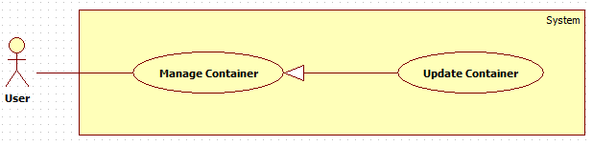

Figure 3‑23 Update Container use case diagram

###### Use case specification

|  |  |  |  |  |
| --- | --- | --- | --- | --- |
| **USE CASE – CLS017** | | | | |
| **Use case No.** | CLS019 | **Use case version** | | 2.0 |
| **Use case name** | Update Container | | | |
| **Author** | Võ Ngọc Luyến | | | |
| **Date** | 02/06/2013 | **Priority** | High | |
| **Actor:**   * User   **Summary:**   * User want to update their own container, they use this function.   **Goal:**   * Allow user change some information of the container.   **Triggers:**   * In manage container table, click on Edit button and “Cập nhật thông tin container” pop-up will be showed, then input information in which filed user want to change, then click “Cập nhật” button to finish.   **Preconditions:**   * Guest must log in as the role “User”. * Manage container page is load successful. * User has at least one container which show in container table.   **Post Conditions:**   * New container information is updated to database.   **Main Success Scenario:**   |  |  | | --- | --- | | Actor Action | System Response | | 1. Click on “Edit” button to request “Cập nhật thông tin container” pop-up. | 1. System will response by displaying an Edit Container pop-up (Please view Page Description below for more information of this page) | | 1. Change information into text fields.   Click on “Cập nhật” button to finish. [Alternative 1] [Alternative 2] | 1. The pop up is closed and system will return to manage container page and display message: “Cập nhật thông tin thành công”.[Exception 1,2,3,4,5,6,7] |   **Alternative Scenario:**  [Alternative 1]   |  |  |  | | --- | --- | --- | | Step | Actor Action | System Response | | 1 | Click on “Hủy bỏ” button to finish | 1. System will return to manage container page. |   [Alternative 2]   |  |  | | --- | --- | | Actor Action | System Response | | 1. Change information into text fields. Click on “Cập nhật” button to finish. | 1. System will check and show a warning message to notify user”Container này đang được sử dụng trong một số giải pháp. Nếu bạn cập nhật container này. Giải pháp liên quan sẽ bị xóa”. | | 1. Click on “Đồng ý” | 1. Container will be updated with new information and relational solution is deleted. |   **Exceptions:**   |  |  |  | | --- | --- | --- | | No. | Actor Action | System Response | | 1 | Container Name existed in user’s warehouse. | Display error message: “Container này đã tồn tại trong kho hàng của bạn. Vui lòng đổi tên khác.” | | 2 | Container Name is blank. | Display error message: “Tên Container không thể để trống” | | 3 | Container Length is not numberic or negative number or blank. | Display error message: “Chiều dài phải là một số không âm” or “Chiều dài container không thể để trống” | | 4 | Container Width is not numberic or negative number or blank. | Display error message: “Chiều rộng phải là một số không âm” or “Chiều container không thể để trống” | | 5 | Container Height is not numberic or negative number or blank. | Display error message: “Chiều cao phải là một số không âm” or “Chiều cao container không thể để trống” | | 6 | Container Weight is not numberic or negative number or blank. | Display error message: “Khối lượng phải là một số không âm” or “Khối lượng container không thể để trống” |   **Relationships:**   * View Container List, Search Container, Delete Solution.   **Business Rules:**   * If user edit the cotainer and that container is using in the other solution. System will check and show a warning message to notify user”Container này đang được sử dụng trong một số giải pháp. Nếu bạn cập nhật container này. Giải pháp liên quan sẽ bị xóa”. User can choose “Đồng ý” or “Hủy bỏ”.   **Page Description:**   |  |  |  | | --- | --- | --- | | Field Name | Data Type and Constraints | Required | | Tên Container | Textbox, Min length: 1, Max length: 50. | Yes | | Chiều dài | Textbox, Min length: 1 | Yes | | Chiều rộng | Textbox, Min length: 1 | Yes | | Chiều cao | Textbox, Min length: 1 | Yes | | Khối lượng | Textbox, Min length: 1 | Yes | | Danh sách ảnh | Dropdownlist |  | | Tạo mới, Xóa hết, Hủy bỏ. | Button |  | | Tạo mới, Xóa hết, Hủy bỏ. | Button |  | | | | | |

##### <User> Delete Container

###### Use case diagram

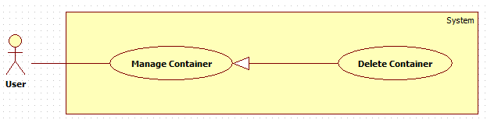

Figure 3‑24 Delete Container use case diagram

###### Use case specification

|  |  |  |  |  |
| --- | --- | --- | --- | --- |
| **USE CASE – CLS018** | | | | |
| **Use case No.** | CLS020 | **Use case version** | | 2.0 |
| **Use case name** | Delete Container | | | |
| **Author** | Võ Ngọc Luyến | | | |
| **Date** | 02/06/2013 | **Priority** | High | |
| **Actor:** User  **Summary:**   * User want to delete their own container, they use this function.   **Goal:**   * Allow user to remove their Container.   **Triggers:**   * In manage container table, click on “x” button   **Preconditions:**   * Manage Container page is load successful. * User has at least one container in manage container table.   **Post Conditions:**   * User can delete container successfully.   **Main Success Scenario:**   |  |  | | --- | --- | | Actor Action | System Response | | 1. Click on “x” button to delete container. | 1. System will response by showing “Xóa Container” confirm pop-up with the message “Bạn chắc là muốn xóa Container này”(Please view Page Description below for more information of this page) | | 1. Click on “Xóa” button to finish. [Alternative 1], [Alternative 2] | 1. System will remove that container from database datatable, pop up is closed and system will return to manage container page and show a notification”Xóa thành công”. |   **Alternative Scenario:**  Alternative 1:   |  |  | | --- | --- | | Actor Action | System Response | | 1. Click on “Hủy bỏ” button to finish | 1. System will return to manage container page. |   Alternative 2:   |  |  | | --- | --- | | Actor Action | System Response | | 1. Click on “Xóa” button to finish. | 1. System will check and show a warning message to notify user”Container này đang được sử dụng trong một số giải pháp. Nếu bạn xóa container này. Giải pháp liên quan sẽ bị xóa”. | | 1. Click on “Đồng ý” | 1. Container will be removed from database and datatable. |   **Relationships:**   * View Container List, Delete Solution.   **Business Rules:**   * If user delete the container and that container is using in the other solution. System will check and show a warning message to notify user”Container này đang được sử dụng trong một số giải pháp. Nếu bạn xóa container này. Giải pháp liên quan sẽ bị xóa”. User can choose “Đồng ý” or “Hủy bỏ”.   **Page Description:**   |  |  |  | | --- | --- | --- | | Field Name | Data Type and Constraints | Required | | Confirm message | Text:”Bạn có chắc muốn xóa container này” |  | | Xóa | Button |  | | Hủy bỏ | Button |  | | | | | |

##### <User> Buy Main Charge Package via Paypal

###### Use case diagram

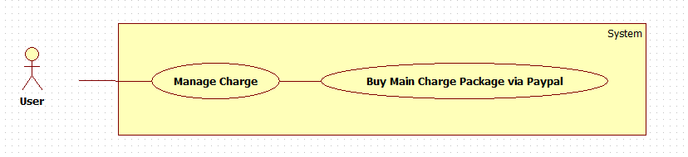

Figure 3‑25 Buy Main Charge Package use case diagram

###### Use case specification

|  |  |  |  |  |
| --- | --- | --- | --- | --- |
| **USE CASE – CLS019** | | | | |
| **Use case No.** | CLS021 | **Use case version** | | 2.0 |
| **Use case name** | Buy Main Charge Package via Paypal | | | |
| **Author** | Phan Duy Khánh | | | |
| **Date** | 05/06/2013 | **Priority** | High | |

|  |  |  |  |  |  |  |  |  |  |  |  |  |  |  |  |  |  |  |  |  |  |  |  |  |  |  |  |  |
| --- | --- | --- | --- | --- | --- | --- | --- | --- | --- | --- | --- | --- | --- | --- | --- | --- | --- | --- | --- | --- | --- | --- | --- | --- | --- | --- | --- | --- |
| **Actor:** User  **Summary:**   * User will use this function for purchasing a main charge package for them to use.   **Goal:**   * A main charge package is added to user after they fulfill transaction on paypal   **Triggers:**   * Click on “Mua ngay” on “Gói tham khảo” tab in “Hiện trạng sử dụng” page   **Preconditions:**   * User logged successful to system. * User is viewing Charge Usage   **Post Conditions:**   * User is added a new main charge package as they can see in “Hiện trạng sử dụng” page.   **Main Success Scenario:**   |  |  | | --- | --- | | Actors action:   1. Click on “Mua ngay” button on tab “Gói tham khảo” in “Hiện trạng sử dụng” page | System Response: | |  | 1. Navigate to Paypal | | 1. Enter paypal account and submit payment successfully |  | |  | 1. Create a main charge package for this current user. And navigate to Payment Success page. There should be an message “Cảm ơn bạn đã mua gói. Vui lòng nhấp vào đây để quay trở lại và thực hiện dịch vụ”. | | 1. User click on “tại đây” link |  | |  | 1. System navigate user back to “Hiện trạng sử dụng” page |   **Alternative Scenario:**   |  |  | | --- | --- | | Actors action:   1. Click on “Cancel” during the transaction with paypal. | System Response: | |  | 1. System will cancel the transaction and navigate user back to “Hiện trạng sử dụng” page |   **Exceptions:**  **Relationships:**  **Business Rules:**  **Page Description:**   |  |  |  | | --- | --- | --- | | Field Name | Data Type and Constraints | Required | | Tên gói, giá tiền, số làn sử dụng, thời hạn sử dụng | Label  Unicode String | Yes | | “Mua ngay” | Button |  | | “Mua gói cộng thêm” | Button link |  | |
|  |

##### <User> Buy Additional Charge Package via Paypal

###### Use case diagram

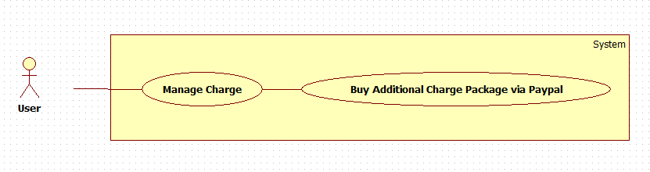

Figure 3‑26 Buy Additional Charge Package use case diagram

###### Use case specification

|  |  |  |  |  |
| --- | --- | --- | --- | --- |
| **USE CASE – CLS019** | | | | |
| **Use case No.** | CLS022 | **Use case version** | | 2.0 |
| **Use case name** | Buy Additional Charge Package via Paypal | | | |
| **Author** | Phan Duy Khánh | | | |
| **Date** | 05/06/2013 | **Priority** | High | |

|  |  |  |  |  |  |  |  |  |  |  |  |  |  |  |  |  |  |  |  |  |  |  |  |  |  |  |  |  |
| --- | --- | --- | --- | --- | --- | --- | --- | --- | --- | --- | --- | --- | --- | --- | --- | --- | --- | --- | --- | --- | --- | --- | --- | --- | --- | --- | --- | --- |
| **Actor:** User  **Summary:**   * User will use this function for purchasing a additional charge package for them to use.   **Goal:**   * The additonal charge package is added to user after they fulfill transaction on paypal. Which is increase their number of used but not   **Triggers:**   * Click on “Mua gói cộng thêm” on “Gói tham khảo” tab in “Hiện trạng sử dụng” page   **Preconditions:**   * User logged successful to system. * User is viewing Charge Usage   **Post Conditions:**   * User is added a new main charge package as they can see in “Hiện trạng sử dụng” page.   **Main Success Scenario:**   |  |  | | --- | --- | | Actors action:   1. Click on “Mua gói cộng thêm” button on tab “Gói tham khảo” in “Hiện trạng sử dụng” page | System Response: | |  | 1. Navigate to Paypal | | 1. Enter paypal account and submit payment successfully |  | |  | 1. Create an additional charge package for this current user which is base on current additional package of user. And navigate to Payment Success page. There should be a message “Cảm ơn bạn đã mua gói. Vui lòng nhấp vào đây để quay trở lại và thực hiện dịch vụ”. | | 1. User click on “tại đây” link |  | |  | 1. System navigate user back to “Hiện trạng sử dụng” page |   **Alternative Scenario:**   |  |  | | --- | --- | | Actors action:   1. Click on “Cancel” during the transaction with paypal. | System Response: | |  | 1. System will cancel the transaction and navigate user back to “Hiện trạng sử dụng” page |   **Exceptions:**  **Relationships:**  **Business Rules:**  **Page Description:**   |  |  |  | | --- | --- | --- | | Field Name | Data Type and Constraints | Required | | Tên gói, giá tiền, số làn sử dụng, thời hạn sử dụng | Label  Unicode String | Yes | | “Mua ngay” | Button |  | | “Mua gói cộng thêm” | Button link |  | |

##### <User> View Charge History

###### Use case diagram

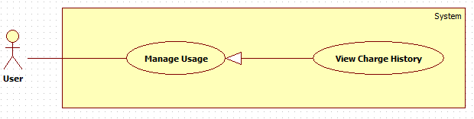

Figure 3‑27 View Charge History use case diagram

###### Use case specification

|  |  |  |  |  |
| --- | --- | --- | --- | --- |
| **USE CASE – CLS019** | | | | |
| **Use case No.** | CLS023 | **Use case version** | | 2.0 |
| **Use case name** | View Charge History | | | |
| **Author** | Phan Duy Khánh | | | |
| **Date** | 05/06/2013 | **Priority** | High | |
| **Actor:** User  **Summary:**   * User will use this function for viewing and keep track of their added package.   **Goal:**   * All Charge Package and their status display on the screen   **Triggers:**   * Click on “Hiện trạng sử dụng” on menu bar for viewing their history.   **Preconditions:**   * User logged successful to system. * User is viewing Charge Usage   **Post Conditions:**   * All Customers’ submitted Charge Package display on the screen.   **Main Success Scenario:**   |  |  | | --- | --- | | Actors action:   1. Click on “Hiện trạng sử dụng” title | System Response: | |  | 1. Show User Charge Usage and history Page. |   **Alternative Scenario:**   |  |  | | --- | --- | | Actors action:   1. Click on tab “Sử dụng” to see the chart. | System Response: | |  | 1. System will transfer to Charge Usage Tab |   **Exceptions:**  **Relationships:**  **Business Rules:**  **Page Description:**   |  |  |  | | --- | --- | --- | | Field Name | Data Type and Constraints | Required | | Id, Ngày bắt đầu, Ngày kết thúc, Số lần sử dụng, Gói, Đơn giá gói, Trạng thái | Label  Unicode String | Yes | | “Số lần sử dụng” bar | Progress bar show the call solution left for this active package | Yes | | “Thời gian” bar | Progress bar show the duration left for this active package | Yes | | | | | |

##### <User> View Charge Usage

###### Use case diagram

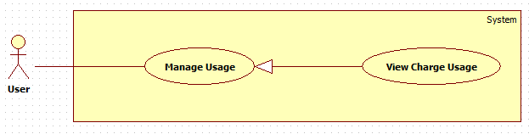

Figure 3‑28 View Charge Usage use case diagram

###### Use case specification

|  |  |  |  |  |
| --- | --- | --- | --- | --- |
| **USE CASE – CLS020** | | | | |
| **Use case No.** | CLS024 | **Use case version** | | 2.0 |
| **Use case name** | View Charge Usage | | | |
| **Author** | Phan Duy Khánh | | | |
| **Date** | 05/06/2013 | **Priority** | High | |
| **Actor:** User  **Summary:**   * User will use this function for viewing and keep track of their usage call solutions   **Goal:**   * All Charge used are displayed on the screen with the chart   **Triggers:**   * Click on “Hiện trạng sử dụng” on menu bar for viewing their History of Charge.   **Preconditions:**   * User logged successful to system. * User view Profile Page   **Post Conditions:**   * All User’s usage of Charge display on the screen.   **Main Success Scenario:**   |  |  | | --- | --- | | Actors action:   1. Click “Hiện trạng sử dụng”. | System Response: | |  | 1. Show User Charge Usage and history Page. | | 1. Click tab “Usage”   [Alternative 1] |  | |  | 1. System will response”Sử dụng” tab and show a chart which display the usage of this user (Please view Page Description below for more information of this page). |   **Alternative Scenario:**   |  |  | | --- | --- | | Actors action:   1. Click on tab “Lịch sử” to see the charge history. | System Response: | |  | 1. System will transfer to Charge history Tab |   **Exceptions:**  **Relationships:**  **Business Rules:**  **Page Description:**   |  |  |  | | --- | --- | --- | | Field Name | Data Type and Constraints | Required | | Chart | Line chart represent the usage of this user per day in the period of 1 month | Yes | | | | | |

##### <User> View Solution List

###### Use case diagram

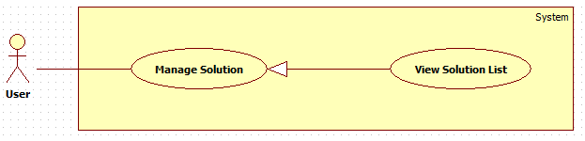

Figure 3‑29 View Solution List use case diagram

###### Use case specification

|  |  |  |  |  |
| --- | --- | --- | --- | --- |
| **USE CASE – CLS021** | | | | |
| **Use case No.** | CLS025 | **Use case version** | | 2.0 |
| **Use case name** | View Solution List | | | |
| **Author** | Nguyễn Đinh Bảo Tú | | | |
| **Date** | 02/06/2013 | **Priority** | High | |
| **Actor:** User  **Summary:**   * User can build many solution plans for multiple containers and products and save them to reuse later. This function shows all the user’s solutions. User clicks to choose the solution plans they want to view.   **Goal:**   * Allow user to view a list of solutions (if any).   **Triggers:**   * On header page, click on “Quản lý Giải pháp” title, choose Solution List link and this page will be displayed.   **Preconditions:**   * Guest must log in as the role “User”.   **Post Conditions:**  **Main Success Scenario:**   |  |  | | --- | --- | | Actors action:   1. Click on “Giải pháp” title, choose “Quản lý Giải pháp” in dropdown list. | System Response: | |  | 1. Display **Manage Solution** Page which includes solution list. Each solution include some solution information. |   **Alternative Scenario:**  **Exceptions:**  **Relationships:**   * Create Solution, Update Solution, Delete Solution, Clone Solution, View Solution Detail Result (Algorithm) and View Solution Visualization Result (3D).   **Page Description:**   |  |  |  | | --- | --- | --- | | Field Name | Data Type and Constraints | Required | | Solution | Titles control includes some information:   * Image * Name * Create Date * Last Modify Date * ProductNameList * View button * Delete button * Clone button |  | | | | | |

##### <User> Create Solution

###### Use case diagram

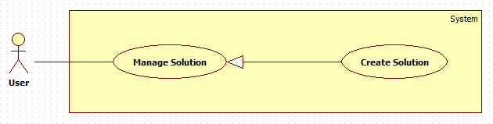

Figure 3‑30 Create Solution use case diagram

###### Use case specification

|  |  |  |  |  |
| --- | --- | --- | --- | --- |
| **USE CASE – CLS022** | | | | |
| **Use case No.** | CLS026 | **Use case version** | | 2.0 |
| **Use case name** | Create Solution | | | |
| **Author** | Nguyễn Đinh Bảo Tú | | | |
| **Date** | 3/6/2013 | **Priority** | High | |
| **Actor:** User  **Summary:**   * When user wants to create a new solution, this page allows them to fill the solution name, choose container and choose products and input addition information (quantity, color) and press “Lưu” button to add to solutions list.   **Goal:**   * Allow user to create a new solution.   **Triggers:**   * On header page, click on “Giải pháp” title, choose “Giải pháp mới” in dropdown list.   **Preconditions:**   * Guest must log in as the role “User”.   **Post Conditions:**   * A new solution is added to database and can be seen in the solutions list of user.   **Main Success Scenario:**   |  |  | | --- | --- | | Actors action:   1. Click on “Giải pháp” title, choose “Giải pháp mới” in dropdown list. | System Response: | |  | 1. Display Solution Editor Page for editing solution information. | | 1. User choose container, products and input additional information of product (quantity, color). Then user click “Lưu” button to finish. |  | |  | 1. System will check data, create new solution with solution information is provided by user. |   **Alternative Scenario:**   |  |  | | --- | --- | | Actors action:   1. Leave page without saving. | System Response: | |  | 1. Notify user “Giải pháp của bạn chưa được lưa. Bạn có muốn tiếp tục?” | | 1. User press “Leave page now” button. |  | |  | 1. System will not save new solution. |   **Exceptions:**   |  |  |  | | --- | --- | --- | | No. | Actor Action | System Response | | 1 | The Solution Name is blank. | Display error message: “Tên giải pháp không được bỏ trống” | | 2 | Solution Name is same with other user’s Solution Name | Display error message: “Tên giải pháp đã tồn tại.” |   **Relationships:**   * View Solution List, Update Solution, Delete Solution, Clone Solution, View Solution Detail Result (Algorithm) and View Solution Visualization Result (3D).   **Page Description:**   |  |  |  | | --- | --- | --- | | Field Name | Data Type and Constraints | Required | | Solution Name | Textbox - Unicode String  Min length: 1.  Max length: 20 |  | | Container | Title Control which include information:   * Name * Length * Width * Height |  | | ProductList | Table which include information:   * Name * Length * Width * Height * Weight * Maximum High * Quantity * Color |  | | Choose container | Button |  | | Choose products | Button |  | | Loading | Button |  | | Save | Button |  | | Clone | Button |  | | | | | |

##### <User> Update Solution

###### Use case diagram

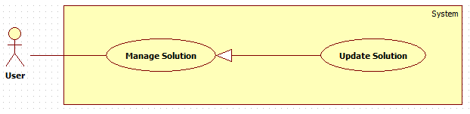

Figure 3‑31 Update Solution use case diagram

###### Use case specification

|  |  |  |  |  |
| --- | --- | --- | --- | --- |
| **USE CASE – CLS023** | | | | |
| **Use case No.** | CLS027 | **Use case version** | | 2.0 |
| **Use case name** | Update Solution | | | |
| **Author** | Nguyễn Đinh Bảo Tú | | | |
| **Date** | 4/6/2013 | **Priority** | High | |
| **Actor:** User  **Summary:**   * When user wants to update some information in their solution for other purposes, they view solution details, edit something and save these change.   **Goal:**   * Allow user to update information and save to database.   **Triggers:**   * On Manage Solution Page, click on “Xem” link and Solution Editor with solution saved information will be shown.   **Preconditions:**   * Guest must log in as the role “User”. * The solutions list page is load successfully.   **Post Conditions:**   * Solution’s information is updated and saved in to database successfully.   **Main Success Scenario:**   |  |  | | --- | --- | | Actors action:   1. Click on “Xem” button on “Quản lý Giải pháp” page | System Response: | |  | 1. Display **Solution Editor** Page which contains saved information in solution. | | 1. User choose other container, other products and input additional information of product (quantity, color). Then user click “Lưu” button to finish. |  | |  | 1. System will check data, update solution with solution information is provided by user. |   **Alternative Scenario:**   |  |  | | --- | --- | | Actors action:   1. Leave page without saving. | System Response: | |  | 1. Notify user “Giải pháp của bạn chưa được lưa. Bạn có muốn tiếp tục?” | | 1. User press “Leave page now” button. |  | |  | 1. System will not save new solution. |   **Exceptions:**  **Relationships:**   * View Solution List, Create Solution, Delete Solution, Clone Solution, View Solution Detail Result (Algorithm) and View Solution Visualization Result (3D).   **Page Description:**   |  |  |  | | --- | --- | --- | | Field Name | Data Type and Constraints | Required | | Container | Title Control which include information:   * Name * Length * Width * Height |  | | ProductList | Table which include information:   * Name * Length * Width * Height * Weight * Maximum High * Quantity * Color |  | | Choose container | Button |  | | Choose products | Button |  | | Loading | Button |  | | Save | Button |  | | Clone | Button |  | | | | | |

##### <User> Delete Solution

###### Use case diagram

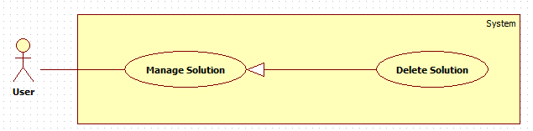

Figure 3‑32 Delete Solution use case diagram

###### Use case specification

|  |  |  |  |  |
| --- | --- | --- | --- | --- |
| **USE CASE – CLS024** | | | | |
| **Use case No.** | CLS028 | **Use case version** | | 2.0 |
| **Use case name** | Delete Solution | | | |
| **Author** | Nguyễn Đinh Bảo Tú | | | |
| **Date** | 4/6/2013 | **Priority** | High | |
| **Actor:** User  **Summary:**   * User can delete solution in solutions list if they do not want to use anymore.   **Goal:**   * Remove solution out of the database.   **Triggers:**   * On Manage Solution Page, click on “Xóa” button of the solution need deleted.   **Preconditions:**   * Guest must log in as the role “User”. * The solutions list page is load successfully.   **Post Conditions:**   * The selected solution is removed from database and user cannot find it in solutions list anymore.   **Main Success Scenario:**   |  |  | | --- | --- | | Actors action:   1. User click on “Xóa” button on “Quản lý Giải pháp” page | System Response: | |  | 1. System will display confirmation pop-up with message “Bạn muốn xóa Giải pháp này?” | | 1. User click “Đồng ý” button. |  | |  | 1. System will remove this solution from User Solution List. |   **Alternative Scenario:**   |  |  | | --- | --- | | Actors action:   1. User click on “Hủy bỏ” button on confirmation pop-up. | System Response: | |  | 1. System will cancel delete solution request. |   **Exceptions:**  **Relationships:**   * View Solution List, Create Solution, Update Solution, Clone Solution, View Solution Detail Result (Algorithm) and View Solution Visualization Result (3D). | | | | |

##### <User> Clone Solution

###### Use case diagram

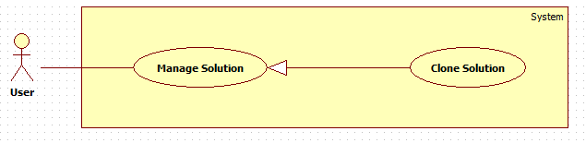

Figure 3‑33 Clone Solution use case diagram

###### Use case specification

|  |  |  |  |  |
| --- | --- | --- | --- | --- |
| **USE CASE – CLS025** | | | | |
| **Use case No.** | CLS029 | **Use case version** | | 2.0 |
| **Use case name** | Clone Solution | | | |
| **Author** | Nguyễn Đinh Bảo Tú | | | |
| **Date** | 4/6/2013 | **Priority** | High | |
| **Actor:** User  **Summary:**   * User wants to create a copy of a solution which existed in solutions list, they use this function.   **Goal:**   * Create a new solution with the same contents with selected solution.   **Triggers:**   * On Manage Solution Page, click on “Nhân bản” button of the solution need to be copied. * Or click on “Nhân bản” button in Solution Editor Page.   **Preconditions:**   * Guest must log in as the role “User”. * The solutions list page is load successfully   **Post Conditions:**   * A new solution which contains all contents of selected solution is displayed for user to use immediately.   **Main Success Scenario:**   |  |  | | --- | --- | | Actors action:   1. User click on “Nhân bản” button on “Quản lý Giải pháp” page | System Response: | |  | 1. System will display pop-up allow you input new solution name. | | 1. User input new solution name. |  | |  | 1. System will remove this solution from User Solution List. |   **Alternative Scenario:**  **Exceptions:**   |  |  |  | | --- | --- | --- | | Step | Actor Action | System Response | | 1 | The Solution Name is blank. | Display error message: “Tên giải pháp không được bỏ trống” | | 2 | Solution Name is same with other user’s Solution Name | Display error message: “Tên giải pháp đã tồn tại.” |   **Relationships:**   * Create Solution, Update Solution, Delete Solution, Clone Solution, View Solution Detail Result (Algorithm) and View Solution Visualization Result (3D). | | | | |

##### <User> View Solution Detail Result (Algorithm)

###### Use case diagram

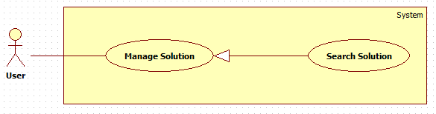

Figure 3‑34 View Solution Detail Result use case diagram

###### Use case specification

|  |  |  |  |  |
| --- | --- | --- | --- | --- |
| **USE CASE – CLS026** | | | | |
| **Use case No.** | CLS030 | **Use case version** | | 2.0 |
| **Use case name** | View Solution Detail Result | | | |
| **Author** | Nguyễn Đinh Bảo Tú | | | |
| **Date** | 4/6/2013 | **Priority** | High | |
| **Actor:** User  **Summary:**   * Solution detail result include how many product is loaded into container and loading sequence.   **Goal:**   * Allow user to view summary result as: How many product is loaded into container? How many product isn’t loaded into container? Loading sequence?   **Triggers:**   * User create solution, choose container, choose products and input additional product information (quantity, color), then click “Sắp xếp”. * Or User view created solution, change container or choose other products or input new additaional product information (quantity, color), then click “Sắp xếp”.   **Preconditions:**   * Guest must log in as the role “User”. * User choose Container, choose Products and also input additional information product.   **Post Conditions:**   * Loaded product quantity / Total product quantity will be displayed in “Tổng kết” tab. * Loaded product quantity (per product) column will be added to SolutionProduct table which allow user know how many this product type is loaded. * Loading Sequence is display (each product is displayed in container follow loading sequence) when use click “Thử sắp xếp”.   **Main Success Scenario:**   |  |  | | --- | --- | | Actors action:   1. User click on “Chọn Container” button and choose Container. | System Response: | | 1. User click on “Chọn sản phẩm” button and choose products. |  | | 1. User input additional product information (quantity, color) |  | | 1. User click “Sắp xếp” |  | |  | 1. System use AlgorithmAPI for calculating result 2. System result result to User. | | 1. User click “Tổng kết” tab or view Solution Product table or click “Thử sắp xếp” |  | |  | 1. System will display corresponding result. |   **Alternative Scenario:**  **Exceptions:**  **Relationships:**   * Create Solution, Update Solution, Delete Solution, Clone Solution, View Solution Summary Result (Algorithm)   **Page Description:**   |  |  |  | | --- | --- | --- | | Field Name | Data Type and Constraints | Required | | SolutionProduct | Table which include some information:   * Name * Length * Width * Height * Weight * Maximum High * Quantity * Color * Loaded Quantity |  | | Summary | Tab which include a label display Loaded Product / Total Product |  | | Arrange | Button |  | | | | | |
|  | | | | |

##### <User> View Solution Visualization Result (3D)

###### Use case diagram

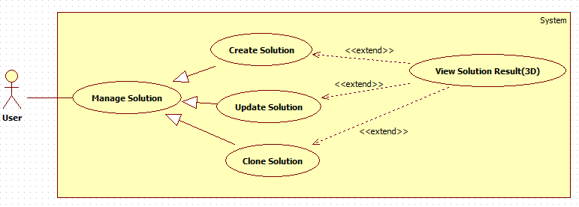

Figure 3‑35 View Solution Detail Result (3D) use case diagram

###### Use case specification

|  |  |  |  |  |
| --- | --- | --- | --- | --- |
| **USE CASE – CLS027** | | | | |
| **Use case No.** | CLS031 | **Use case version** | | 2.0 |
| **Use case name** | View Solution Visualization Result (3D) | | | |
| **Author** | Nguyễn Đinh Bảo Tú | | | |
| **Date** | 4/6/2013 | **Priority** | High | |
| **Actor:** User  **Summary:**   * Solution Visualization Result is 3D result after loading success.   **Goal:**   * Allow user to view the result in 3D cube, rotate cube to see all sides of that cube and view all details about loading result.   **Triggers:**   * User create solution, choose container, choose products and input additional product information (quantity, color), then click “Sắp xếp”. * Or User view created solution, change container or choose other products or input new additaional product information (quantity, color), then click “Sắp xếp”.   **Preconditions:**   * Guest must log in as the role “User”. * User choose Container, choose Products and also input additional information product.   **Post Conditions:**   * The Solution Result will be displayed in Solution Result tab in a 3D Cube shape which can be rotated to see any sides of the container to view location of products.   **Main Success Scenario:**   |  |  | | --- | --- | | Actors action:   1. User click on “Chọn Container” button and choose Container. | System Response: | | 1. User click on “Chọn sản phẩm” button and choose products. |  | | 1. User input additional product information (quantity, color) |  | | 1. User click “Sắp xếp” |  | |  | 1. System use AlgorithmAPI for calculating result 2. System use Render3DAPI for rendering html. 3. System return result. | | 1. User uses mouse to rotate the 3D cube to see all the sides of that cube |  | |  | 1. System display the view of each side clearly and effectively. |   **Alternative Scenario:**  **Exceptions:**  **Relationships:**   * Create Solution, Update Solution, Delete Solution, Clone Solution and View Solution Summary Result (Algorithm).   **Page Description:**   |  |  |  | | --- | --- | --- | | Field Name | Data Type and Constraints | Required | | 3D Result | 3D cube includes loaded products with their location in a loaded container | Yes | | | | | |

##### <User> Export Solution Result

###### Use case diagram

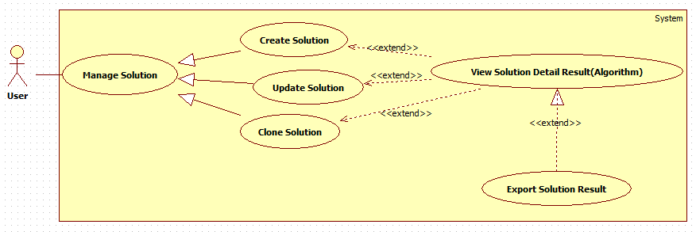

Figure 3‑36 Export Solution Detail Result use case diagram

###### Use case specification

|  |  |  |  |  |
| --- | --- | --- | --- | --- |
| **USE CASE – CLS028** | | | | |
| **Use case No.** | CLS032 | **Use case version** | | 2.0 |
| **Use case name** | Export Solution Result | | | |
| **Author** | Võ Ngọc Luyến | | | |
| **Date** | 4/6/2013 | **Priority** | High | |
| **Actor:** User  **Summary:**   * User can export solution result includes the complete data of the Containers and Products involved, so that all data relevant for this Load will be included in a excel file.   **Goal:**   * Allow user to print the solution result details in an excel file.   **Triggers:**   * After choosing Solution Detail Result tab. Press Export button to export file.   **Preconditions:**   * Guest must log in as the role “User”. * The result of the new loading solution or the result which saved in Solution Details page must calculated successfully.   **Post Conditions:**   * User can download the file with solution detail result.   **Main Success Scenario:**   |  |  | | --- | --- | | Actor Action | System Response | | 1. Click on Export button in “Solution Detail Result” Tab. | 1. System will print the Solution Result in pdf file. |   **Alternative Scenario:**  **Exceptions:**  **Relationships:**   * View Solution Detail Result. | | | | |

#### Admin Features

##### <Admin> Log out

* + - Optional.

##### <Admin> View User List

###### Use case diagram

Figure 3‑37 View User List use case diagram

###### Use case specification

|  |  |  |  |  |
| --- | --- | --- | --- | --- |
| **USE CASE – CLS029** | | | | |
| **Use case No.** | CLS033 | **Use case version** | | 2.0 |
| **Use case name** | View User List | | | |
| **Author** | Hồ Đỗ Minh Trung | | | |
| **Date** | 16/08/2013 | **Priority** | High | |
| **Actor:** Admin  **Summary:**   * Admin can view all User in system.   **Goal:**   * Allow Admin view all User in system.   **Triggers:**   * On header page, click on “Quản Lý Thành Viên” link and “Thành Viên” page will be showed.   **Preconditions:**   * Admin must login.   **Post Conditions:**   * Admin can view any User in system.   **Main Success Scenario:**   |  |  | | --- | --- | | Actors action:   1. Click on “Quản Lý Thành Viên” to request “Thành Viên” page. | System Response: | |  | 1. System will response “Thành Viên” page (Please view Page Description below for more information of this page). |   **Alternative Scenario:**  **Exceptions:**  **Relationships:**  **Business Rules:**  **Page Description:**   |  |  |  | | --- | --- | --- | | Field Name | Data Type and Constraints | Required | | Table | “Tên”.  Email. “Giới Tính”.  “Ngày Sinh”.  “Kích Hoạt”. | Yes | | | | | |

##### <Admin> Search User

###### Use case diagram



Figure 3‑38 Search User use case diagram

###### Use case specification

|  |  |  |  |  |
| --- | --- | --- | --- | --- |
| **USE CASE – CLS014** | | | | |
| **Use case No.** | CLS034 | **Use case version** | | 2.0 |
| **Use case name** | Search User | | | |
| **Author** | Hồ Đỗ Minh Trung | | | |
| **Date** | 16/08/2013 | **Priority** | High | |
| **Actor:** Admin.  **Summary:**   * Admin wants to search User, they use this function.   **Goal:**   * Allow Admin to search all user in system.   **Triggers:**   * In Manage User page, input keyword in search textbox such as user’s name. If it matches with any user, the system will list them into Container List table.   **Preconditions:**   * Guest must log in as the role “Admin”. * Manage user page has loaded successfully.   **Post Conditions:**  **Main Success Scenario:**   |  |  | | --- | --- | | Actors action:   1. Input keyword in search text box. | System Response: | |  | 1. System will list items which match with keyword in Container List table. |   **Alternative Scenario:**   |  |  | | --- | --- | | Actors action:   1. User input container information which isn’t match with any user container information. | System Response: | |  | 1. Container List table has no row. |   **Relationships:**   * View User List, Create User.   **Business Rules:**  **Page Description:**   |  |  |  | | --- | --- | --- | | Field Name | Data Type and Constraints | Required | | Text-Search | Textbox | Yes | | | | | |

##### <Admin> Create User

###### Use case diagram

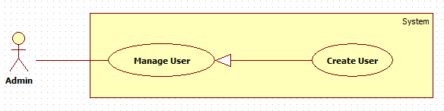

Figure 3‑39 Create User use case diagram

###### Use case specification

|  |  |  |  |  |
| --- | --- | --- | --- | --- |
| **USE CASE – CLS030** | | | | |
| **Use case No.** | CLS035 | **Use case version** | | 2.0 |
| **Use case name** | Create User | | | |
| **Author** | Ho Do Minh Trung | | | |
| **Date** | 16/08/2013 | **Priority** | High | |
| **Actor:** Admin  **Summary:**   * Admin can create User.   **Goal:**   * Allow Admin create a new Users to system.   **Triggers:**   * On header page, click on “Tạo mới thành viên” button. “Tạo mới thành viên” pop-up is appear. Then input information of user to blank filed. Click on Create to finish.   **Preconditions:**   * Admin must login. * Manage User page is load successful.   **Post Conditions:**   * A new user is add successful to system. User can use that account to login and use services.   **Main Success Scenario:**   |  |  | | --- | --- | | Actors action:   1. Click on “Tạo mới thành viên” button to request “Tạo mới thành viên” pop-up | System Response: | |  | 1. System will response “Tạo mới thành viên” pop-up (Please view Page Description below for more information of this page) | | 1. System will response “Tạo mới thành viên” pop-up (Please view Page Description below for more information of this page) [Alternative 1] | 1. System response: User is added successfully and system will transfer to “Quản Lý Thành Viên” page. [Exception 1,2,3,4,5,6,7] |   **Alternative Scenario:**   |  |  | | --- | --- | | Actors action:   1. Click on “Cancel” button to finish. | System Response: | |  | 1. System will transfer to “Quản Lý Thành Viên” page. |   **Exceptions:**   |  |  |  | | --- | --- | --- | | No | Actor Action | System Response | | 1 | Email has existed in database. | Display error message: “Email đã tồn tại. Xin sử dụng một email khác”. | | 2 | Email is invalid. | Display error message: “Email không hợp lệ”. |   **Relationships:** View User Profile.  **Business Rules:**  **Page Description:**   |  |  |  | | --- | --- | --- | | Field Name | Data Type and Constraints | Required | | Name | Textbox.  Min length: 1.  Max length: 50. | Yes | | Email | Textbox.  Min length: 10.  Max length: 50. | Yes | | Gender | Radio button. | No | | Birthday | Date time picker. | No | | Create | Button |  | | Cancel | Button |  | | | | | |

##### <Admin> Activate/Deactivate User

###### Use case diagram

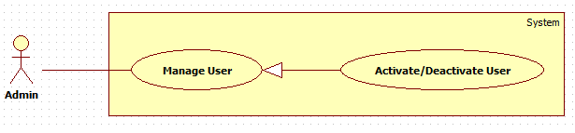

Figure 3‑40 Activate/Deactivate User use case diagram

###### Use case specification

|  |  |  |  |  |
| --- | --- | --- | --- | --- |
| **USE CASE – CLS032** | | | | |
| **Use case No.** | CLS036 | **Use case version** | | 2.0 |
| **Use case name** | Activate User | | | |
| **Author** | Ho Do Minh Trung | | | |
| **Date** | 16/08/2013 | **Priority** | Normal | |
| **Actor:**   * Admin.   **Summary:**   * Admin want to activate a User, they use this function.   **Goal:**   * Allow Admin activate/deactivate a User.   **Triggers:**   * In data table of “Thành Viên” page. Check/Uncheck on IsActive checkbox.   **Preconditions:**   * Admin is at “Thành Viên” page.   **Post Conditions:**   * User Status: Change to Active/Deactivate.   **Main Success Scenario:**   |  |  |  | | --- | --- | --- | | Step | Actor Action | System Response | | 1 | Check/Uncheck on “IsActive” checkbox. | System will update user new status of that User (Please view Page Description below for more information of this page) |   **Alternative Scenario:**  **Exceptions:**  **Relationships:**   * View User List, Search User.   **Business Rules:**  **Page Description:**   |  |  |  | | --- | --- | --- | | Field Name | Data Type and Constraints | Required | | IsActive | Checkbox. | Yes | | | | | |

##### <Admin> View Common Container List

* + - This feature is same with View Product List.

##### <Admin> Search Common Container

* + - This feature is same with Seach Product.

##### <Admin> Create Common Container

* + - This feature is same with Create Product.

##### <Admin> Update Common Container

* + - This feature is same with Update Product.

##### <Admin> Delete Common Container

* + - This feature is same with Delete Product.

##### <Admin> View Charge Package List

###### Use case diagram

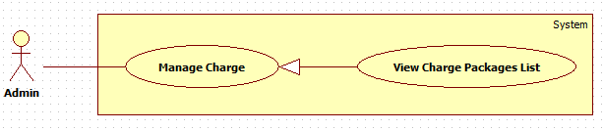

Figure 3‑41 View Charge Package List use case diagram

###### Use case specification

|  |  |  |  |  |
| --- | --- | --- | --- | --- |
| **USE CASE – CLS039** | | | | |
| **Use case No.** | CLS037 | **Use case version** | | 2.0 |
| **Use case name** | View Charge Usage Package List | | | |
| **Author** | Phan Duy Khánh | | | |
| **Date** | 05/06/2013 | **Priority** | High | |
| **Actor:** Admin  **Summary:**   * Admin uses this use case to view a list of charge packages.   **Goal:**   * Allow Admin to view all charge packages.   **Triggers:**   * Click on “Quản lý gói”. System will show a list of Package’s information.   **Preconditions:**   * Admin must login as admin role.   **Post Conditions:**   * Admin can view all package’s information in the Package list successfully.   **Main Success Scenario:**   |  |  | | --- | --- | | Actors action:   1. Click on “Quản lý gói” to request Manage Charge Package page | System Response: | |  | 1. System will response ”Quản ly gói” page and show a list of Charge Package(Please view Page Description below for more information of this page) |   **Alternative Scenario:**  **Relationships:** Create Charge Package, Update Charge Package  **Business Rules:**   * The Package’s information will be taken from database and show in this page.   **Page Description:**   |  |  |  | | --- | --- | --- | | Field Name | Data Type and Constraints | Required | | Table | Tên gói, Giá/Tháng, Số lần sử dụng, Phí cộng thêm, Trạng thái | Yes | | Activate/Deactivate | Toggle button | Yes | | Update | Button | Yes | | | | | |

##### <User> Search Charge Package

###### Use case diagram

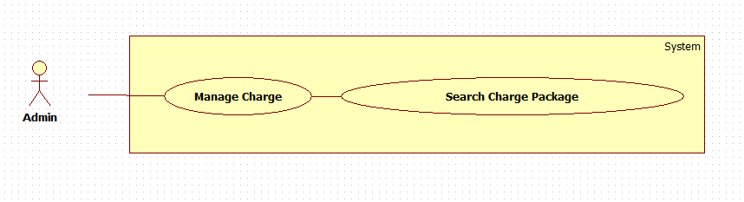

Figure 3‑42 Search Charge Package use case diagram

###### Use case specification

|  |  |  |  |  |
| --- | --- | --- | --- | --- |
| **USE CASE – CLS014** | | | | |
| **Use case No.** | CLS038 | **Use case version** | | 2.0 |
| **Use case name** | Search Charge Package | | | |
| **Author** | Phan Duy Khánh | | | |
| **Date** | 02/06/2013 | **Priority** | High | |
| **Actor:** Admin  **Summary:**   * Admin uses this use case to search charge packages.   **Goal:**   * Allow Admin to search Charge Packages   **Triggers:**   * User can search charge packages. * Click on “Quản lý gói”. Search field will show above a list of charge packages’ information.   **Preconditions:**   * Admin must login as admin role.   **Post Conditions:**   * User can search containers in the container list.   **Main Success Scenario:**   |  |  | | --- | --- | | Actors action:   1. Click on “Quản lý gói” to request charge package management page | System Response: | |  | 1. System will show a search field above the list of charge package(Please view Page Description below for more information of this page) |   **Relationships:** View Container List, Insert Container, Update Container  **Business Rules:**  **Page Description:**   |  |  |  | | --- | --- | --- | | Field Name | Data Type and Constraints | Required | | Search | Text field |  | | | | | |

##### <Admin> Create Charge Package

###### Use case diagram

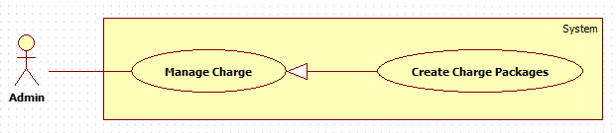

Figure 3‑43 Create Charge Package use case diagram

###### Use case specification

|  |  |  |  |  |
| --- | --- | --- | --- | --- |
| **USE CASE – CLS040** | | | | |
| **Use case No.** | CLS039 | **Use case version** | | 2.0 |
| **Use case name** | Create Charge Package | | | |
| **Author** | Phan Duy Khánh | | | |
| **Date** | 05/06/2013 | **Priority** | High | |
| **Actor:** Admin  **Summary:**   * Admin uses this use case to create new charge package.   **Goal:**   * Allow guest to create new charge package   **Triggers:**   * Click on “Quản lý gói”. After that click on the button “Thêm gói mới” and create form will be showed, then input information and then click “Tạo mới” button to finish.   **Preconditions:**   * Admin must login as admin role.   **Post Conditions:**   * Admin can create a new charge package successfully. System will insert this package to the Charge Package List * New package information can be created and saved on database.   **Main Success Scenario:**   |  |  | | --- | --- | | Actors action:   1. Click on “Quản lý gói” to request manage charge package page | System Response: | |  | 1. System will response ”Quản ly gói” page and show a list of Charge Package(Please view Page Description below for more information of this page) | | 1. Click on “New Charge Package” button. |  | |  | 1. System will show a form with some information need to be filled to create new Package. | | 1. Enter information into text fields. Click on “Create” button to finish. [Alternative 1] |  | |  | 1. System response: Create successfully and system will transfer to “Manage Charge package” page.[Exception 1,2,3,4,5,6] |   **Alternative Scenario:**   |  |  | | --- | --- | | Actors action:   1. Click on “Hủy” button to finish | System Response: | |  | 1. System will transfer to “Quản lý gói”page |   **Exceptions:**   |  |  |  | | --- | --- | --- | | No | Actor Action | System Response | | 1 | “Tên gói”’s length is not in range: [6,50] | Display error message: “Độ dài tên gói không được vượt quá 50 kí tự” | | 2 | “Đơn giá” is <0 | Display error message: “Giá của gói phải lớn hơn 0” | | 3 | “Số lần sử dụng” is <0 | Display error message: “Số lần sử dụng phải lớn hơn 0.” | | 4 | “Thời hạn sử dụng” is <0 | Display error message: “Thời hạn sử dụng phải lớn hơn 0.” | | 5 | “Phí cộng thêm” is <0 | Display error message: “Phí công thêm phải lớn hơn 0.” | | 6 | “Số lần cộng thêm” is <0 | Display error message: “Số lần công thêm phải lớn hơn 0.” |   **Relationships:**   * View Charge Package, Update Charge Package, Deactivate Charge package   **Business Rules:**  **Page Description:**   |  |  |  | | --- | --- | --- | | Field Name | Data Type and Constraints | Required | | Tên gói | Textbox.  Min length: 1.  Max length: 50 | Yes | | Đơn giá | Textbox.  Min length: 1.  Max length: 20.  More than 9 and less than 100 millions | Yes | | Số lần sử dụng | Number.  Min Length: 1.  Max length: 20.  More than 9 and less than 1 million. | Yes | | Thời hạn sử dụng | Number.  Min Length: 1.  Max length: 20.  More than 0 | Yes | | Phí cộng thêm | Textbox.  Min length: 1.  Max length: 20.  More than 9 and less than 100 millions | Yes | | Số làn sử dụng | Textbox.  Min length: 1.  Max length: 20.  More than 9 and less than 100 millions | Yes | | Trạng thái | Checkbox. | Yes | | Recommend | Checkbox | Yes | | Hủy | Button |  | | Mặc định | Button |  | | Khởi tạo | Button |  | | | | | |

##### <Admin> Update Charge Package

###### Use case diagram

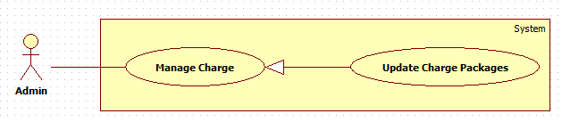

Figure 3‑44 Update Charge Package use case diagram

###### Use case specification

|  |  |  |  |  |
| --- | --- | --- | --- | --- |
| **USE CASE – CLS041** | | | | |
| **Use case No.** | CLS040 | **Use case version** | | 2.0 |
| **Use case name** | Update Charge Package | | | |
| **Author** | Phan Duy Khánh | | | |
| **Date** | 05/06./2013 | **Priority** | High | |
| **Actor:** Admin  **Summary:**   * Admin uses this use case to edit a Charge Package.   **Goal:**   * Allow guest to edit a charge package.   **Triggers:**   * Click on “Quản lý gói”. After that click on the “Cập nhật” button and update form will be showed, then change information, what you want to edit and then click “Lưu thay đổi” button to finish.   **Preconditions:**   * Admin must login with admin role.   **Post Conditions:**   * Admin can edit a Charge’s Package information successfully. System will change this package’s information in the Package List   **Main Success Scenario:**   |  |  | | --- | --- | | Actors action:   1. Click on “Quản lý gói” to request manage charge package page | System Response: | |  | 1. System will response ”Quản lý gói” page and show a list of Charge Package(Please view Page Description below for more information of this page) | | 1. Click on “Cập nhật” button. |  | |  | 1. System will show a form with some information of charge package. Allow admin to modify these information. | | 1. Enter information into text fields. Click on “Lưu thay đổi” button to finish. [Alternative 1] |  | |  | 1. System response: The information of this container be changed successfully and system will transfer to “Quản lý gói” page.   [Exception 1,2,3,4,5,6] |   **Alternative Scenario:**   |  |  | | --- | --- | | Actors action:   1. Click on “Hủy” button to finish | System Response: | |  | 1. System will transfer to “Quản lý gói”page |   **Exceptions:**   |  |  |  | | --- | --- | --- | | Step | Actor Action | System Response | | 1 | “Tên gói”’s length is not in range: [6,50] | Display error message: “Độ dài tên gói không được vượt quá 50 kí tự” | | 2 | “Đơn giá” is <0 | Display error message: “Giá của gói phải lớn hơn 0” | | 3 | “Số lần sử dụng” is <0 | Display error message: “Số lần sử dụng phải lớn hơn 0.” | | 4 | “Thời hạn sử dụng” is <0 | Display error message: “Thời hạn sử dụng phải lớn hơn 0.” | | 5 | “Phí cộng thêm” is <0 | Display error message: “Phí công thêm phải lớn hơn 0.” | | 6 | “Số lần cộng thêm” is <0 | Display error message: “Số lần công thêm phải lớn hơn 0.” |   **Relationships:**   * View Charge package, Create Charge package, Deactivate Charge package   **Business Rules:**   * The Package’s information can be edit and saved on database.   **Page Description:**   |  |  |  | | --- | --- | --- | | Field Name | Data Type and Constraints | Required | | “Tên gói” | Textbox. Min length: 1. Max length: 50 | Yes | | “Đơn giá” | Textbox. Min length: 1. Max length: 20.  More than 9 and less than 100 millions | Yes | | “Số lần sử dụng” | Number. Min Length: 1. Max length: 20.  More than 9 and less than 1 million. | Yes | | “Thời hạn sử dụng” | Number. Min Length: 1. Max length: 20. More than 0 | Yes | | “Phí cộng thêm” | Textbox. Min length: 1. Max length: 20.  More than 9 and less than 100 millions | Yes | | “Số lần sử dụng” | Textbox. Min length: 1. Max length: 20.  More than 9 and less than 100 millions | Yes | | “Trạng thái” | Checkbox. | Yes | | Recommend | Checkbox | Yes | | “Hủy” | Button |  | | Mặc định | Button |  | | “Lưu thay đổi” | Button |  | | | | | |

##### <Admin> Activate/Deactivate Charge Package

###### Use case diagram

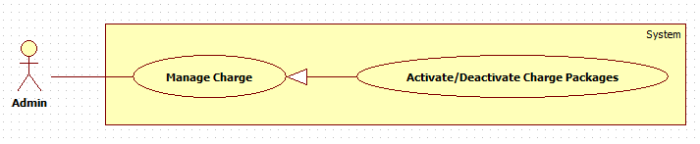

Figure 3‑45 Activate/Deactivate Charge Package use case diagram

###### Use case specification

|  |  |  |  |  |
| --- | --- | --- | --- | --- |
| **USE CASE – CLS042** | | | | |
| **Use case No.** | CLS041 | **Use case version** | | 2.0 |
| **Use case name** | Activate/Deactivate Charge Package | | | |
| **Author** | Phan Duy Khánh | | | |
| **Date** | 05/06/2013 | **Priority** | High | |
| **Actor:** Admin  **Summary:**   * Admin uses this use case to activate/deactivate Charge Package.   **Goal:**   * Allow guest to activate/deactivate charge package.   **Triggers:**   * Click on “Activate/Deactivate”. After that click on toggle button, the status of the package will change from on to off. Then finish.   **Preconditions:**   * Admin must log in as the role “Admin”. * The chosen Charge Package is active.   **Post Conditions:**   * Admin can deactivate in the package list successfully. System will deactivate this package from the package List * Package Status is changed from “Activate” to “Deactivate” or another side and is updated to database.   **Main Success Scenario:**   |  |  | | --- | --- | | Actors action:   1. Click on “Activate/Deactivate” toggle button on Manage Package page   [Alternative 1] | System Response: | |  | 1. The current package’s status will be change into deactivate. System will refresh the “View Charge Package” page |   **Alternative Scenario:**  **Exceptions:**  **Relationships:** View Charge Package  **Business Rules:**  **Page Description:**   |  |  |  | | --- | --- | --- | | Field Name | Data Type and Constraints | Required | | Active/Deactivate | Toggle button |  | | | | | |

##### <Admin> View Transaction

###### Use case diagram

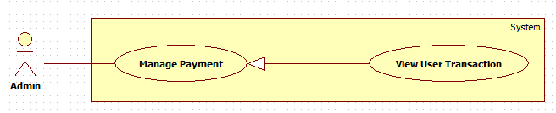

Figure 3‑46 View Transaction use case diagram

###### Use case specification

|  |  |  |  |  |
| --- | --- | --- | --- | --- |
| **USE CASE – CLS0434** | | | | |
| **Use case No.** | CLS042 | **Use case version** | | 2.0 |
| **Use case name** | View Transaction | | | |
| **Author** | Phan Duy Khánh | | | |
| **Date** | 05/06/2013 | **Priority** | High | |
| **Actor:** Admin  **Summary:**   * Admin will use this function for viewing and keep track of current adding package to user   **Goal:**   * All Charge Package and their status display on the screen   **Triggers:**   * Click on “Quản lý giao tác” on homepage of Admin   **Preconditions:**   * Admin must login as admin role.   **Post Conditions:**   * Admin can view any Transactions in system.   **Main Success Scenario:**   |  |  | | --- | --- | | Actors action:   1. Click on “Quản lý giao tác” to request transaction page | System Response: | |  | 1. System will response Transaction page (Please view Page Description below for more information of this page) |   **Alternative Scenario:**  **Exceptions:**  **Relationships:** Add Main Charge Package, Add Extra Charge Package  **Business Rules:**  **Page Description:**   |  |  |  | | --- | --- | --- | | Field Name | Data Type and Constraints | Required | | Table | Label Unicode String  Id, “Ngày bắt đầu”, “Ngày kết thúc”, “Số lần sử dụng”, “Gói”, “Đơn giá”. | Yes | | | | | |

##### <Admin> View User Charge Usage

###### Use case diagram

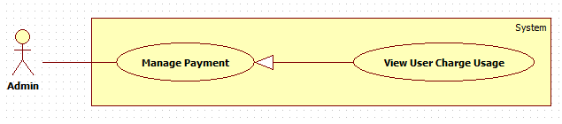

Figure 3‑47 View User Charge Usage use case diagram

###### Use case specification

|  |  |  |  |  |
| --- | --- | --- | --- | --- |
| **USE CASE – CLS044** | | | | |
| **Use case No.** | CLS043 | **Use case version** | | 2.0 |
| **Use case name** | View User Charge Usage | | | |
| **Author** | Phan Duy Khánh | | | |
| **Date** | 05/06/2013 | **Priority** | High | |
| **Actor:** Admin  **Summary:**   * Admin will use this function for viewing and keep track of current history added package of user and their usage call solutions   **Goal:**   * All Charge Package of current user and their status is displayed on the screen   **Triggers:**   * Click on “Charge Usage” on Status bar for viewing their usage history.   **Preconditions:**   * Admin must login as “Admin” role. * Admin is view Manage User Page   **Post Conditions:**   * All Customers’ submitted Charge Package display in a popup on the screen.   **Main Success Scenario:**   |  |  | | --- | --- | | Actors action:   1. Click on “Sử dụng” icon to view Usage history of current user. | System Response: | |  | 1. System will response Usage history information as in a popup (Please view Page Description below for more information of this page) |   **Alternative Scenario:**   |  |  |  | | --- | --- | --- | | Step | Actor Action | System Response | | 1 | Click on “x” button to finish | System will transfer to “Quản lý giao tác” page |   **Exceptions:**  **Relationships:** N/A  **Business Rules:** N/A  **Page Description:**   |  |  |  | | --- | --- | --- | | Field Name | Data Type and Constraints | Required | | Table | Id, Ngày bắt đầu, Ngày kết thúc, Số lần sử dụng, Gói, đơn giá. | Yes | | “Số lần sử dụng” bar | Progress bar show the call solution left for this package | Yes | | “Thời hạn sử dụng” bar | Progress bar show the duration left for this package | Yes | | | | | |

##### <Admin> Create Charge Package for User

###### Use case diagram

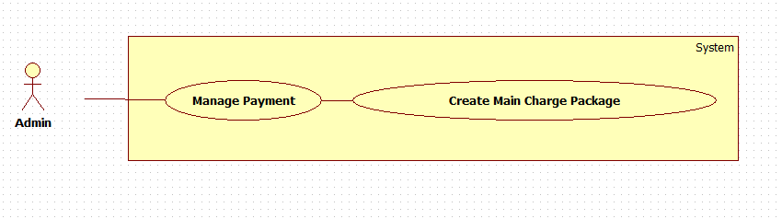

Figure 3‑48 Create Charge Package use case diagram

###### Use case specification

|  |  |  |  |  |
| --- | --- | --- | --- | --- |
| **USE CASE – CLS045** | | | | |
| **Use case No.** | CLS044 | **Use case version** | | 2.0 |
| **Use case name** | Create Main Charge Package | | | |
| **Author** | Phan Duy Khánh | | | |
| **Date** | 05/06/2013 | **Priority** | 1 | |
| **Actor:** Admin  **Summary:**   * Admin uses this use case to create main charge package to particular account.   **Goal:**   * Allow admin to create main charge package account.   **Triggers:**   * Click on “Thêm gói”   **Preconditions:**   * Admin is logged in as “Admin” role. * Admin is on “Quản lý giao tác” page   **Post Conditions:**   * Admin can add a main package to an account successfully. System will transfer to user “Quản lý giao tác” page. * A main charge package is create for user and is updated to database   **Main Success Scenario:**   |  |  | | --- | --- | | Actors action:   1. Click on “Thêm gói” to request New Charge Package Popup | System Response: | |  | 1. System will response “Thêm gói” Popup (Please view Page Description below for more information of this page) | | 1. Enter information into text fields. Click on “Khởi tạo” button to finish. [Alternative 1] |  | |  | 1. System response: Create transaction successfully and system will transfer to login page.[Exception 1,2,3,4] |   **Alternative Scenario:**   |  |  | | --- | --- | | Actors action:   1. Click on “Hủy” button to finish | System Response: | |  | 1. System will transfer to “Quản lý giao tác” page |   **Exceptions:**   |  |  |  | | --- | --- | --- | | Step | Actor Action | System Response | | 1 | “Khách hàng” hasn’t been selected. | Display error message: “Vui lòng chọn gói phù hợp” | | 2 | “Gói” hasn’t been selected. | Display error message: “Vui lòng chọn gói phù hợp” | | 3 | “Ngày mua” hasn’t been selected. | Display error message: “Vui lòng chọn ngày mua cho giao tác này” | | 4 | “Ngày bắt đầu” hasn’t been selected. | Display error message: “Vui lòng chọn ngày bắt đầu cho gói.” |   **Relationships:** View Transaction, View Charge Usage  **Business Rules**  **Page Description:**   |  |  |  | | --- | --- | --- | | Field Name | Data Type and Constraints | Required | | “Khách hàng” | Search – Drop down list  Show current selected user. | Yes | | “Gói” | Dropdown List | Yes | | “Đơn giá” | Textbox. Disabled, Min length: 1, Max length: 20. | Yes | | “Ngày mua” | Date time Picker | Yes | | “Ngày bắt đầu” | Date time Picker, Greater than the date of Purchase. | Yes | | “Số lần sử dụng” | Textbox. Disable, Min length: 1, Max length: 20. | Yes | | “Thời hạn sử dụng” | Textbox. Disabled, Min length: 1, Max length: 20. | Yes | | "Hủy” | Button |  | | “Khởi tạo” | Button |  | | | | | |

##### <Admin> Create Extra Charge for User

###### Use case diagram

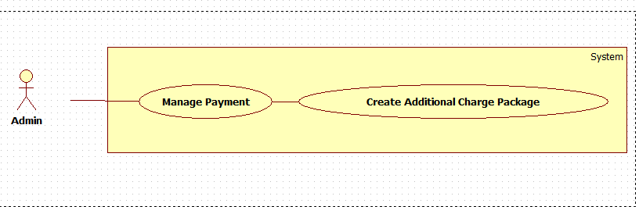

Figure 3‑49 Create Extra Charge use case diagram

###### Use case specification

|  |  |  |  |  |
| --- | --- | --- | --- | --- |
| **USE CASE – CLS046** | | | | |
| **Use case No.** | CLS045 | **Use case version** | | 2.0 |
| **Use case name** | Create Additional Charge Package | | | |
| **Author** | Phan Duy Khánh | | | |
| **Date** | 05/06/2013 | **Priority** | High | |
| **Actor:** Admin  **Summary:**   * Admin uses this use case to create extra charge package to particular account.   **Goal:**   * Allow admin to create extra charge package account.   **Triggers:**   * Click on “Thêm gói công thêm”   **Preconditions:**   * Admin is logged in as “Admin” role. * Admin is on “Quản lý giao tác” page   **Post Conditions:**   * Admin can create an extra package to an account successfully. System will transfer to user “Quản lý giao tác” page. * A extra charge package is create for user and is updated to database   **Main Success Scenario:**   |  |  | | --- | --- | | Actors action:   1. Click on “Thêm gói cộng thêm” to request “Thêm gói cộng thêm” Popup | System Response: | |  | 1. System will response “Thêm gói cộng thêm” Popup (Please view Page Description below for more information of this page) | | 1. Enter information into text fields. Click on “Thêm mới” button to finish. [Alternative 1] |  | |  | 1. System response: Create transaction successfully and system will transfer to login page.   [Exception 1,2,3,4] |   **Alternative Scenario:**   |  |  | | --- | --- | | Actors action:   1. Click on “Hủy” button to finish | System Response: | |  | 1. System will transfer to “Quản lý giao tác” page |   **Exceptions:**   |  |  |  | | --- | --- | --- | | Step | Actor Action | System Response | | 1 | “Khách hàng” hasn’t been selected. | Display error message: “Vui lòng chọn gói phù hợp” | | 2 | “Ngày mua” hasn’t been selected. | Display error message: “Vui lòng chọn ngày mua cho giao tác này” | | 3 | “Phí cộng thêm”’s length more than 11 | Display error message: “Phí cộng thêm quá không hợp lệ. Vui lòng thử lại.” | | 4 | “Ngày bắt đầu” hasn’t been selected. | Display error message: “Vui lòng chọn ngày bắt đầu cho gói.” |   **Relationships:** View Transaction, View Charge Usage  **Business Rules:**   * The additional price must be divided by minimum request, which is setup while creating the main package. * The additional charge package will be expired within the duration of the main charge package, which is added to. * In case of 2 package is available at the same time, the charge package will be added to the main charge package which has the smaller start date.   **Page Description:**   |  |  |  | | --- | --- | --- | | Field Name | Data Type and Constraints | Required | | Khách hàng | Search – Drop down list  Show current selected user. | Yes | | Ngày mua | Date time Picker | Yes | | Gói hiện tại | Drop down list | Yes | | Số lần cộng thêm | Textbox. Disabed, Min length: 1. Max length: 20. | Yes | | Phí cộng thêm | Textbox. Disabed, Min length: 1. Max length: 20. | Yes | | Số lần | Textbox. Min length: 1. Max length: 20. | Yes | | Hủy | Button |  | | Thêm mới | Button |  | | | | | |

### Non-functional Requirements

#### Reliability

* The system can be used like “always on” system.

#### Availability

* The server shall be working 24/7.

#### Security

* User need login for using system under “User” permission or “Admin permission.
* “User” and “Admin” has separate functions (exclude log out).

#### Maintainability

* System using Entity Framework with Database First. So it’s easy for maintain.
* System separate AlgorithmAPI and RenderAPI into dll for easy repair or enhance functions.

#### Portability

* Most browser support CSS3 so system easy work on.

#### Performance

* System using parallel programming for reducing waiting time of user.

## Entity Relationship Diagram

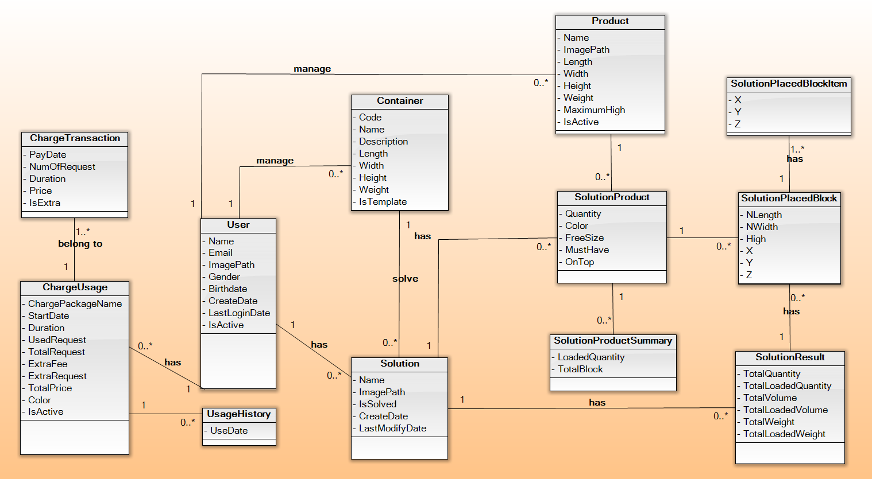

Figure 3‑46 Entity Relationship Diagram

## Other material (if any)

# Software Design Description (SDD)

## Design Overview

This part describes the detailed design of the Container Loading System website. It includes the system architectural design, component details and sequence diagrams. It also describes the graphical user interface and data structures of the system. This is to give the reader, a better understanding of the design process and procedure for this web application.

## System Architechure Design

### Choice of System Architecture

The system will use MVC implemented in a three-tier architecture



Figure 4-1 – MVC implemented in a three-tier architecture

The above diagram is explained as the following:

* **Model**: Functions that interact with the database or perform complex operations. contains data and business logic (Action, BLO (business logic object), DAO (data access object) and DTO (data transfer object) classes)
* **View**: The view displays the data and also takes input form user. It renders the model data into a form, such as graphics, buttons, and tables, and so on to display to the user. In this system, we use cshtml page.
* **Controller:** The controller handles all requests coming from the view or user interface. The data flows to whole application are controlled by controller. It forwards the request to the appropriate handler. Only the controller is responsible for accessing model and rendering it into various user interfaces.
* **Business Logic:** This layer coordinates the application, processes commands, makes logical decisions and evaluations, and performs calculations. It also moves and processes data between the two surrounding layers.
* **Data Access:** Here information is stored and retrieved from a database or file system. The information is then passed back to the logic tier for processing, and then eventually back to the user.

### Discussion of Aternative Designs

#### MVC (Model-View-Controller)



Figure 4-2 – MVC architecture

The above diagram is explained as the following:

* **Model**: Functions that interact with the database or perform complex operations.
* **View**: The view displays the data and also takes input form user. It renders the model data into a form, such as graphics, buttons, and tables, and so on to display to the user. In this system, we use cshtml page.
* **Controller:** The controller handles all requests coming from the view or user interface. The data flows to whole application are controlled by controller. It forwards the request to the appropriate handler. Only the controller is responsible for accessing model and rendering it into various user interfaces.

In this architechture, model includes business logic and data access in one layer. It should be separate into two layer.

### Description of System Interface

N/A

## Component Diagram

The architecture of Container Loading System is MVC implemented in a three-tier architecture. Inside each layer, ther are some components that handle one or some specific function.

* View Layer’s Components:

This component has responsibility to deliver the front end to the users and accept their inputs. It will be developed by using cshtml page in .NET MVC4 combines with JavaScript, jQuery and CSS.

* Controller Layer’s Components:

This component handles requests from users. It is resonsible for rendering back a respone with the aid of both the Business Logic Layer and Presentation Layer. More details, these components wait for petitions from clients, checks their validity accroding to authentication or authorization rules, delegate’s data fetching or processing to the Business Logic Layer, and select the correct type of presentational data that the client is accepting, to finally delegate this rendering process to the Presentation Layser.

* Business Logic Layer’s Components:

This component contains all business logic for the system. It includes business layer object classes, data transfer object classes… These components have responsibility to process importing data, validation, transferring data to presentation layer or data access layer.

* Data Access Layer’s Components:

This component contains all data access objects which is responsible for accessing data in database system component and exchange data information with database for the system. It includes data access classes.

* AlgorithmAPI’s Components:

This component contains API for solving container loading problem and return result of solving.

* RenderAPI’s Components:

This component contains API for render result from Algorithm into HTML which can be viewed by user as 3D result.

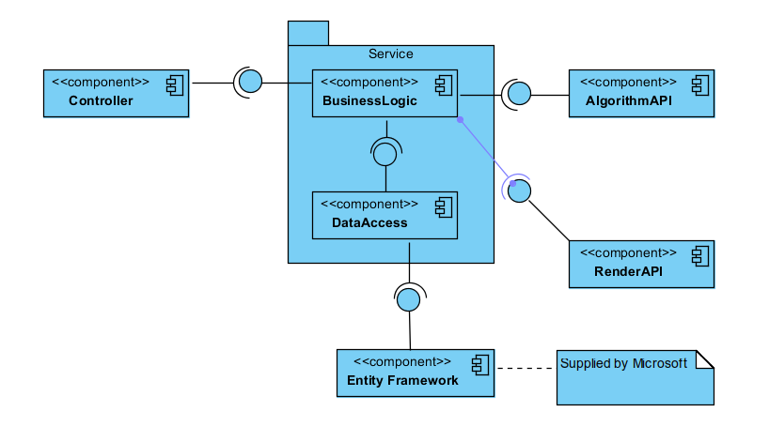

Figure 4-3 – Component Diagram

## Detail Description of Components

### Model

#### Class Diagram

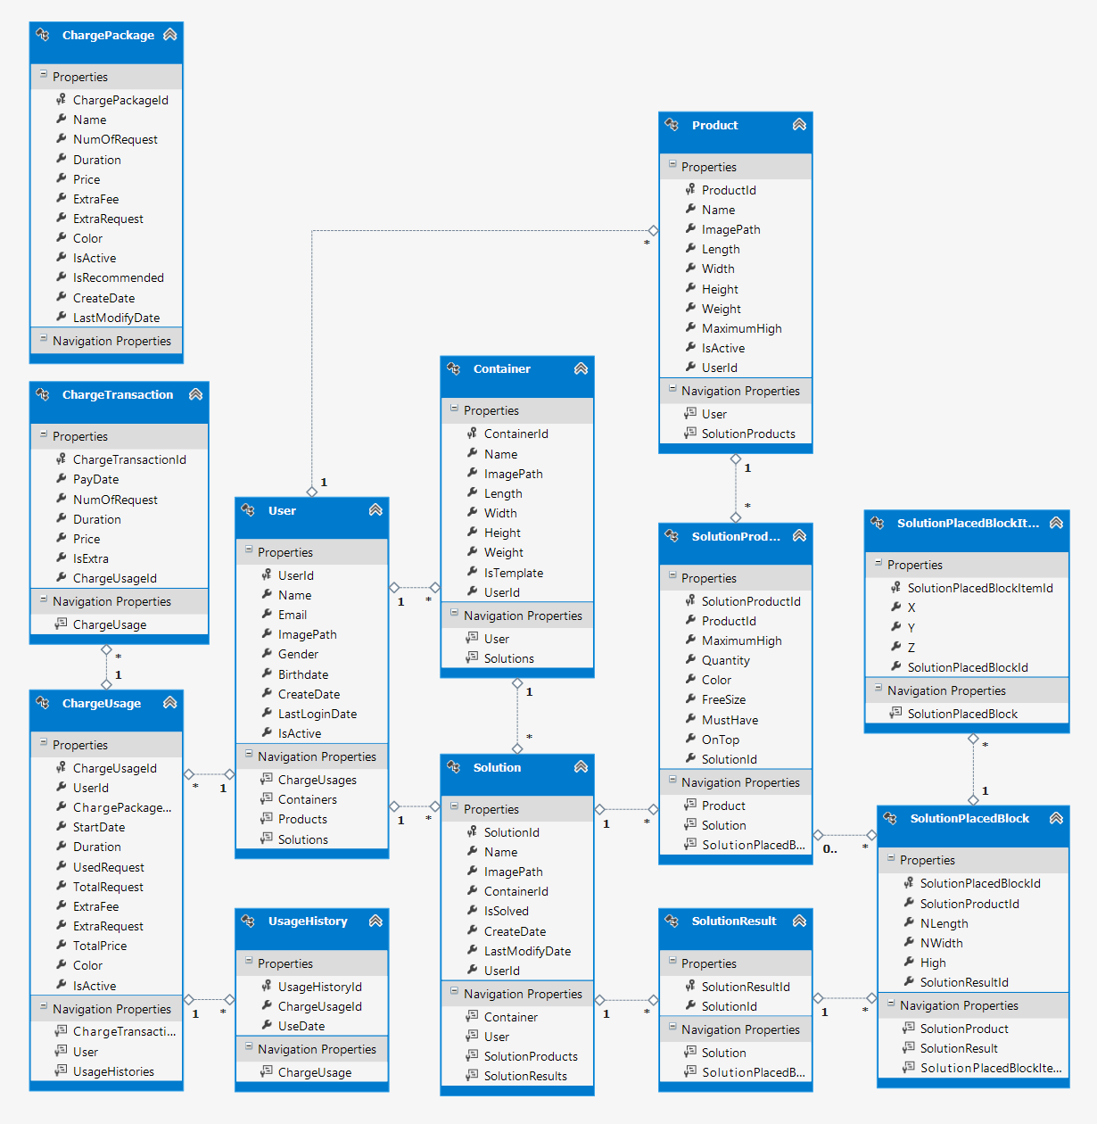

Figure 4-4 – Model Class Diagram

#### Class Diagram Explanation

### Controller

#### Class Diagram

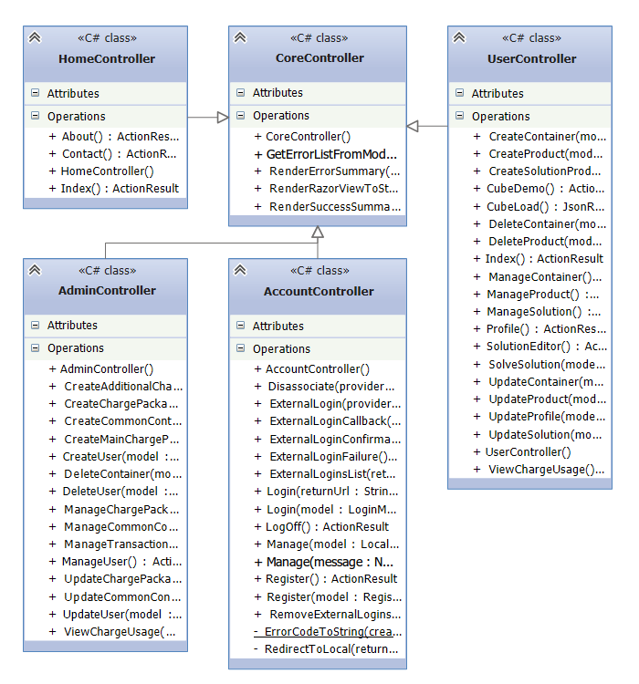

Figure 4-5 – Controller Class Diagram

#### Class Diagram Explanation

|  |  |
| --- | --- |
| CoreController | |
| Properties | |
| Methods | |
| public List<string> GetErrorListFromModelState() | Get Errors from Model State. |
| public string RenderErrorSummary() | Return Error as Html. |
| public string RenderSuccessSummary(string message) | Return Success Message as Html. |
| public string RenderRazorViewToString(string viewName, object model) | Return Html from RazorView. |

|  |  |
| --- | --- |
| HomeController | |
| Properties | |
| Methods | |
| public ActionResult Index() | Index Action |

|  |  |
| --- | --- |
| AccountController | |
| Properties | |
| Methods | |
| public ActionResult Login(string returnUrl) | Login Action |
| Public ActionResult Login(LoginModel model, string returnUrl) | Login Action with LoginModel |
| … |  |

|  |  |
| --- | --- |
| UserController | |
| Properties | |
| Methods | |
| public ActionResult Index() | Index Action |
| public ActionResult ManageSolution() | ManageSolution Action |
| public ActionResult UploadCsvProduct(UploadCsvProductModel model) | UploadCsvProduct Action |
| … |  |

|  |  |
| --- | --- |
| Admin Controller | |
| Properties | |
| Methods | |
| public ActionResult Index() |  |
| public ActionResult ManageChargePackage() |  |
| Public ActionResult CreateChargePackage(ChargePackageModel) |  |
| … |  |

### Service

#### Class Diagram



Figure 4-6 – Service Class Diagram

#### Class Diagram Explanation

|  |  |
| --- | --- |
| ChargePackageBLO | |
| Properties | |
| Methods | |
| public IEnumerable<ChargePackage> GetAll() | Get All Charge Packages |
| Public ChargePackage GetChargePackageById(long chargePackageId) | Get Charge Package by Charge Package Id |
| … |  |

|  |  |
| --- | --- |
| ChargeTransactionBLO | |
| Properties | |
| Methods | |
| Public IEnumerable<ChargeTransaction> GetAll() | Get All Charge Transaction |
| Public bool isExistedActivePackage(long p) | Check Charge Package is Active or note |
| … |  |

|  |  |
| --- | --- |
| ChargeUsageBLO | |
| Properties | |
| Methods | |
| Public IEnumerable<ChargeUsage> GetAll() | Get All Charge Usage |
| Public List<ChageUsage> GetChargeUsagesByUserId(long userId) | Get Charge Usage by Charge Usage Id |
| … |  |

|  |  |
| --- | --- |
| ContainerBLO | |
| Properties | |
| Methods | |
| Public Container FindByName(string name) | Find Container By Name |
| Public IEnumerable<Container> GetAll() | Get All Container |
| … |  |

|  |  |
| --- | --- |
| ProductBLO | |
| Properties | |
| Methods | |
| Public Product FindByName(string name) | Find Product By Name |
| Public string IEnumerable<Product> GetAll() | Get All Product |
| … |  |

|  |  |
| --- | --- |
| SolutionBLO | |
| Properties | |
| Methods | |
| Public List<Solution> GetAll() | Get All Solution |
| Public Solution GetSolutionById(long solutionId) | Get Solution By Solution Id |
| … |  |

|  |  |
| --- | --- |
| SolutionPlacedBlockBLO | |
| Properties | |
| Methods | |
| public void CreateSolutionPlacedBlock(SolutionPlacedBlock solutionPlacedBlock) | Create SolutionPlacedBlock |

|  |  |
| --- | --- |
| SolutionProductBLO | |
| Properties | |
| Methods | |
| Public IEnumerable<SolutionProduct> GetAll() | Get All SolutionProduct |
| Public List<SolutionProduct> GetSolutionProductsBySolutionId(long solutionId) | Get SolutionProduct List by Solution Id |
| … |  |

|  |  |
| --- | --- |
| SolutionResultBLO | |
| Properties | |
| Methods | |
| Public void CreateSolutionResult(SolutionResult solutionResult) | Create SolutionResult |

|  |  |
| --- | --- |
| UsageHistoryBLO | |
| Properties | |
| Methods | |
| Public void CreateUsageHistory(UsageHistory usageHistory) | Create UsageHistory |

|  |  |
| --- | --- |
| UserBLO | |
| Properties | |
| Methods | |
| Public GetUserById(long userId) | Get User by UserId |
| Public User IsExisted(string email) | Check User is existed or not |
| … |  |

|  |  |
| --- | --- |
| BaseBLO | |
| Properties | |
| Protected TEntityDAO DataAccess | DataAccess includes common functions from BaseDAO and it’s functions. |
| Methods | |
| Public BaseBLO() | Contrucstor |
| Public void Dispose() | Dispose object |

|  |  |
| --- | --- |
| ChargePackageDAO | |
| Properties | |
| Methods | |
| Public List<ChargePackage> GetChargePackageList() | Get ChargePackage List |

|  |  |
| --- | --- |
| ChargeUsageDAO | |
| Properties | |
| Methods | |
| Public List<ChargeUsage> GetChargeUsagesByUserId(long userId) | Get CharegUsage List by User Id |

|  |  |
| --- | --- |
| ProductDAO | |
| Properties | |
| Methods | |
| Public GetProductsByUserId(long userId) | Get Product List by User Id |

|  |  |
| --- | --- |
| SolutionDAO | |
| Properties | |
| Methods | |
| Public void ClearSolutionProducts(Solution solution) | Clear SolutionProducts in Solution |
| Public void ClearSolutionResults(Solution solution) | Clear SolutionResults in Solution |

|  |  |
| --- | --- |
| SolutionProductDAO | |
| Properties | |
| Methods | |
| Public List<SolutionProduct> GetSolutionProductsBySolutionId(long solutionId) | Get SolutionProducts By Solution Id |

|  |  |
| --- | --- |
| BaseDAO | |
| Properties | |
| Protected GenericDAO CoreData | CoreData include basic functions. |
| Methods | |
| Public TEntity GetByKey(object keyValue) | Get Entity by key |
| Public IQueryable<TEntity> GetQuery() | Get Query by Entity |
| … |  |

|  |  |
| --- | --- |
| GenericDAO | |
| Properties | |
| Public ContainerLoadingEntities Entities | Entities which is used access Database |
| Methods | |
| Public GenericDAO() | Constructor |
| Public void Dispose() | Dispose |

### AlgorithmAPI

#### Class Diagram



Figure 4-7 – AlgorithmAPI Class Diagram

#### Class Diagram Explanation

|  |  |
| --- | --- |
| ContainerLoading | |
| Properties | |
| public long excutionTime = 0L | Excution Time |
| public static int width = 0 | Container Width |
| public static int length = 0 | Container Length |
| public static int height = 0 | Container Height |
| public static int volume = 0 | Container Volume |
| public static Box[] boxes = null |  |
| Methods | |
| public ContainerLoading(Instance instance) | Constructor |
| public virtual ExecutionResult solve(long timeLimit, int blockType, int version) | Solve Problem |

|  |  |
| --- | --- |
| Box | |
| Properties | |
| public static int DIMENSIONALITY = 3 | Dimension Amount |
| public int type | Type |
| public int[] dimension = null | Dimension Array |
| public bool[] indicator = null | Indicator Array |
| public int count | Box Quantity |
| public string color | Box Color |
| public int volume | Box Volume |
| public int[][] variation = null | Box Variations. This depend on Indicator Array |
| Methods | |
| public Box(int length, int width, int height, int count, string color) | Constuctor |
| public void initialize(int containerLength, int containerWidth, int containerHeight) | Initialize Box with Container Size |

|  |  |
| --- | --- |
| PlacedCuboid | |
| Properties | |
| public int x | Position X |
| public int y | Position Y |
| public int z | Position Z |
| public int length | Placed Box Length |
| public int width | Placed Box Width |
| public int height | Placed Box Height |
| public Box box | Object Box |
| Methods | |
| public PlacedCuboid(int px, int py, int pz, int l, int w, int h, Box b) | Constructor |
| public virtual PlacedCuboid clone() | Clone function |
| public override string ToString() | ToString function |

|  |  |
| --- | --- |
| GeneralBlock | |
| Properties | |
| public int length | Block Length |
| public int width | Block Width |
| public int height | Block Heigh |
| public int blockVolume | Block Volume |
| public int boxVolume = 0 | Box of Block ‘s Volume |
| public int count = 0 | Box Quantity in Block |
| public List<PlacedCuboid> cuboid | Box List which is placed in Container |
| public int[] typeCount | Box Type Array in Block |
| public int[] component = null | Block Component |
| Methods | |
| public GeneralBlock(int l, int w, int h) | Constructor |
| public GeneralBlock(int l, int w, int h, int nl, int nw, int nh, Box b) | **Constructor** |
| public virtual void buildComponent() | Block Component Constructor |
| public virtual void add(PlacedCuboid c) | Add Placed Box into Block |
| public virtual bool equalsTo(GeneralBlock b) | Check whether Block equals with other. |
| public virtual int CompareTo(GeneralBlock o) | Compare Block with other. |
| public virtual void draw(string path) | Draw Block. |

|  |  |
| --- | --- |
| Solution | |
| Properties | |
| public List<PlacedCuboid> placedCuboid | Placed Box List in Container |
| private int boxesVolume = 0 | Total Volume of Placed Box List |
| public virtual double Utilization |  |
| Methods | |
| public virtual void add(PlacedCuboid p) | Add Placed Box into Solution |
| public virtual void add(PlacedBlock pb) | Add Placed Block into Soluiton |
| public virtual Solution clone() | Clone function |
| public override string ToString() | ToString function |
| public virtual void draw(string path) |  |

|  |  |
| --- | --- |
| ExecutionResult | |
| Properties | |
| public Solution solution |  |
| public long blockGenerationTime | Block Generation Time |
| public int blockCount | Box Count in Block |
| public long totalExecutionTime | Total Execution Time |
| Methods | |

|  |  |
| --- | --- |
| LookAheadOnMaximalQuantityV1 | |
| Properties | |
| private const int DEPTH = 2 |  |
| private static int WIDTH |  |
| private static int bestBlockScore |  |
| private static GeneralBlock bestBlock |  |
| private static int blockIndex |  |
| private static Space firstSpace |  |
| private static long finishTime = 0L |  |
| private static IComparer<Space> yComparator = new ComparatorAnonymousInnerClassHelper() |  |
| private class ComparatorAnonymousInnerClassHelper : IComparer<Space> |  |
| private static int[] xKnap |  |
| private static int[] yKnap |  |
| private static int[] zKnap |  |
| Methods | |
| public static ExecutionResult solve(long timeLimit, int blockType) |  |
| private static GeneralBlock[] updateBlockList(int[] freeBoxes, GeneralBlock[] blockList) |  |
| private static Space chooseMaximalSpace(State state) |  |
| private static State completeSolution(State initState, GeneralBlock[] blockList) |  |
| private static void blockSearch(State state, GeneralBlock[] blockList, int depth) |  |
| private static GeneralBlock chooseBlock(State state, GeneralBlock[] blockList, Space s) |  |
| private static List<GeneralBlock> chooseBlocks(State state, GeneralBlock[] blockList, Space s, int count) |  |
| private static void packBlock(State state, Space s, GeneralBlock b) |  |

### RenderAPI

#### Class Diagram



Figure 4-8 – Component Diagram

#### Class Diagram Explanation

|  |  |
| --- | --- |
| Face | |
| Properties | |
| public double Width | Face Width |
| public double Height | Face Height |
| public string Rotate | Face Rotate |
| public double TranslateZ | Face TranslateZ |
| public string Color | Face Color |
| Methods | |
| public Face(double width, double height, string rotate, double translateZ, string color) | Constructor |
| public string ToHtml() | Render Html from Face Properties |

|  |  |
| --- | --- |
| Cube | |
| Properties | |
| public double Length | Cube Length |
| public double Height | Cube Height |
| public double Width | Cube Width |
| public string Color | Cube Color |
| public List<Face> Faces | Cube Faces |
| Methods | |
| public Cube(double length, double height, double width, string color) | Constructor |

|  |  |
| --- | --- |
| Box | |
| Properties | |
| public double TranslateX | Box TranslateX |
| public double TranslateY | Box TranslateY |
| public double TranslateZ | Box TranslateZ |
| public double X | Position X |
| public double Y | Position Y |
| public double Z | Position Z |
| public double OldX | Old Position X |
| public double OldY | Old Position Y |
| public double OldZ | Old Position Z |
| Methods | |
| public Box(double length, double width, double height, string color) | Constructor |
| public string ToHtml() | Render Html from Box Properties |

|  |  |
| --- | --- |
| Instance | |
| Properties | |
| public List<Box> Products | Product List in Container |
| Methods | |
| public Instance(double length, double width, double height) | Constructor |
| public void AddProduct(Box product, double x, double y, double z) | Add Product to Container |
| public string ToHtml() | Render Html from Container Properties |

## Sequence Diagram

Sequence is referenced at <http://msdn.microsoft.com/en-us/magazine/dd942833.aspx> (The Sequence Diagram of an ASP.NET MVC Request)

### Guest Features

#### <Guest> Register CLS Account

* + This feature allows Guest to create an account in the system in other to have more authorization.
  + Validating input data format will be done in JavaScript based on restrictions of corresponding attributes in database.
  + The email which used to register must not be as same as exiting email in the database.

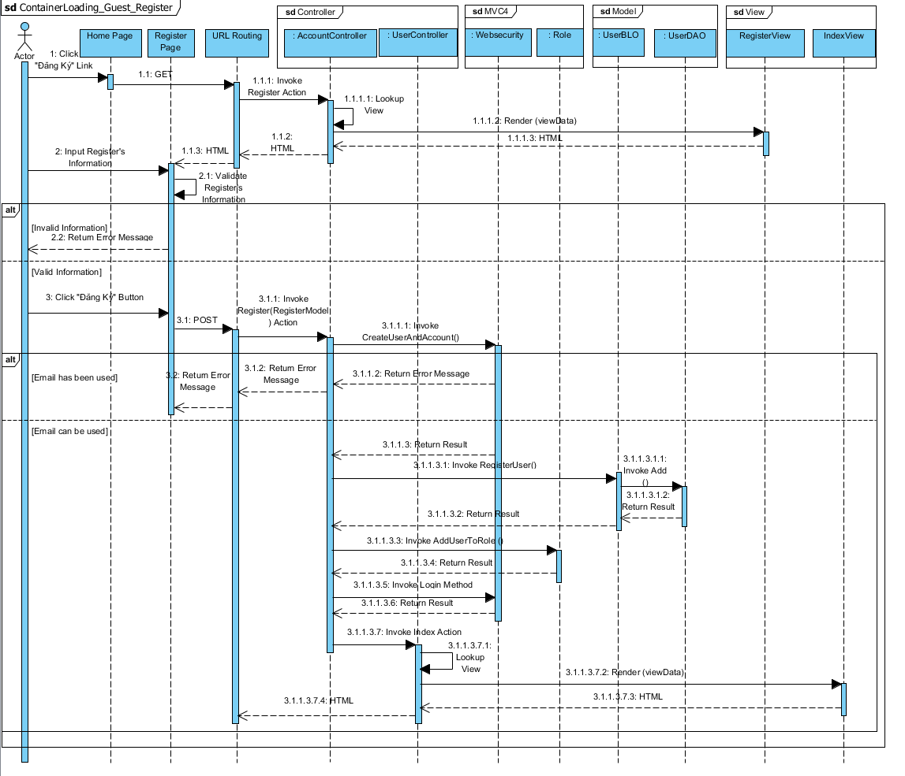

Figure 4-9 – Register Sequence Diagram

#### <Guest> Login by CLS Account

* + - This feature allows all people who have an account can login into the system.

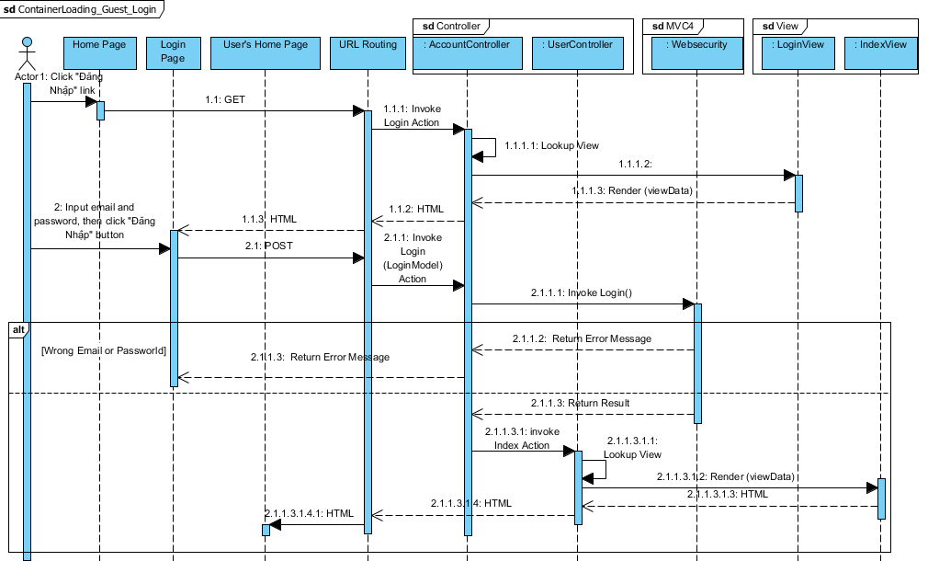

Figure 4-10 – Login Sequence Diagram

#### <Guest> Login by Facebook Account

* + - This feature is supplied by MVC4.

#### <Guest> Login by Google Account

* + - This feature is supplied by MVC4.

### User Features

#### <User> Log out

* + - This feature is simple.

#### <User> View User Profile

* + - This feature allow user view their Profile

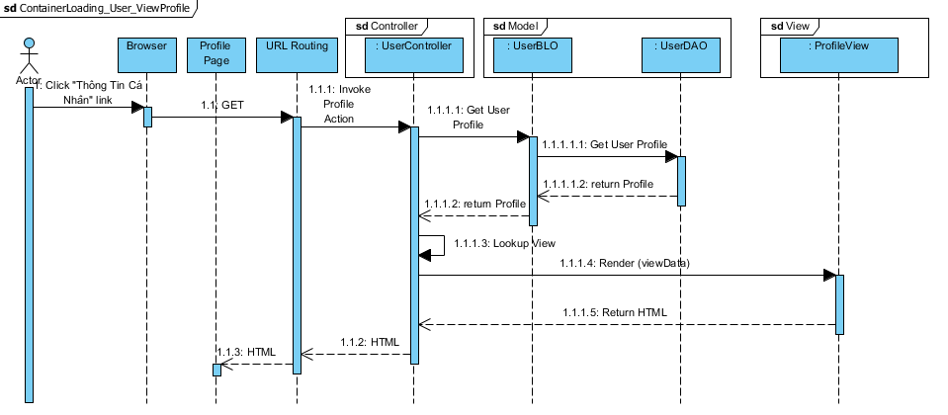

Figure 4-11 – View Profile Sequence Diagram

#### <User> Update User Profile

* + - This feature allow user Update their profile.

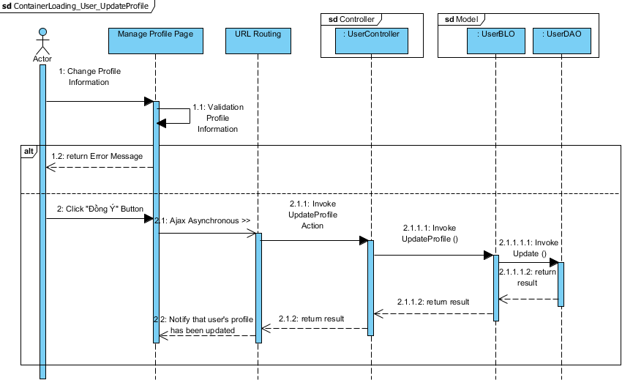

Figure 4-12 – Update Profile Sequence Diagram

#### <User> Change Password

* + - This feature allow user change their Password.

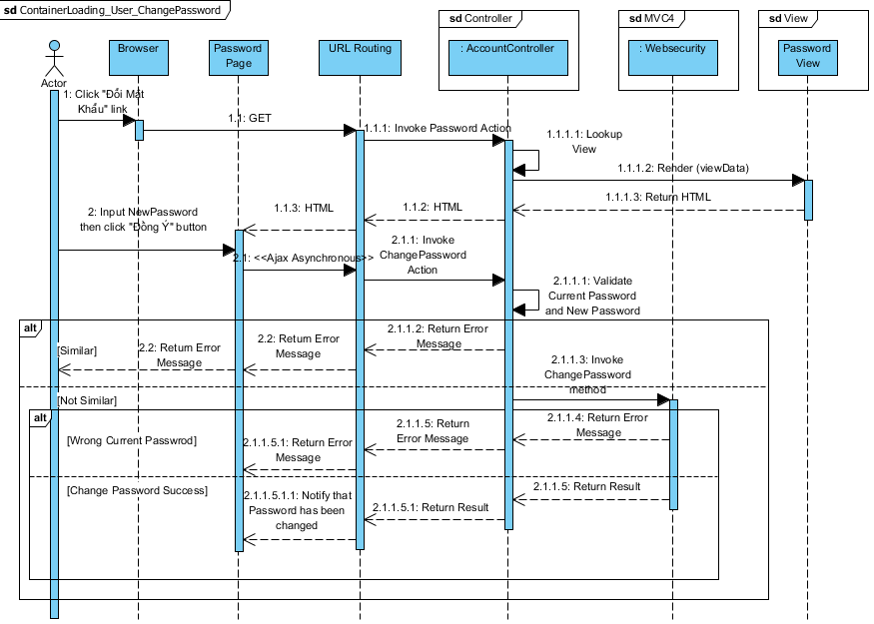

Figure 4-13 – Change User’s Password Sequence Diagram

#### <User> Reset Password

* + - This feature allow user reset their Password.

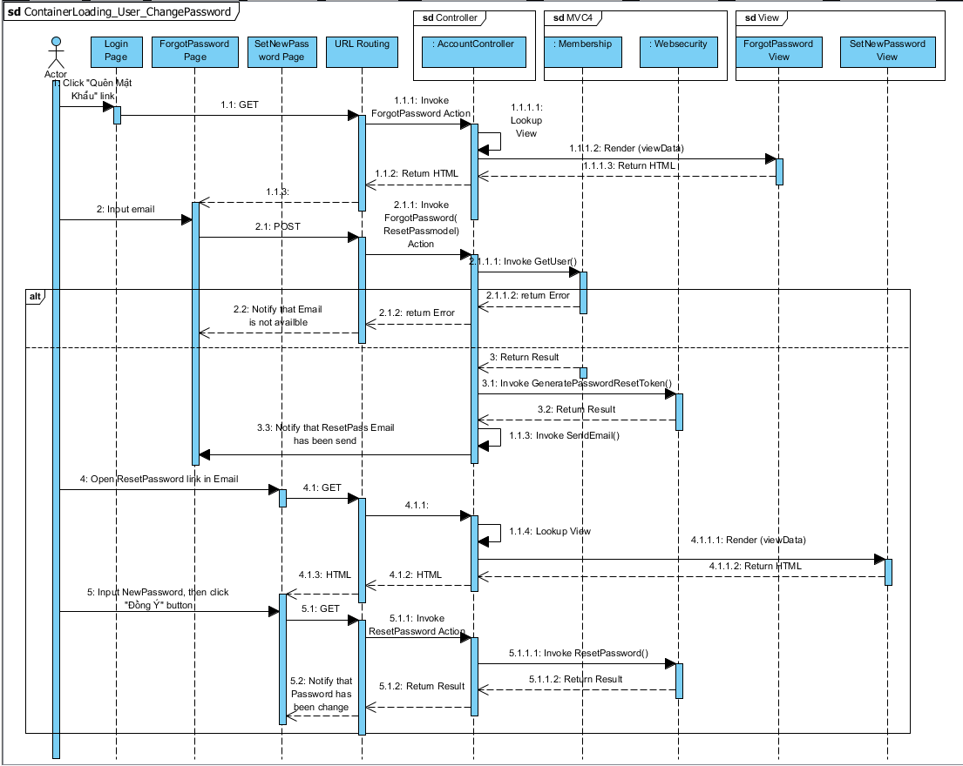

Figure 4-14 – Change User’s Password Sequence Diagram

#### <User> View Product List

* + - This feature allow user view their Product List

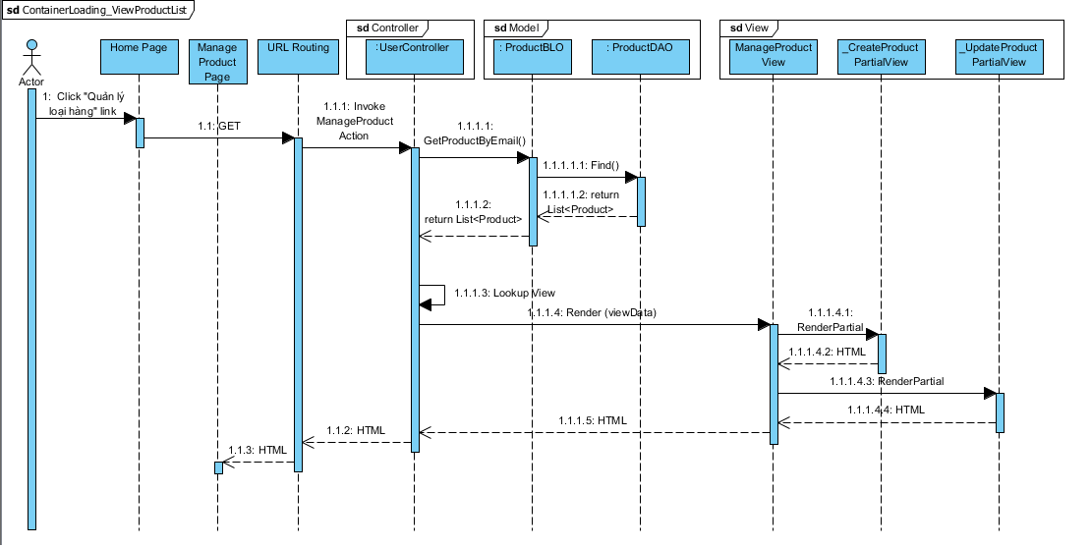

Figure 4-15 – View Product List Sequence Diagram

#### <User> Search Product

* + - This feature is supplied by DataTable library.

#### <User> Create Product

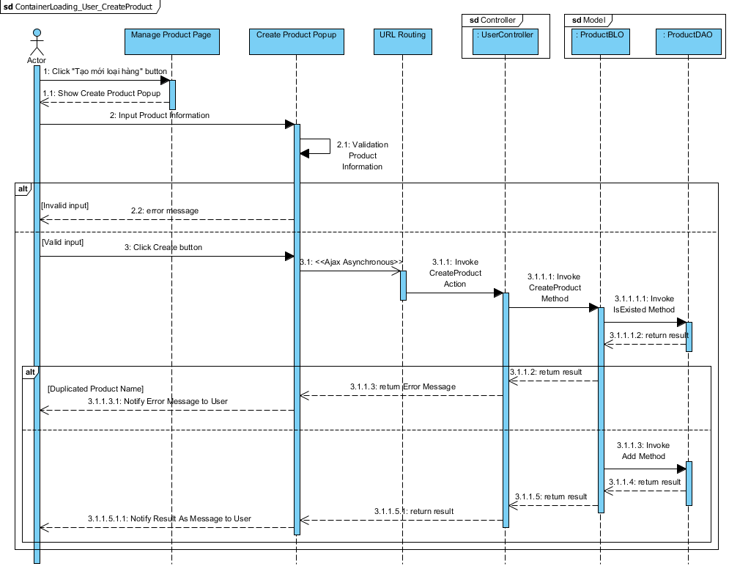

Figure 4-16 – Create Product Sequence Diagram

#### <User> Import Products by Excel file

* + - This feature same with Create Product.

#### <User> Update Product

* + - This feature allow User update product.

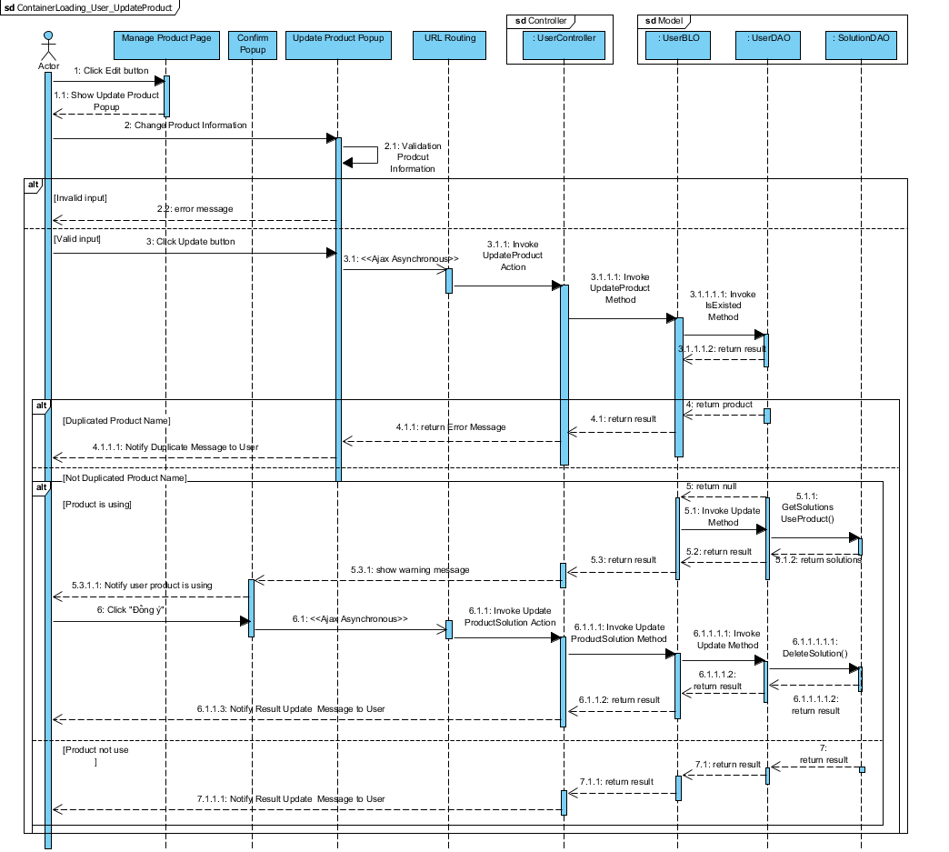

Figure 4-17 – Update Product Sequence Diagram

#### <User> Delete Product

* + - This feature allow User delete product.

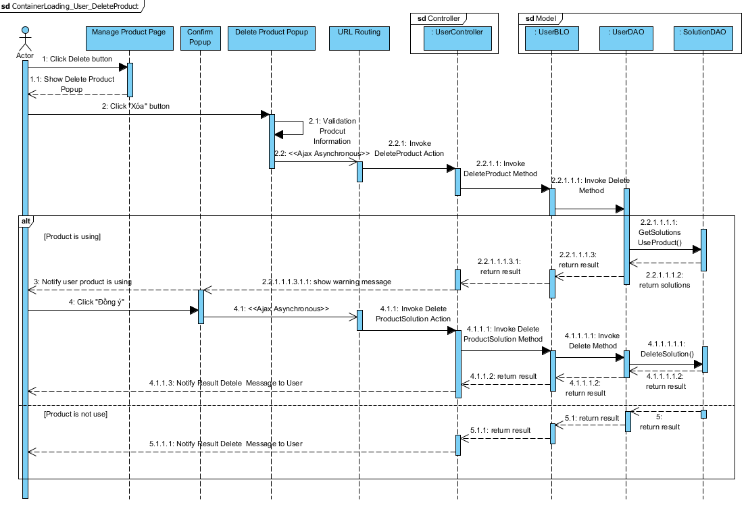

Figure 4-18 – Delete Product Sequence Diagram

#### <User> View Container List

* + - This feature same as View Product List.

#### <User> Search Container

* + - This feature same as Search Product.

#### <User> Create Container

* + - This feature same as Create Product.

#### <User> Update Container

* + - This feature same as Update Product.

#### <User> Delete Container

* + - This feature same as Delete Product.

<User> Buy Main Charge Package via PayPal

* + - Optional.

<User> Buy Additional Charge Package via PayPal

* + - Optional.

#### <User> View Charge History

* + - Optional.

#### <User> View Charge Usage

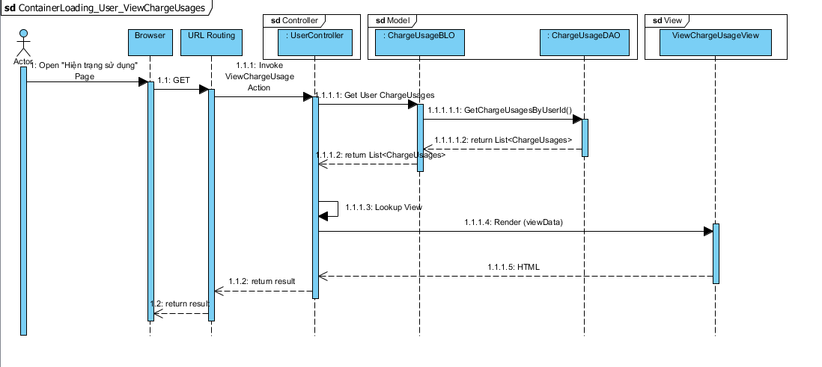

Figure 4-19 – View Charge Usage Sequence Diagram

#### <User> View Solution List

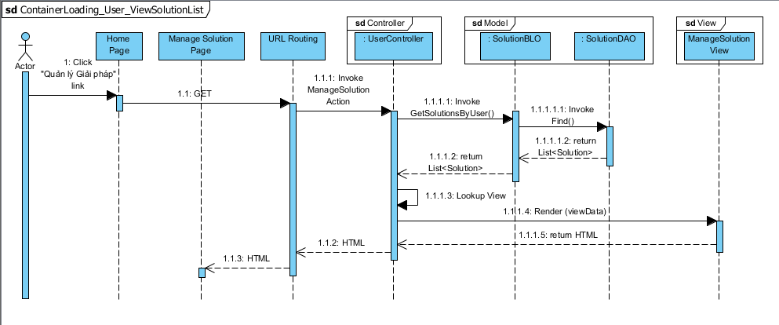

Figure 4-20 – View Solution List Sequence Diagram

#### <User> Create Solution

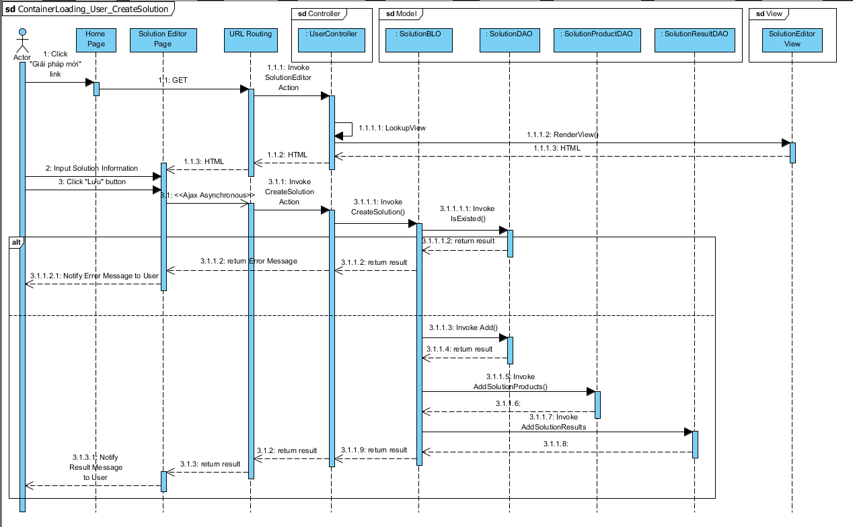

Figure 4-21 – View Solution List Sequence Diagram

#### <User>Update Solution

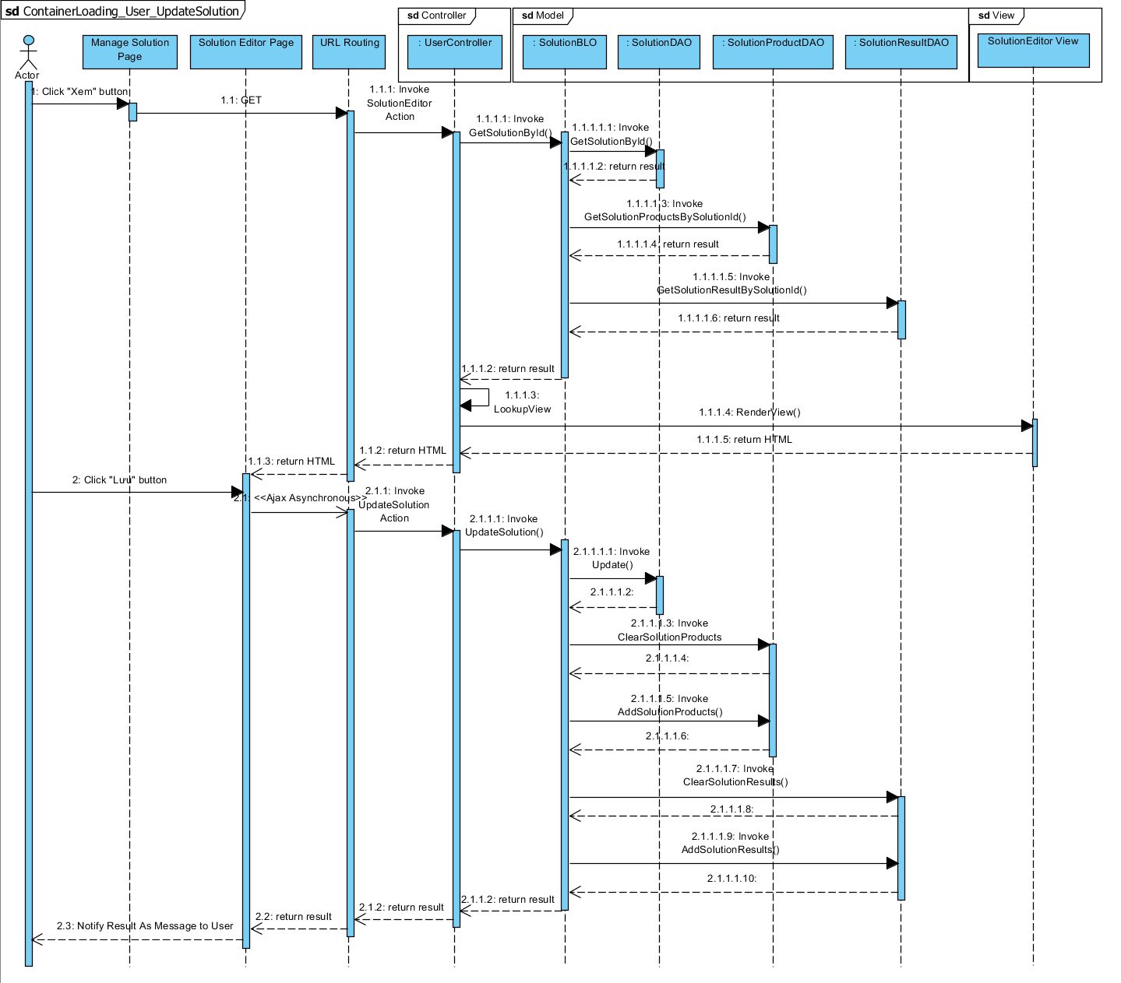

Figure 4-22 – Update Solution Sequence Diagram

#### <User> Delete Solution

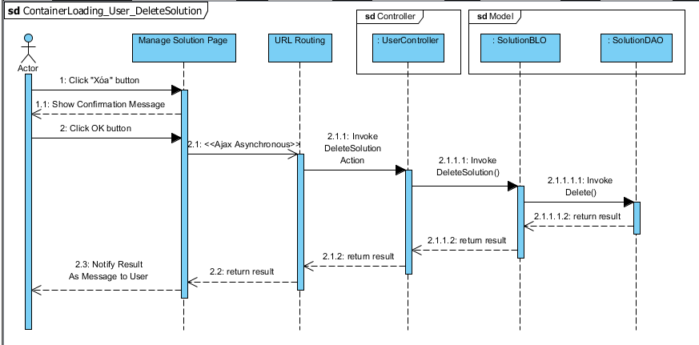

Figure 4-23 – Delete Solution Sequence Diagram

#### <User> Clone Solution

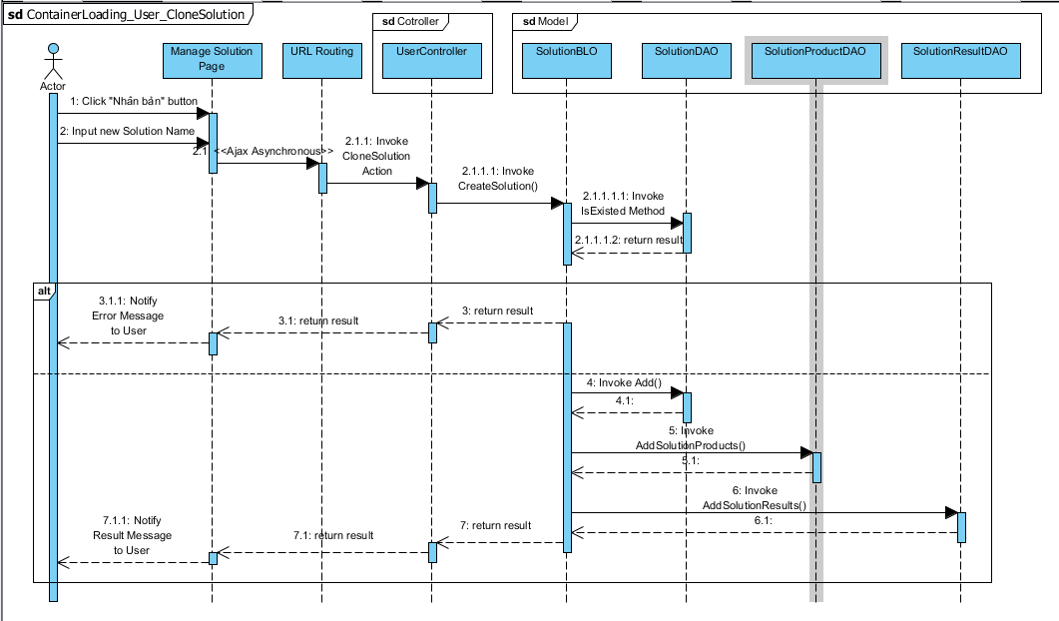

Figure 4-24 – Delete Solution Sequence Diagram

#### <User> View Solution Detail Result (Algorithm)

* + - This feature is complicated. It will be describe at presentation.

#### <User> View Solution Visualization Result (3D)

* + - This feature is complicated. It will be describe at presentation.

#### <User> Export Solution Result

* + - Optional.

### Admin Features

#### <Admin> Log out

* + - This feature is simple.

#### <Admin> View User List

* + - This feature allow Admin view User list.

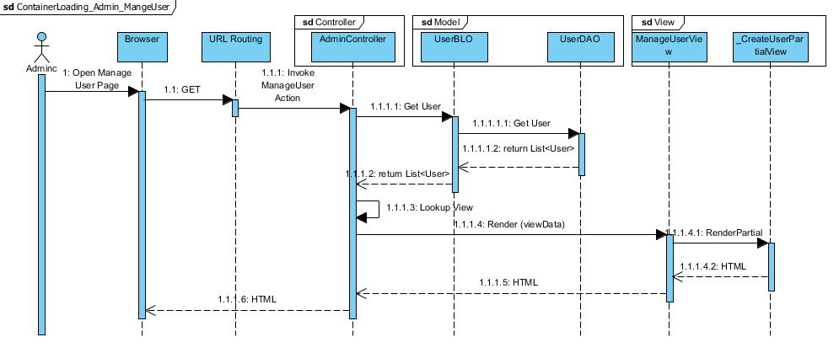

Figure 4-22 – View User Sequence Diagram

#### <Admin> Search User

* + - This feature is supplied by Data Table library.

#### <Admin> Create User

* + - This feature allow Admin create new user.

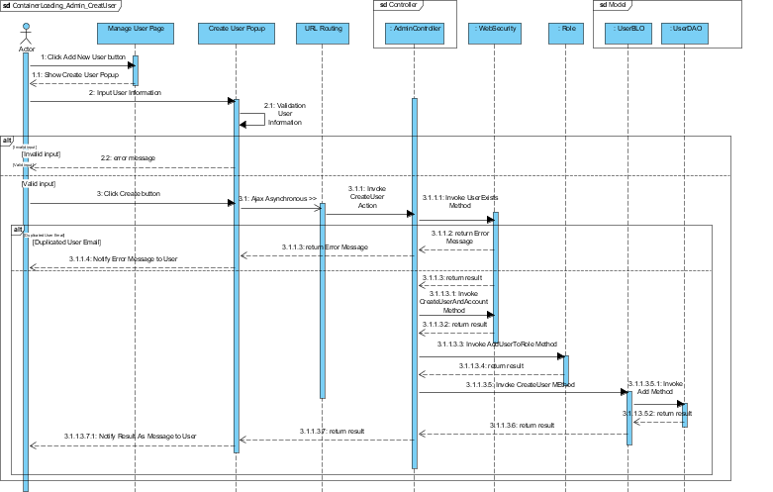

Figure 4-26 – Create User Sequence Diagram

#### <Admin> Activate/Deactivate User

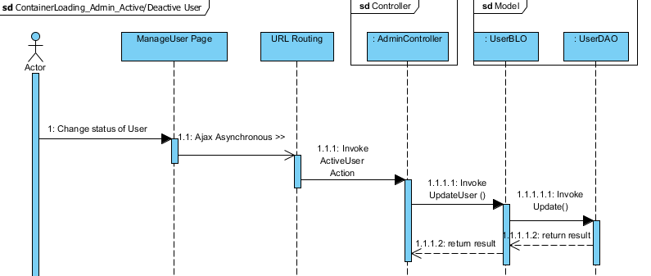

Figure 4-27 – Activate/Deactivate User Sequence Diagram

#### <Admin> View Container Template List

* + - This feature is same with View Product List.

#### <Admin> Search Container Template

* + - This feature is same with Search Product.

#### <Admin> Create Container Template

* + - This feature is same with Create Product.

#### <Admin> Update Container Template

* + - This feature is same with Update Product.

#### <Admin> Delete Container Template

* + - This feature is same with Delete Product.

#### <Admin> Search Charge Package

* + - This feature is supplied by Data Table library.

#### <Admin> View Charge Package List

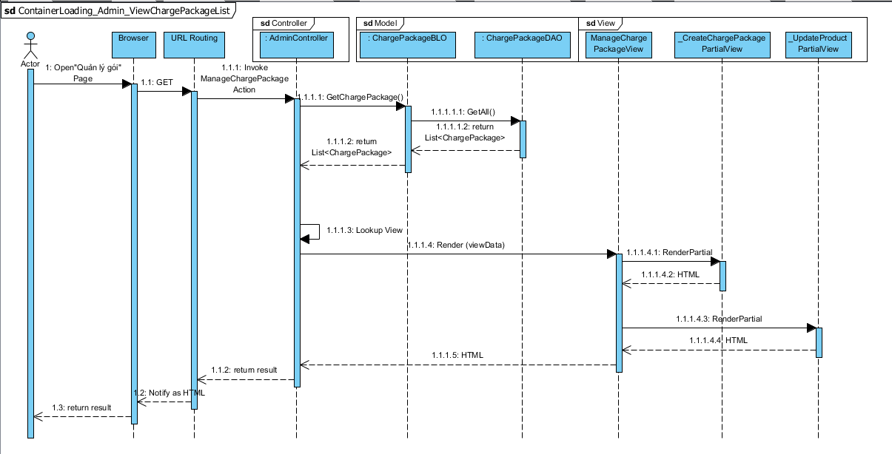

Figure 4-28 – View Charge Package List Sequence Diagram

#### <Admin> Create Charge Package

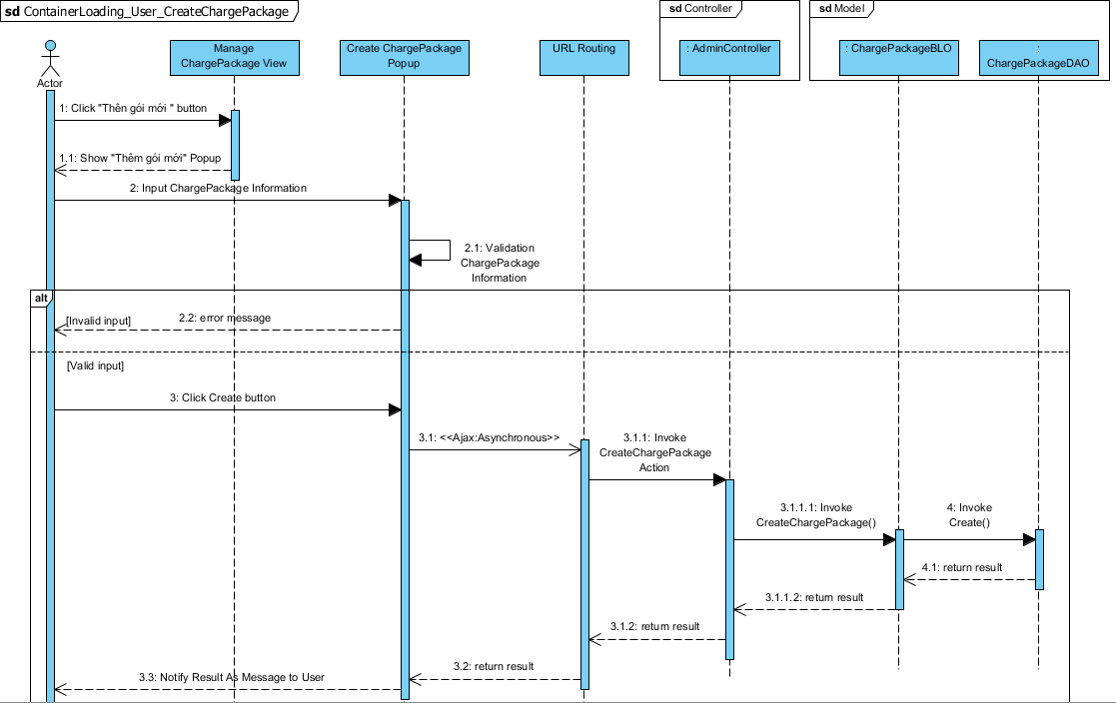

Figure 4-29 – Create Charge Package Sequence Diagram

#### <Admin> Update Charge Package

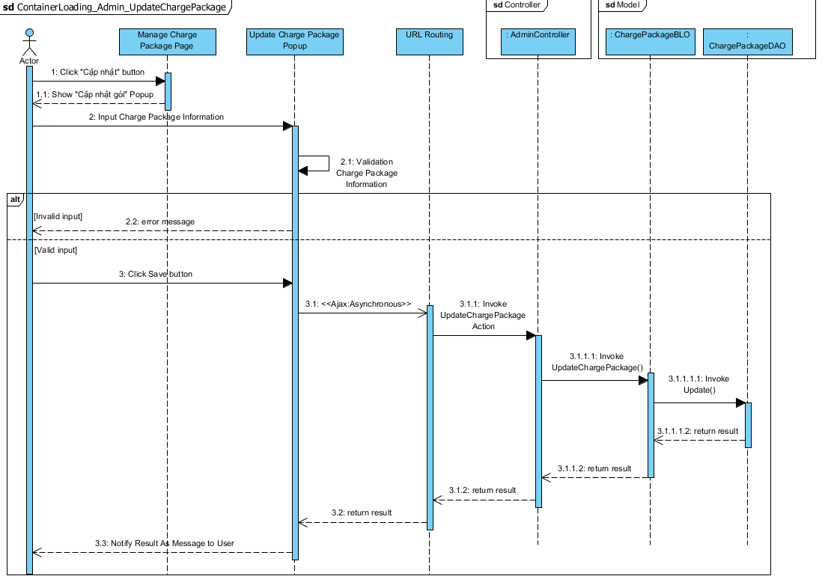

Figure 4-30 – Update Charge Package Sequence Diagram

#### <Admin> Activate/Deactivate Charge Package

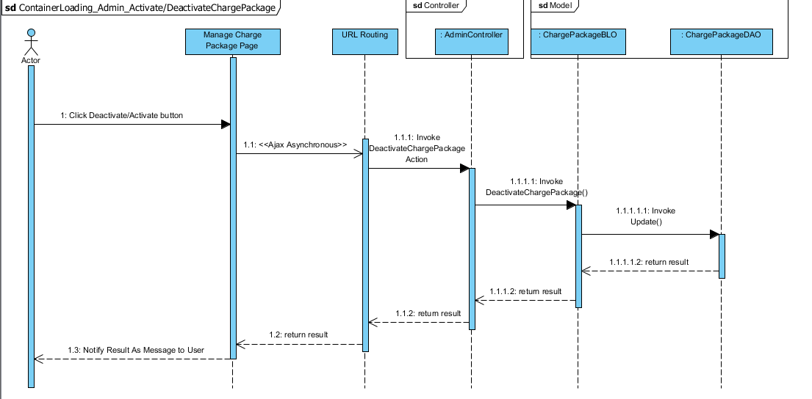

Figure 4-31 – Active/Deactivate Charge Package Sequence Diagram

#### <Admin> View Transaction

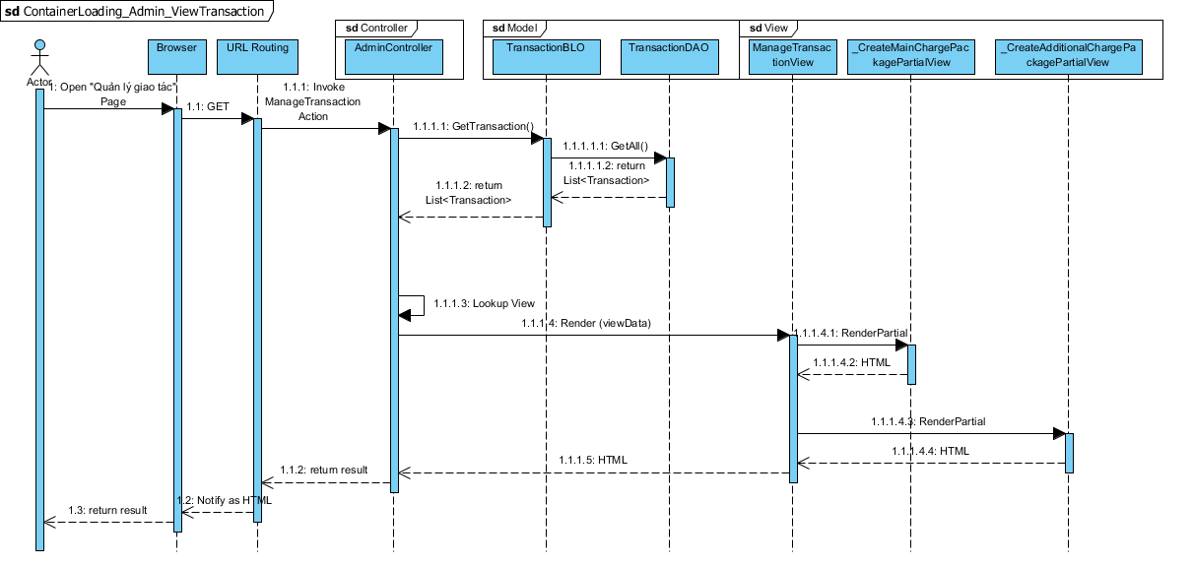

Figure 4-32 – View Transaction Sequence Diagram

#### <Admin> View User Charge Usage

* + - This feature is same with <User> View Charge Usage.

#### <Admin> Create Main Charge

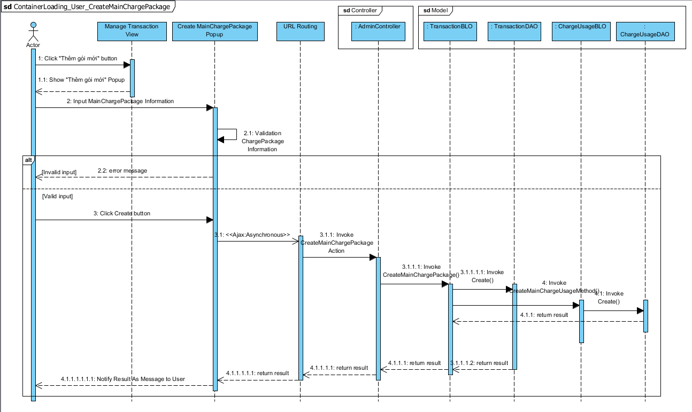

Figure 4-33 – Create Main Charge Sequence Diagram

#### <Admin> Create Additional Charge Package

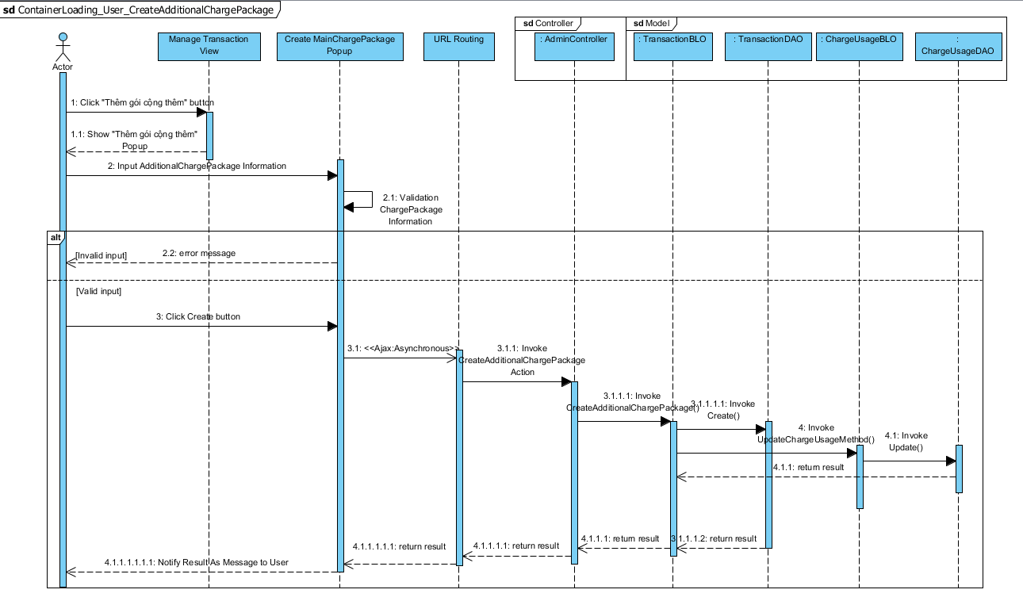

Figure 4-34 – Create Additional Charge Package Sequence Diagram

## User Interface Design

### Module User

#### <User> Manage User Page

##### Screen Images

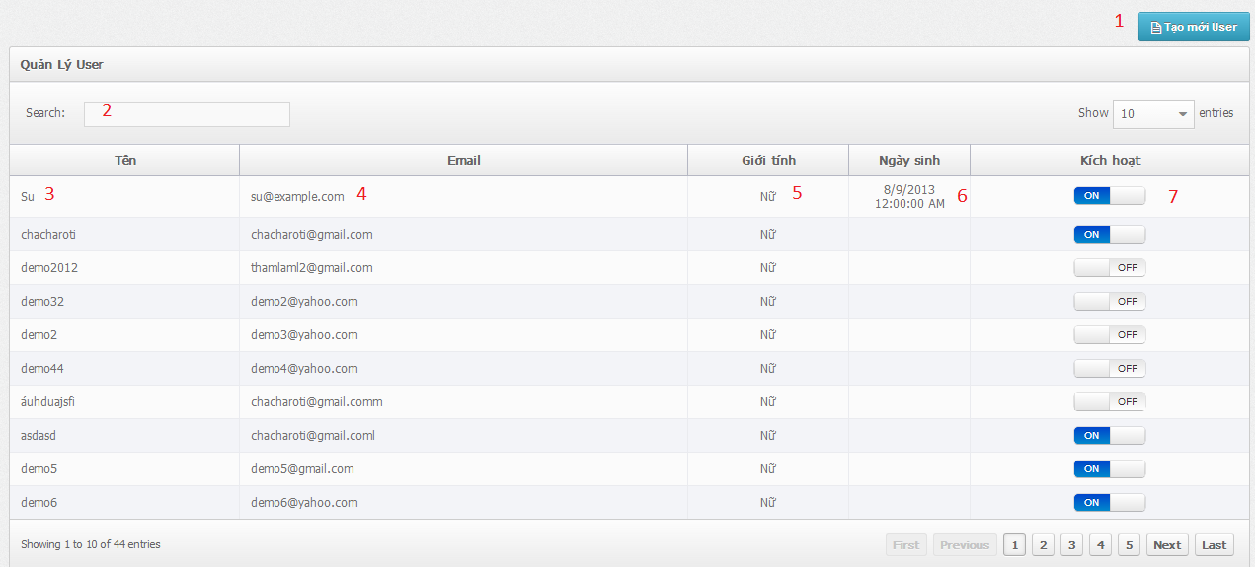

Figure 4-35 – Manage User Page

##### Objects and Actions

|  |  |  |  |  |  |
| --- | --- | --- | --- | --- | --- |
| Field No | Field Name | Type | Mandatory | Datatype | Description |
| 1 | Create User | Button | Y |  | Tạo Mới User |
| 2 | Search User | Label | Y | String | Search User |
| 3 | User’s Name | Label | Y | String | User’s Name |
| 4 | User’s Email | Label | Y | String | User’s Email |
| 5 | User’s Gender | Label | Y | String | Clone Solution |
| 6 | User’s Birthday | Label | Y | String | User’s Birthday |
| 7 | User’s Status | Checkbox | Y |  | User’s Status |

Table 4-1 – Manage User Page

#### <User> User Profile Page

##### Screen Images

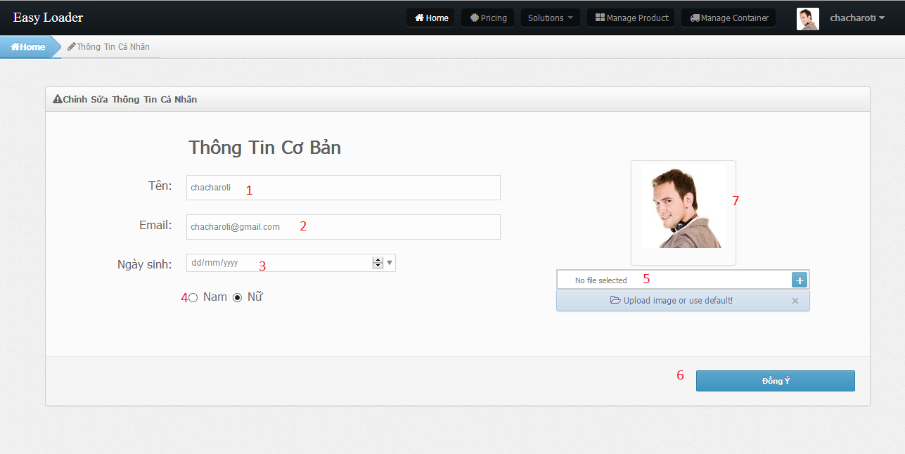

Figure 4-36 –User Profile Page

##### Objects and Actions

|  |  |  |  |  |  |
| --- | --- | --- | --- | --- | --- |
| Field No | Field Name | Type | Mandatory | Data type | Description |
| 1 | User’s Name | Label | Y | String | User’s Name |
| 2 | User’s Email | Label | Y | String | User’s Email |
| 3 | User’s Birthday | Label | Y | String | User’s Birthday |
| 4 | User’s Gender | Label | Y | String | User’s Gender |
| 5 | Image Picker | Label | Y |  | Image Picker |
| 6 | User’s Image | Label | Y | String | User’s Image |
| 7 | Đồng Ý | button | Y |  | Update Profile |

Table 4-2 –User Profile Page

### Module ManageProduct/Container/ContainerTemplate

#### <User> Manage Product

##### Screen Images

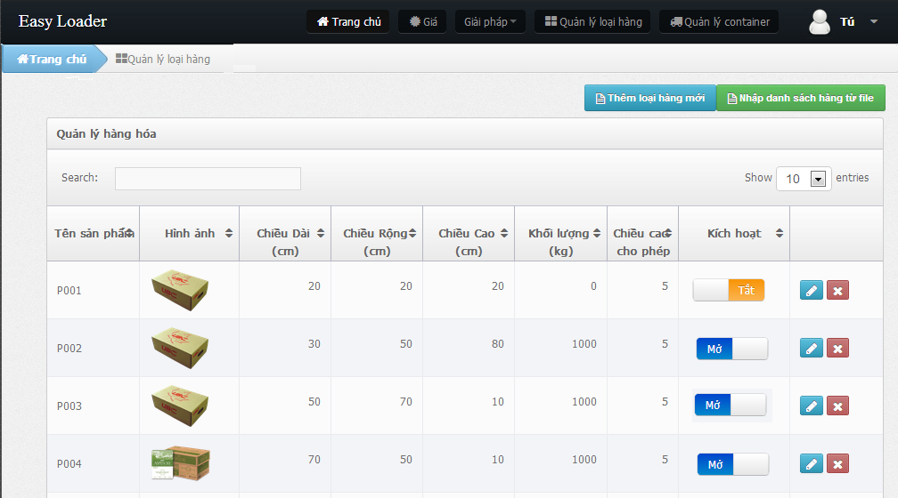

Figure 4-37 –Manage Product Page

##### Objects and Actions

|  |  |  |  |  |  |
| --- | --- | --- | --- | --- | --- |
| Field No | Field Name | Type | Mandatory | Data type | Description |
| 1 | Manage Product Table includes columns:  Product Name, Image, Length, Width, Height, Weight, Maximum High, IsActive. | | | | |
| 2 | Edit | Button |  |  |  |
| 3 | Delete | Button |  |  |  |

Table 4-3 – Manage Product Page

#### <User> Manage Container

##### Screen Images

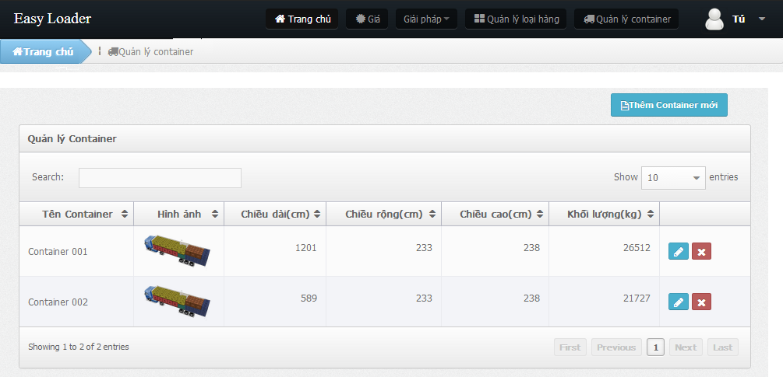

Figure 4-38 – Manage Container Page

##### Objects and Actions

|  |  |  |  |  |  |
| --- | --- | --- | --- | --- | --- |
| Field No | Field Name | Type | Mandatory | Data type | Description |
| 1 | Manage Container Table includes columns:  Container Name, Image, Length, Width, Height, Weight. | | | | |
| 2 | Edit | Button |  |  |  |
| 3 | Delete | Button |  |  |  |

Table 4-4 – Manage Container Page

### Module ManageSolution

#### <User> Manage Solution Page

##### Screen Images

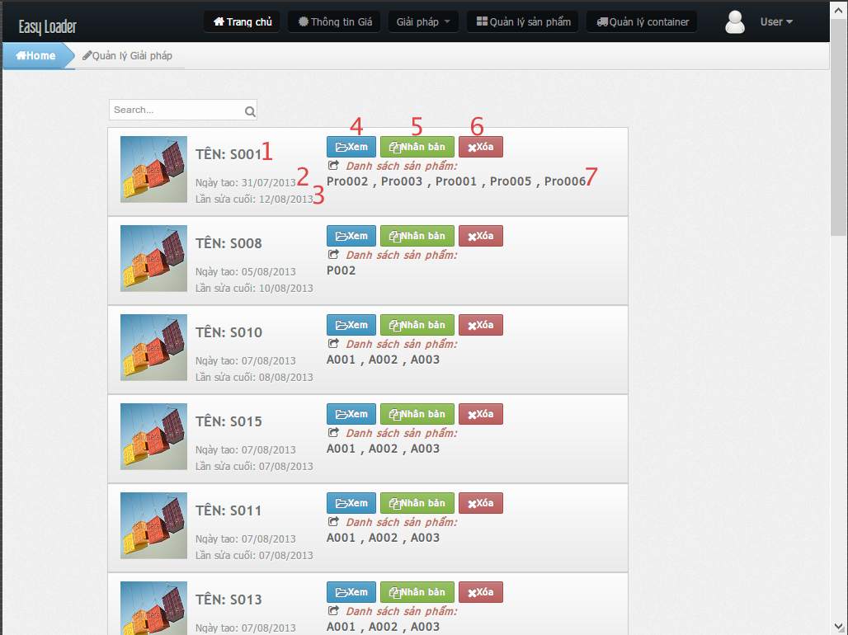

Figure 4-39 – Manage Solution Page

##### Objects and Actions

|  |  |  |  |  |  |
| --- | --- | --- | --- | --- | --- |
| Field No | Field Name | Type | Mandatory | Data type | Description |
| 1 | Solution Name | Label | Y | String | Solution Name |
| 2 | Create Date | Label | Y | String | Solution Create Date |
| 3 | Last Modify Date | Label | Y | String | Solution Last Modify Date |
| 4 | View Solution | Button | Y |  | View Solution |
| 5 | Clone Solution | Button | Y |  | Clone Solution |
| 6 | Delete Solution | Button | Y |  | Delete Solution |

Table 4-5 – Manage Solution Page

#### <User> Solution Editor Page

##### Screen Images

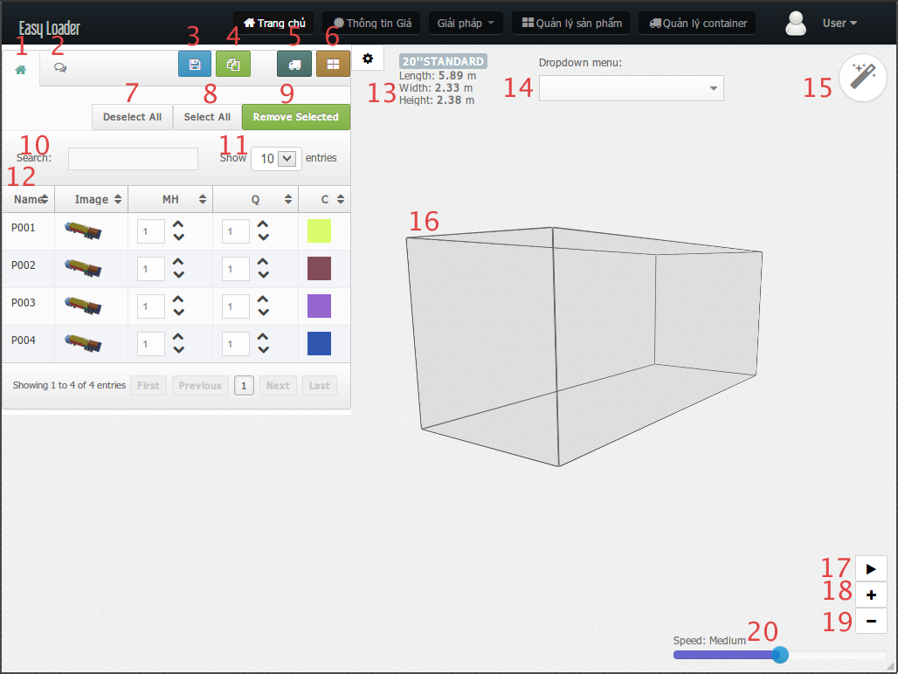

Figure 4-40 –Solution Editor Page

##### Objects and Actions

|  |  |  |  |  |  |
| --- | --- | --- | --- | --- | --- |
| Field No | Field Name | Type | Mandatory | Data type | Description |
| 1 | SolutionProduct Detail | Tab | Y |  | Tab include SolutionProduct Table |
| 2 | SolutionResult Detail | Tab | Y |  | Tab include SolutionResult Information |
| 3 | Save button | Button | Y |  | Save Solution |
| 4 | Clone Solution | Button | Y |  | Clone Solution |
| 5 | Choose Container | Button | Y |  | Pop up Container for choosing |
| 6 | Choose Products | Button | Y |  | Pop up Product List for choosing |
| 7 | Deselect all | Button | Y |  | Remove selection for all product |
| 8 | Select all | Button | Y |  | Add selection for all product |
| 9 | Remove selected | Button | Y |  | Remove selected product out solution |
| 10 | Search input | Input | Y |  | Input for searching product in solution |
| 11 | Maximum Entry | Dropdown list | Y |  | Maximum product is display on each page in table. |
| 12 | Solution Product | Table | Y |  | Table include solution product information |
| 13 | Container Information | Label | Y |  | Container Information |
| 14 | Solution Results | Dropdown list |  |  | Solution Results after loading |
| 15 | Loading | Button | Y |  | Start loading |
| 16 | 3D Cube | 3D Control | Y |  | Visualize container with product inside(if any) |
| 17 | Arrange | Button | Y |  | Run arrangement after loading |
| 18 | Zoom in | Button | Y |  | Zoom in 3D Cube |
| 19 | Zoom out | Button | Y |  | Zoom out 3D Cube |
| 20 | Speeder | Speed Control | Y |  | Control speed of arrangement |

Table 4-6 –Solution Editor Page

### Module ManagePayment

#### <Admin> Manage Transaction Page

##### Screen Images

**1**

**2**

**3**

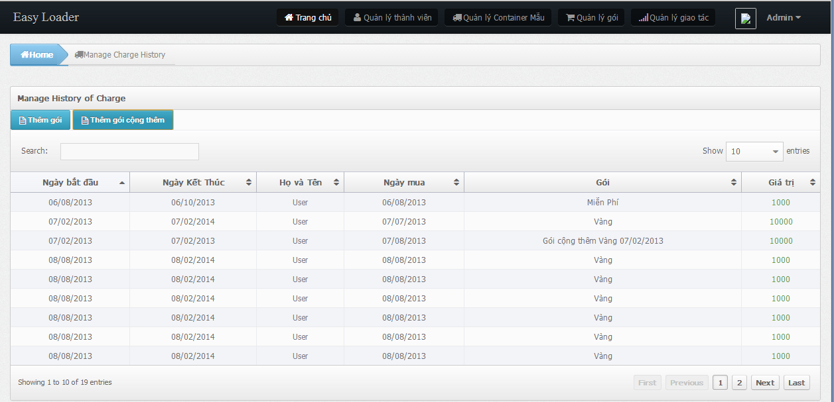

Figure 4-41 –Manage Transaction Page

##### Objects and Actions

|  |  |  |  |  |  |
| --- | --- | --- | --- | --- | --- |
| Field No | Field Name | Type | Mandatory | Data type | Description |
| 1 | Manage Transaction Table includes columns:  Ngày bắt đầu, Ngày kết thúc, Họ và tên, Ngày mua, Gói, Giá trị. | | | | |
| 2 | Thêm gói | Button | Y |  | Create Main Charge Package |
| 3 | Thêm gói cộng thêm | Button | Y |  | Create Additional Charge Package |

Table 4-7 – Manage Transaction Page

#### <Admin> Create Main Charge Package Popup

##### Screen Images

Figure 4-42 – Create Main Charge Package Popup

##### Objects and Actions

|  |  |  |  |  |  |
| --- | --- | --- | --- | --- | --- |
| Field No | Field Name | Type | Mandatory | Data type | Description |
| 1 | Khách hàng | Dropdown list | Y |  | Choose User |
| 2 | Email | Textbox | Y |  | Email |
| 3 | Gói | Dropdown list | Y |  | Gói |
| 4 | Đơn giá | Textbox | Y |  | Đơn giá |
| 5 | Ngày mua | Datetimepicker | Y |  | Ngày mua |
| 6 | Ngày bắt đầu | Datetimepicker | Y |  | Ngày bắt đầu |
| 7 | Thời hạn sử dụng | Textbox | Y |  | Thời hạn sử dụng |

Table 4-8 – Create Main Charge Package Popup

#### <Admin> Create Additional Charge Package Popup

##### Screen Images

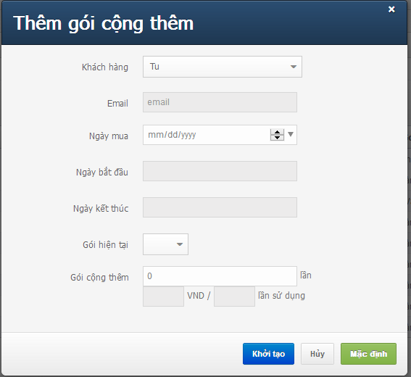

Figure 4-43 – Create Additional Charge Package Popup

##### Objects and Actions

|  |  |  |  |  |  |
| --- | --- | --- | --- | --- | --- |
| Field No | Field Name | Type | Mandatory | Data type | Description |
| 1 | Khách hàng | Dropdown list | Y |  | Choose User |
| 2 | Email | Textbox | Y |  | Email |
| 3 | Ngày mua | Datetimepicker | Y |  | Ngày mua |
| 4 | Ngày bắt đầu | Datetimepicker | Y |  | Ngày bắt đầu |
| 5 | Ngày kết thúc | Datetimepicker | Y |  | Ngày kết thúc |
| 6 | Gói hiện tại | Datetimepicker | Y |  | Gói hiện tại |
| 7 | Gói cộng thêm | Textbox | Y |  | Gói cộng thêm |
| 8 | Đơn giá sử dụng thêm | Textbox | Y |  | Số lần sử dụng thêm |
| 9 | Số lần | Textbox | Y |  | Số lần sử dụng thêm |

Table 4-9 – Create Additional Charge Package Popup

### Module Manage Charge Usage

#### <User> View Charge Usage Page

##### Screen Images

Figure 4-44 – View Charge Usage Page

##### Objects and Actions

#### <User> View Charge History Page

##### Screen Images

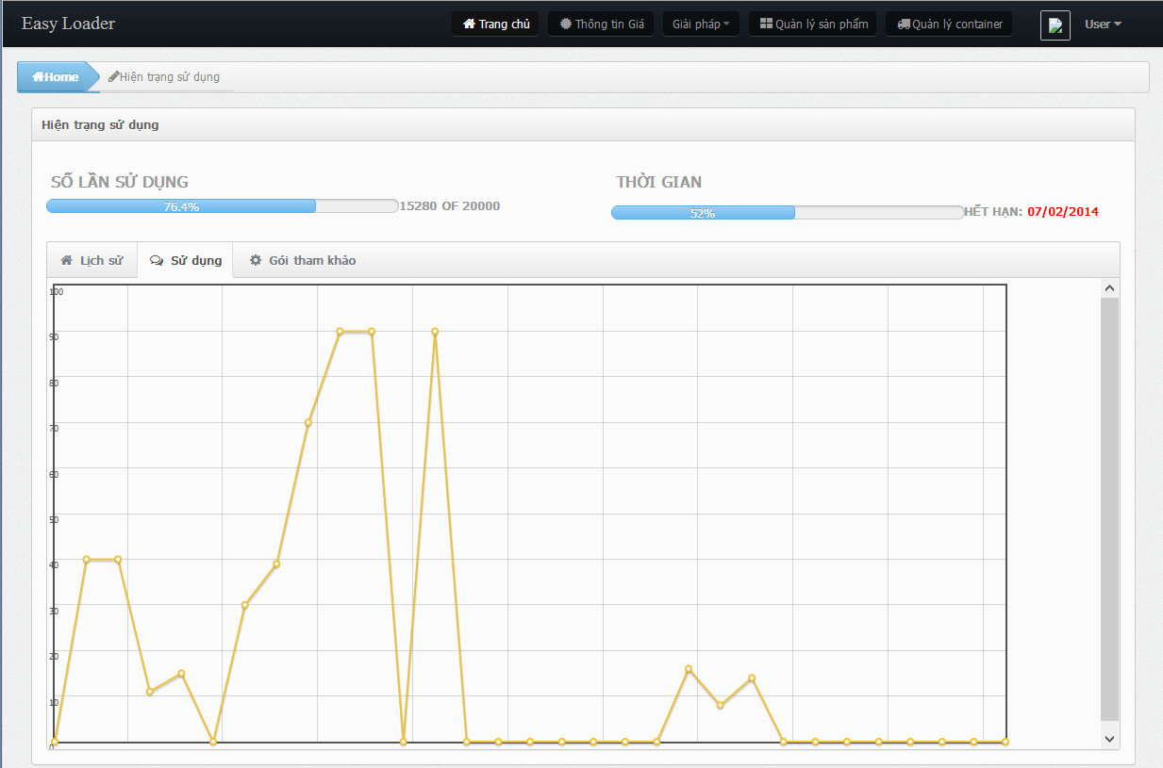

Figure 4-45 – View Charge History Page

##### Objects and Actions

#### <User> Pricing Page

##### Screen Images

Figure 4-46 – View Pricing Page

##### Objects and Actions

### Module ManageCharge Package

#### <Admin> View Charge Package Page

##### Screen Images

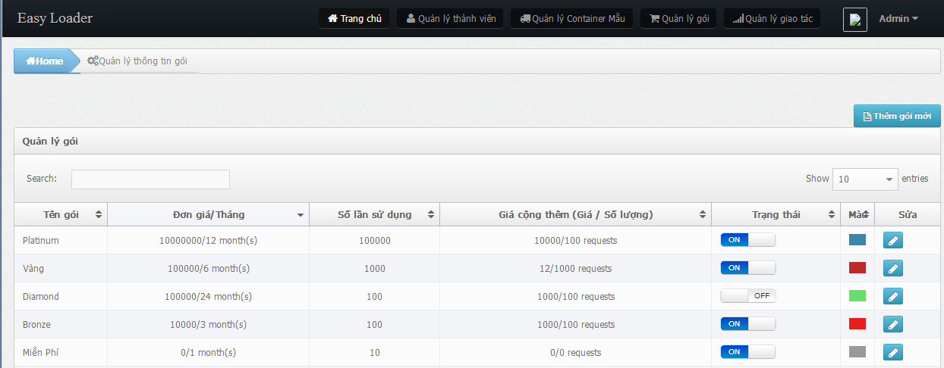

Figure 4-47 – View Charge Package Page

##### Objects and Actions

|  |  |  |  |  |  |
| --- | --- | --- | --- | --- | --- |
| Field No | Field Name | Type | Mandatory | Data type | Description |
| 1 | Manage Charge package Table includes columns:  Tên gói, Đơn giá/Tháng, Số lần sử dụng, Giá cộng thêm (giá/số lượng), Trạng thái, màu. | | | | |
| 2 | Thêm gói mới | Button | Y |  | Create New Charge Package |
| 3 | Trang thái | Toggle Button | Y |  | Activate/Deactivate Charge package. |

Table 4-10 – View Charge Package Page.

#### <Admin> Create Charge Package Page

##### Screen Images

Figure 4-48 – Create Charge Package Page

##### Objects and Actions

|  |  |  |  |  |  |
| --- | --- | --- | --- | --- | --- |
| Field No | Field Name | Type | Mandatory | Data type | Description |
| 1 | Tên gói | Textbox | Y |  | Tên gói |
| 2 | Đơn giá | Textbox | Y |  | Đơn giá |
| 3 | Thời hạn sử dụng | Textbox | Y |  | Thời hạn sử dụng |
| 4 | Số lượng sử dụng | Textbox | Y |  | Số lượng sử dụng |
| 5 | Phí cộng thêm | Textbox | Y |  | Phí cộng thêm |
| 6 | Số lần cộng thêm | Textbox | Y |  | Số lần cộng thêm |
| 7 | Màu | Color picker | Y |  | Màu |
| 8 | Hoạt động | Checkbox | Y |  | Hoạt động |
| 9 | Được Recommend | Checkbox | Y |  | Được Recommend |

Table 4-10 – Create Charge Package Page

#### <Admin> Update Charge Package Page

##### Screen Images

Figure 4-49 – Update Charge Package Page

##### Objects and Actions

|  |  |  |  |  |  |
| --- | --- | --- | --- | --- | --- |
| Field No | Field Name | Type | Mandatory | Data type | Description |
| 1 | Tên gói | Textbox | Y |  | Tên gói |
| 2 | Đơn giá | Textbox | Y |  | Đơn giá |
| 3 | Thời hạn sử dụng | Textbox | Y |  | Thời hạn sử dụng |
| 4 | Số lượng sử dụng | Textbox | Y |  | Số lượng sử dụng |
| 5 | Phí cộng thêm | Textbox | Y |  | Phí cộng thêm |
| 6 | Số lần cộng thêm | Textbox | Y |  | Số lần cộng thêm |
| 7 | Màu | Color picker | Y |  | Màu |
| 8 | Hoạt động | Checkbox | Y |  | Hoạt động |
| 9 | Được Recommend | Checkbox | Y |  | Được Recommend |

Table 4-11 – Update Charge Package Page

## Database Design

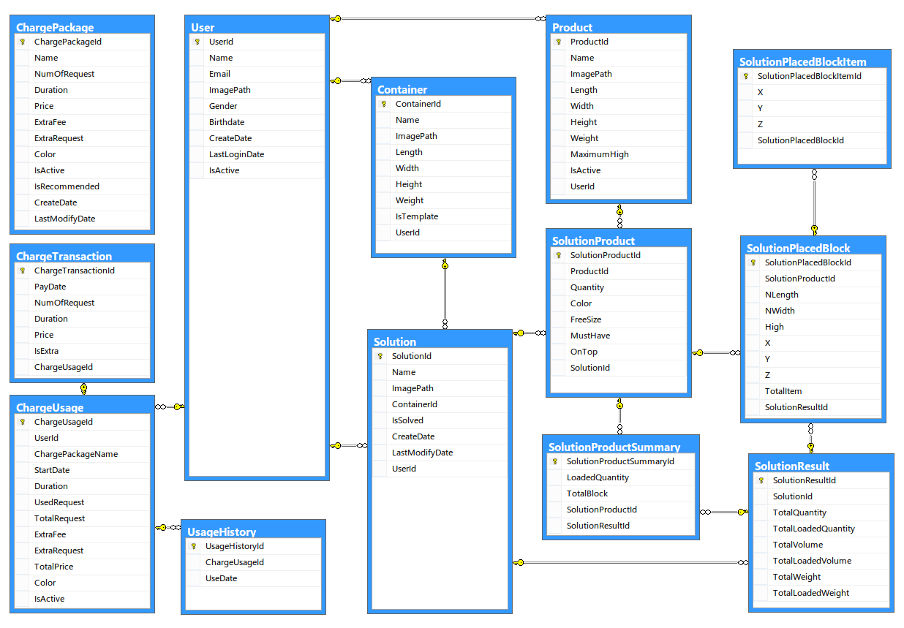

Figure 4-50 – Database Diagram

## Other material (if any)

# Software Test Documentation (STD)

## Introduction

### System Overview

This document provides all the features about test plans, test cases, test results, test environments, pass/fail criteria and risks estimation as well as checklist to cover all cases that can happen in Container Loading System website.

### Test Approach

Test goals: the testing aims to identify the remaining bugs in the system before releasing and confirm the consistency in design and implementation.

Test type: black box testing.

Test level: system and integration test.

## Database Relationship Diagrams

N/A

## Screen shots

N/A

## Test Plan

Test plan document is used to verify and ensure that Container Loading System meets its design specifications and other user requirements. The following part will describe which features will be tested and which is not, test tools and test environment.

### Features to be test

#### Module User

##### <User> View/Update User Profile.

##### *- Test all functions in “Chỉnh Sửa Thông Tin Cá Nhân” include: View/Update User Profile*

##### <Admin> View/Search/Active/Deactivate User.

##### *- Test all functions in “Chỉnh Sửa Thông Tin Cá Nhân” include: View/Update User Profile*

#### Module Manage Product/Container/ContainerTemplate

##### <User> View/Search/Create/Import/Update/Delete/Active/Deactivate Product.

##### *- Test all functions in “Quản lý sản phẩm” page include: View, Create Product, Update Product, Delete Product*

##### Module Charge Package

##### <User> View Charge History / Charge Usage.

##### *- Test all functions in “Hiện trạng sử dụng” include: View Charge Usage, View Charge Histories*

##### <Admin> View/Search/Create/Update/Delete Charge Package.

##### *- Test all functions in “Quản lý gói” include: View, Create Charge package, Update Charge package, Activate/Deactivate Charge Package*

##### <Admin> Add Main Charge / Addition Charge for User.

##### *- Test all functions in “Hiện trạng sử dụng” include: View Charge History, View Charge Usage*

##### <User> Buy Main Charge / Addition Charge via PayPal

##### *- Test all functions in “Gói tham khảo” include: Buy Main Charge Package via PayPal, Buy Additional Charge Package.*

### Features not to be test

#### Module User

##### <Guest> Register/Login CLS (Container Loading System)/Facebook/Google.

##### <User> View/Update User Profile.

##### <User> Change/Reset Password.

#### Module Manage Product/Container/ContainerTemplate

##### <User> View/Search/Create/Import/Update/Delete/Active/Deactivate Product.

#### Module Solution

##### <User> View/Clone/Update/Delete Solution.

##### <User> View Solution Detail Result. (Algorithm)

##### <User> View Solution 3D Result.

##### <User> Export Solution Result as excel file.

### Test Tool and Environment

* Test tool: There is no special testing tool used in testing this product.
* Test environment:
  + Hardware: Intel Core 2 Duo 2.00GHz or above, RAM at least 2GB, HDD free at least 1GB, Screen with 1024x768 or higher resolution.
  + Operating System: Microsoft Windows 7 Ultimate SP1.
  + Browser: Mozilla Firefox 13+, Google Chrome 22+

## Test Cases

### Module User

#### <Guest> Register/Login CLS (Container Loading System)/Facebook/Google.

#### <User> View/Update User Profile.

#### <User> Change/Reset Password.

#### <Admin> View/Search/Active/Deactivate User.

Input User Data

|  |  |  |  |  |
| --- | --- | --- | --- | --- |
| **Name** | **Email** | **Gender** | **Birthday** | **IsActive** |
| chacharoti | chacharoti@gmail.com | True | 6/10/1990 | True |
| megagtron | megatron\_135@yahoo.com | True | 1/8/1992 | True |
| Tram | phuthuysophire279@yahoo.com | False | 27/9/1992 | True |
| Tu | tattysad@yahoo.com | False | 2/3/1997 | True |

Table 5-1 – User Data

|  |  |  |  |  |  |  |  |
| --- | --- | --- | --- | --- | --- | --- | --- |
| **ID** | **Test Case Description** | **Pre-Conditions** | **Test Case Procedure** | **Expected Output** | **Result** | **Test Date** | **Note** |
| <Admin> View/Search/Active/Deactivate User. | | | | | | | |
| Steps 1. Login the system with Admin role.  2. Click “Profile” in navigation bar | | | | | | | |
| MP1 | View User list |  |  | Data table will be shown with user’s information (Input Product Data) | Passed | 27/07/2013 | TrungHDM |
| MP2 | Update User’s information |  | Click “Edit button” of user “chacharoti”.  “Update User” popup will be shown detail information:   * User Name (textbox, chacharoti) * Email (textbox, chacharoti@gmail.com) * Gender (text, Nam) * Birthday (datetime picker, 6/10/1990) * IsActive (checkbox, checked)   =>Change Gender from Nam to Nữ.  Click “Update” button | * Popup will be closed * User’s information will be changed and updated into data table. * Gender will be updated to Nữ. * A notification “Update successfully” will be displayed in 5s. | Passed | 27/07/2013 | TrungHDM |
| MP3 | Create User |  | Click “New User” button.  Input information of new user into “New User” popup:   * Name (textbox :60) * Email (textbox: 60) * Gender(bool) * Birthday(daytime)   IsActive(bool) Click “Create” button | * Popup will be closed * User’s information will be added into data table. * A notification “Create successfully” will be displayed in 5s. | Passed | 27/07/2013 | TrungHDM |
| MP4 | User deactivation |  | Click IsActive button of user tram. | * User’s property : IsActive change from true to false | Passed | 27/07/2013 | TrungHDM |

Table 5-2 – Module User Test Case

### Module Manage Product/Container/ContainerTemplate

#### <User> View/Search/Create/Import/Update/Delete/Active/Deactivate Product.

Input Product Data

|  |  |  |  |  |  |
| --- | --- | --- | --- | --- | --- |
| **Name** | **ImagePath** | **Length** | **Width** | **Height** | **Weight** |
| P001 | /Content/LuyenVN\_Solution\_css/images/20Feet.png | 10 | 20 | 30 | 40 |
| P002 | /Content/LuyenVN\_Solution\_css/images/40Feet\_2.png | 20 | 40 | 10 | 50 |
| P003 | /Content/LuyenVN\_Solution\_css/images/Default.png | 60 | 60 | 70 | 80 |
| P004 | /Content/LuyenVN\_Solution\_css/images/Default\_csv.png | 55 | 35 | 14 | 27 |
| P005 | /Content/LuyenVN\_Solution\_css/images/40\_FeetHighCube.png | 14 | 20 | 15 | 20 |

Table 5-3 - Product Data

|  |  |  |  |  |  |  |  |
| --- | --- | --- | --- | --- | --- | --- | --- |
| **ID** | **Test Case Description** | **Pre-Conditions** | **Test Case Procedure** | **Expected Output** | **Result** | **Test Date** | **Note** |
| <User> View/Search/Create/Import/Update/Delete/Active/Deactive Product. | | | | | | | |
| Steps  1. Login the system with User role.  2. Click “Manage Product” in navigation bar | | | | | | | |
| MP1 | View Products list |  | Click “Products” tab in the left menu | Data table will be shown with product’s information (Input Product Data) | Passed | 25/07/2013 | LuyenVN |
| MP2 | Edit Product’s information |  | Click “Edit button” of product P001.  “Update Product” popup will be shown detail information:   * Product Name(textbox, P001. * Display Image: /Content/LuyenVN\_Solution\_css/images/20Feet.png * Length(textbox: 10) * Width(textbox: 20) * Height(textbox: 30) * Weight(textbox: 40)   =>Change Length from 10 to 45.  Click “Update” button | * Popup will be closed * Product’s information will be changed and updated into data table. * Length will be updated to 45. * A notification “Update successfully” will be displayed in 5s. | Passed | 25/07/2013 | LuyenVN |
| MP3 | Change product’s image |  | Click “Edit button” of product P001.  Choose another image  Click Update | * Popup will be closed * Product’s image will be changed and updated into data table. * Click Edit button, the new image is being selected. | Passed | 25/07/2013 | LuyenVN |
| MP4 | Delete product |  | Click on “x” button of Product P001. | - A confirmation message will be show with content: “Are you sure want to delete product P001?”   * After click “Delete” button, P001 will be deleted from data table. * A notification “Delete successfully” will be displayed in 5s. | Passed | 25/07/2013 | LuyenVN |
| MP5 | Add Product |  | Click “New product” button.  Input information of new product into “New Product” popup:   * Name (textbox): P006 * Image: Choose Default Image. * Length(textbox: 50) * Width(textbox: 60) * Height(textbox: 70) * Weight(textbox: 10)   Click “Create” button | * Popup will be closed * Product’s information will be added into data table. * A notification “Create successfully” will be displayed in 5s. | Passed | 25/07/2013 | LuyenVN |
| MP6 | Import Product from Excel file |  | Click Upload button.  Choose Excel file to Upload Product List. | * All Products will be shown on data table for user to review. * Invalid records are displayed first will red background to notify error. * A record which has duplicated name will displayed a button for user to choose the old product (orange color) in database to use or use the new product from the file (green color). | Passed | 25/07/2013 | LuyenVN |
| MP7 | Upload Product List from Excel file successfully |  | After review data, click Upload button | * All valid records will be inserted into data table. * A notification “Create successfully” will be displayed in 5s. | Passed | 25/07/2013 | LuyenVN |

Table 5-4 – Module Manage Product Test Case

#### <User> View/Search/Create/Update/Delete Container.

#### <Admin> View/Search/Create/Update/Delete ContainerTemplate.

### Module Solution

#### <User> View/Clone/Update/Delete Solution.

|  |  |  |  |  |  |  |  |
| --- | --- | --- | --- | --- | --- | --- | --- |
| **ID** | **Test Case Description** | **Pre-Conditions** | **Test Case Procedure** | **Expected Output** | **Result** | **Test Date** | **Note** |
| <User> View/Clone/Update/Delete Product. | | | | | | | |
| Steps  1. Login the system with User role.  2. Click “Quản lý Giải pháp” in navigation bar | | | | | | | |
| MP1 | View Solution list |  | Click “Quản lý Giải pháp” tab in the left menu | Manage Solution Page will be shown include solution information. | Passed | 25/07/2013 | TuNDB |
| MP2 | View Solution |  | Click “Xem” button | Solution Editor Page will be shown include solution information which are saved in last modify. (Product, Container, Result…) | Passed | 25/07/2013 | TuNDB |
| MP3 | Change product’s image |  | * Click "Nhân bản” button. * Input new solution name. | Solution will be cloned to new solution and include fully information (Product, Container, Result...) | Passed | 25/07/2013 | TuNDB |
| MP4 | Delete product |  | Click “Xóa” button | A confirmation message will be show with content: “Bản có muốn xóa Giải pháp”.  After click “Đồng ý” button, solution will be delete from User Solution List. | Passed | 25/07/2013 | TuNDB |

Table 5-5 – Module Manage Solution Test Case

#### <User> View Solution Detail Result. (Algorithm)

#### <User> View Solution Visualization Result (3D).

#### <User> Export Solution Result as excel file.

### Module Charge Usage

#### <User> View Charge History / View Usage.

Input Charge Usage Data

|  |  |  |  |  |  |  |  |  |  |  |  |
| --- | --- | --- | --- | --- | --- | --- | --- | --- | --- | --- | --- |
| **Charge UsageID** | **UserID** | **ChargePackage Name** | **StartDate** | **Duration** | **UsedRequest** | **TotalRequest** | **ExtraFee** | **ExtraRequest** | **TotalPrice** | **Color** | **IsActive** |
| 1 | 5 | Vàng | 2013-02-07 | 12 | 15280 | 20000 | 12 | 1000 | 100000 | #be2a2a | True |
| 8 | 5 | Miễn Phí | 2013-08-06 | 2 | 0 | 10 | 0 | 0 | 0 | #999999 | False |
| 10007 | 5 | Vàng | 2013-08-08 | 6 | 0 | 1000 | 12 | 1000 | 100000 | #be2a2a | False |

Table 5-5 – Charge Usage Data

|  |  |  |  |  |  |  |  |
| --- | --- | --- | --- | --- | --- | --- | --- |
| **ID** | **Test Case Description** | **Pre-Conditions** | **Test Case Procedure** | **Expected Output** | **Result** | **Test Date** | **Note** |
| <User> View Charge History / View Usage. | | | | | | | |
| Steps  1. Login the system with User role.  2. Click “Hiện trạng sử dụng” in navigation bar | | | | | | | |
| VC1 | View Charge History |  | Click “Hiện trang sử dụng” tab in the left menu | Data table will be shown with ChargeUsages’s information as a slider (Input Charge Usage Data)  With the view as follow. The main package will be display on top.  The 2 others charge usage will be display on the data table with sorting of id. | Passed | 15/08/2013 | KhanhPD |
| VC2 | View Usage |  | Click tab “Sử dụng” in the navigation tab in “Manage Usage” page | The page is display as second tab with the line Chart, which show usage history of current user in the period from 1 month ago to current moment. | Passed | 15/08/2013 | KhanhPD |
| VC3 | View Usage history with Additional Charge package | VC1 | Click “Hiện trang sư dụng” tab in the left menu | With the additional charge package in the data table, the package which user have will be display as sub slider below the charge package in data table. | Untested | 15/08/2013 | KhanhPD |
| VC4 | View current available Charge package to add |  | Click “Gói tham khảo” tab in the menu | There should be show 4 charge package with 1 package is marked as “Phổ biến nhất” | Passed | 15/08/2013 | KhanhPD |

Table 5-6 – Module Charge Usage Test Case

#### <Admin> View/Search/Create/Update/Delete Charge Package.

Input Charge Package Data

|  |  |  |  |  |  |  |  |  |  |
| --- | --- | --- | --- | --- | --- | --- | --- | --- | --- |
| **Charge PackageID** | **Name** | **Number**  **OfRequest** | **Duration** | **Price** | **ExtraFee** | **ExtraRequest** | **Color** | **IsActive** | **IsRecommend** |
| 1 | Silver | 1000 | 2 | 1000 | 500 | 1000 | #999999 | True | True |
| 2 | Gold | 10000 | 12 | 10000 | 12 | 1000 | #3a87ad | True | False |
| 10002 | Platinum | 100000 | 12 | 100000 | 10000 | 1000 | #3a87ad | False | False |
| 10003 | Bronze | 100 | 10 | 500 | 50 | 1000 | #3a87ad | True | True |
| 10004 | Diamond | 1000000 | 24 | 1000000 | 1000 | 1000 | #3a87ad | True | True |

Table 5-7 – Charge Package Data

|  |  |  |  |  |  |  |  |
| --- | --- | --- | --- | --- | --- | --- | --- |
| **ID** | **Test Case Description** | **Pre-Conditions** | **Test Case Procedure** | **Expected Output** | **Result** | **Test Date** | **Note** |
| <Admin> View/Search/Create/Update/Delete Charge Package. | | | | | | | |
| Steps  1. Login the system with Admin role.  2. Click “Quản lý gói” in navigation bar | | | | | | | |
| MP1 | View Charge Packages list |  | Click “Quản lý gói” tab in the left menu | Data table will be shown with ChargePackages’s information (Input Charge Package Data) | Passed | 27/07/2013 | KhanhPD |
| MP2 | Update Charge Package ’s information |  | Click “Cập nhật” of Charge Package 1.  “Cập nhật thông tin gói” popup will be shown detail information:   * Name(textbox, Silver. * NumOfRequest: (textbox:1000) * Duration(textbox: 2) * Price(textbox: 20) * ExtraFee(textbox: 500) * ExtraRequest(textbox:1000) * Color (textbox: #999999) * IsActive(checkbox: true) * IsRecommend(checkbox: true)   =>Change Duration from 2 to 3.  Click “Cập nhật” button | * Popup will be closed * Charge Package’s information will be changed and updated into data table. * Duration will be updated to 3. * A notification “Update successfully” will be displayed in 5s. | Passed | 27/07/2013 | KhanhPD |
| MP3 | Deactivate Charge Package |  | Click on On/Off button of ChargePackage 1. | Charge Package 1 is set to isActive = false | Passed | 27/07/2013 | KhanhPD |
| MP4 | Create Charge Package |  | Click “New Charge Package” button.  Input information of new product into “New Charge Pacakge” popup:   * Name(textbox): Test New. * NumOfRequest: (textbox):1000 * Duration(textbox): 6 * Price(textbox): 20000 * ExtraFee(textbox): 400 * ExtraRequest(textbox):1000 * Color (textbox): #FFFFFF * IsActive(checkbox): true * IsRecommend(checkbox): false   Click “Create” button | * Popup will be closed * Charge Package ‘s information will be added into data table. * A notification “Create successfully” will be displayed in 5s. | Passed | 27/07/2013 | KhanhPD |

Table 5-8 – Module Charge Package Test Case

#### <Admin> Add Main Charge / Addition Charge for User.

Input Charge Usage Data

|  |  |  |  |  |  |  |  |  |  |  |  |
| --- | --- | --- | --- | --- | --- | --- | --- | --- | --- | --- | --- |
| **Charge UsageID** | **UserID** | **ChargePackage Name** | **StartDate** | **Duration** | **UsedRequest** | **TotalRequest** | **ExtraFee** | **ExtraRequest** | **TotalPrice** | **Color** | **IsActive** |
| 1 | 5 | Vàng | 2013-02-07 | 12 | 15280 | 20000 | 12 | 1000 | 100000 | #be2a2a | True |
| 8 | 5 | Miễn Phí | 2013-08-06 | 2 | 0 | 10 | 0 | 0 | 0 | #999999 | False |
| 10007 | 5 | Vàng | 2013-08-08 | 6 | 0 | 1000 | 12 | 1000 | 100000 | #be2a2a | False |

Table 5-9 – Charge Usage Data

Input Charge Transaction Data

|  |  |  |  |  |  |  |
| --- | --- | --- | --- | --- | --- | --- |
| **UserId** | **Name** | **Email** | **ImagePath** | **Gender** | **BirthDate** | **CreateDate** |
| 1 | 2013-07-07 00:00:00.000 | 10000 | 12 | 1000 | False | 1 |
| 2 | 2013-08-06 00:00:00.000 | 1000 | 2 | 123 | False | 8 |
| 10004 | 2013-08-07 00:00:00.000 | 10000 | 0 | 120 | True | 1 |
| 10008 | 2013-08-08 00:00:00.000 | 1000 | 6 | 100000 | False | 10007 |
| 10009 | 2013-08-08 00:00:00.000 | 1000 | 6 | 100000 | False | 10008 |

Table 5-10 – Charge Transaction Data

|  |  |  |  |  |  |  |  |  |
| --- | --- | --- | --- | --- | --- | --- | --- | --- |
| **ID** | **Test Case Description** | **Pre-Conditions** | **Test Case Procedure** | **Expected Output** | | **Result** | **Test Date** | **Note** |
| <Admin> Add Main Charge / Additional Charge Package | | | | | | | | |
| Steps  1. Login the system with Admin role.  2. Click “Quản lý giao tác” in navigation bar | | | | | | | | |
| MT1 | View Transaction list |  | Click “Quản lý giao tác” tab in the left menu | Data table will be shown with ChargePackages’s information (Input Charge Package Data) | Passed | | 15/08/2013 | KhanhPD |
| MT2 | Create Main Charge package for user | MT1 | Click “Thêm gói”.  “Thêm gói mới” popup will be shown detail information:   * Khách hàng(Dropdownlist, Tu) * Email: (textbox:nguyendinhbaotu@gmail.com) * Gói(Dropdown list: Miễn phí) * Đơn giá(textbox: 10000) * Ngày mua(textbox: dd/mm/yyyy) * Ngày bắt đầu(textbox:dd/mm/yyyyy) * Thời hạn sử dụng (textbox: 1)   Click “Khởi tạo” button | * Popup will be closed * Charge Transaction’s information will be changed and updated into data table. * Charge usage will be added 1 more row * A notification “Thêm gói thành công” will be displayed in 5s. | Passed | | 15/08/2013 | KhanhPD |
| MT3 | Create Additional Charge package for user | MT1 | Click “Thêm gói cộng thêm”.  “Thêm gói mới” popup will be shown detail information:   * Khách hàng(Dropdownlist, Tu) * Email: (textbox:nguyendinhbaotu@gmail.com) * Ngày mua(textbox: dd/mm/yyyy) * Ngày bắt đầu(textbox:dd/mm/yyyyy) * Ngày kết thúc(textbox:dd/mm/yyyyy) * Gói hiện tại(Dropdown list: Miễn phí) * Gói cộng thêm(textbox: 0) * (disabled textbox: 1)VND * (disabled textbox: 1)lần sử dụng   Click “Khởi tạo” button | * Popup will be closed * Charge Transaction’s information will be changed and updated into data table. * Charge usage will be added 1 more row * A notification “Thêm gói thành công” will be displayed in 5s. | Passed | | 15/08/2013 | KhanhPD |

Table 5-10 – Module Create Main/Additional Charge Test Case

#### <User> Buy Main Charge / Addition Charge via PayPal

Input Charge Usage Data

|  |  |  |  |  |  |  |  |  |  |  |  |
| --- | --- | --- | --- | --- | --- | --- | --- | --- | --- | --- | --- |
| **Charge UsageID** | **UserID** | **ChargePackage Name** | **StartDate** | **Duration** | **UsedRequest** | **TotalRequest** | **ExtraFee** | **ExtraRequest** | **TotalPrice** | **Color** | **IsActive** |
| 1 | 5 | Vàng | 2013-02-07 | 12 | 15280 | 20000 | 12 | 1000 | 100000 | #be2a2a | True |
| 8 | 5 | Miễn Phí | 2013-08-06 | 2 | 0 | 10 | 0 | 0 | 0 | #999999 | False |
| 10007 | 5 | Vàng | 2013-08-08 | 6 | 0 | 1000 | 12 | 1000 | 100000 | #be2a2a | False |

Table 5-11 – Charge Usage Data

|  |  |  |  |  |  |  |  |
| --- | --- | --- | --- | --- | --- | --- | --- |
| **ID** | **Test Case Description** | **Pre-Conditions** | **Test Case Procedure** | **Expected Output** | **Result** | **Test Date** | **Note** |
| <Admin> Add Main Charge / Additional Charge Package | | | | | | | |
| Steps  1. Login the system with User role.  2. Click “Giá & Phiên bản” in navigation bar | | | | | | | |
| MT1 | Buy Main Charge Package via Paypal |  | Click “Giá & Phiên bản”.  Choose Charge Package and click “Mua ngay”  PayPal popup will be displayed.  User enter paypal account info and click submit | A charge package is added for user in Charge Usage table | Passed | 15/08/2013 | KhanhPD |

Table 5-12 – Module Buy Main Charge Package via PayPal Test Case

## Checklists

### Checklist of validation

|  |  |  |  |  |
| --- | --- | --- | --- | --- |
| Question | | Yes | No | N/A |
| 1 | Check the maximum field lengths to ensure that there are no truncated characters? | x |  |  |
| 2 | Where the database requires a value (other than null) then this should be defaulted into fields. |  |  | x |
| 3 | The user must either enter an alternative valid value or leave the default value intact. | x |  |  |
| 4 | If a set of radio buttons represent a fixed set of values such as A, B and C then what happens if a blank value is retrieved from the database? |  | x |  |
| 5 | If a particular set of data is saved to the database check that each value gets saved fully to the database. |  |  | x |
| 6 | Does a failure of validation on every field cause a sensible user error message? | x |  |  |
| 7 | Is the user required to fix entries, which have failed validation tests? | x |  |  |
| 8 | Have any fields got multiple validation rules and if so are all rules being applied? | x |  |  |
| 9 | If the user enters an invalid value and clicks on the OK, is the invalid entry identified and highlighted correctly with an error message? | x |  |  |
| 10 | Is validation consistently applied at screen level unless specifically required at field level? | x |  |  |
| 11 | For all numeric fields check whether negative numbers can and should be able to be entered. |  | x |  |
| 12 | For all numeric fields check the minimum and maximum values and also some mid-range values allowable? |  | x |  |
| 13 | For all character/alphanumeric fields check the field to ensure that there is a character limit specified and that this limit is exactly correct for the specified database size? |  | x |  |
| 14 | Do all mandatory fields require user input? | x |  |  |
| 15 | If any of the database columns don’t allow null values then the corresponding screen fields must be mandatory. (If any field which initially was mandatory has become optional then check whether null values are allowed in this field.) | x |  |  |

Table 5-13 – Check List of Validation

### Submission Checklist

|  |  |  |  |  |
| --- | --- | --- | --- | --- |
| Question | | Yes | No | N/A |
| TABLES AND FIGURES | | | | |
| 1 | Does every table column, including the stub column, have a heading? | x |  |  |
| 2 | Are all tables referred to in text? |  |  | x |
| 3 | Are the elements in the figures large enough to remain legible after the figure has been reduced to the width of a journal column or page? |  |  | x |
| 4 | Is lettering in a figure no smaller than 8 points and no larger than 14 points? |  |  | x |
| 5 | Are the figures being submitted in a file format acceptable to the publisher? |  | x |  |
| 6 | Has the figure been prepared at a resolution sufficient to produce a high-quality image? |  |  | x |
| 7 | Are all figures numbered consecutively with Arabic numerals? |  | x |  |
| 8 | Are all figures and tables mentioned in the text and numbered in the order in which they are mentioned? | x |  |  |
| REFERENCES | | | | |
| 1 | Are references cited both in text and in the reference list? |  | x |  |
| 2 | Do the text citations and reference list entries agree both in spelling and in date? | x |  |  |
| 3 | Are journal titles in the reference list spelled out fully? |  |  | x |
| 4 | Are the references (both in the parenthetical text citations and in the reference list) ordered alphabetically by the authors’ surnames? |  |  | x |
| 5 | Are inclusive page numbers for all articles or chapters in books provided in the reference list? | x |  |  |
| 6 | Are references to studies included in your meta-analysis preceded by an asterisk? |  |  | x |
| FORMAT | | | | |
| 1 | Have you checked the journal’s website for instructions to authors regarding specific formatting requirements for submission? |  |  | x |
| 2 | Is the entire manuscript—including quotations, references, author note, content footnotes, and figure captions—double-spaced? Is the manuscript neatly prepared? |  |  | x |
| 3 | Are the margins at least 1 in. (2.54 cm)? | x |  |  |
| 4 | Are the title pages, abstracts, references, appendices, content footnotes, tables, and figures on separate pages (with only one table or figure per page)? Are the figure captions on the same page as the figures? Are manuscript elements ordered in sequence, with the text pages between the abstract and the references? |  | x |  |
| 5 | Are all pages numbered in sequence, starting with the title page? | x |  |  |
| PARAGRAPHS AND HEADINGS | | | | |
| 1 | Is each paragraph longer than a single sentence but not longer than one manuscript page? | x |  |  |
| 2 | Do the levels of headings accurately reflect the organization of the paper? | x |  |  |
| 3 | Do all headings of the same level appear in the same format? | x |  |  |

Table 5-14 – Submission Checklist

## Other material (if any)

N/A

# Software User’s Manual (SUM)

## Installation Guide

### Server Side Setting up environment at server side

The following software must be installed into the server machine:

* Microsoft Windows 7 or a higher version
* Server must support ASP.NET 4.0 or higher (can download from <http://www.microsoft.com/en-us/download/details.aspx?id=21>)
* Microsoft SQL Server 2008 R2 or higher.

### Deployment at server sites

The following steps must be installed into the server machine:

* Open SQL Server And run script-1.0.0.sql
* Deploy server.

## User Guide

### Minimum System Requirements

The server must meet the following minimum requirement:

* + Windows Server 2008.
  + 1.4GHz or higher.
  + 512 RAM or above.
  + 25GB HDD or above.
  + Have an internet connection.

The client devices need to have one of the following browsers to launch the Container Loading System website:

* Google Chrome version 20 or higher (can download at <https://www.google.com/intl/en/chrome/browser/>)
* Firefox version 10 or higher (can download at <http://www.mozilla.org/en-US/firefox/new/>)

### Introduction of Container Loading System

With Container Loading System, we give users a new way to explore loading product to container by providing excel input, smart algorithm, 3D model with SaaS payment model.

### Features and How to Use

#### Manage User

##### Register

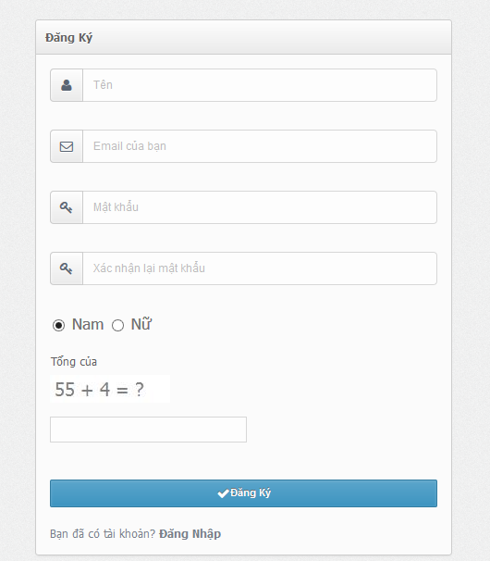

Figure 6-1 – Register Form

* This is Guest’s function.
* Triggers:

1. Click on “Đăng Kí” link on page’s header.
2. Input below information:

|  |  |
| --- | --- |
| “Tên” | Input Name.  Required. |
| Email | Input Email.  Required. |
| “Mật khẩu” | Input Password.  Required. |
| “Xác nhận lại mật khẩu” | Input password again.  Required |
| Gender | Choose gender.  Required. |
| Captcha | Calculate sum of capcha.  Required. |

1. Click on "Đăng kí".

##### G:\ContainerLoadingDocument\Feature and how to use\dangnhap.PNGLogin

Figure 6-2 – Login Form

* This function is use for all user to login to system.
* Triggers:

1. Click on “Đăng Nhập” link on page’s header.
2. Input email and password:

|  |  |
| --- | --- |
| Email | Input “Email”.  Required. |
| Mật khẩu | Input “Mật khẩu”.  Required. |

1. Click on "Lưu thay đổi".

##### Edit User Profile

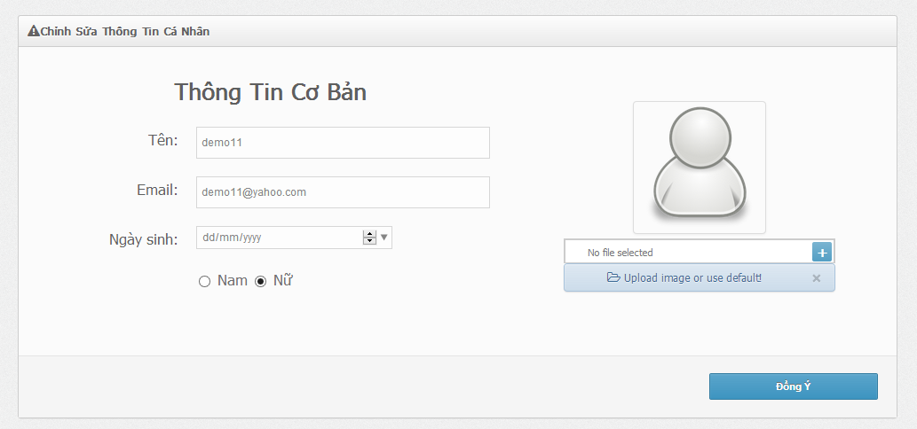

Figure 6-3 – Edit User Profile Form

* This is User’s function.
* Triggers:

1. Click on User dropdown list. Choose “Thông tin cá nhân” link.
2. Edit information:

|  |  |
| --- | --- |
| Tên | Input User’s name.  Required. |
| “Giới Tính” | Choose Gender**.**  Required. |
| “Ngày sinh” | Date time picker. |
| Image | Image picker. |

1. Click on "Đồng Ý" button.

##### Change Password

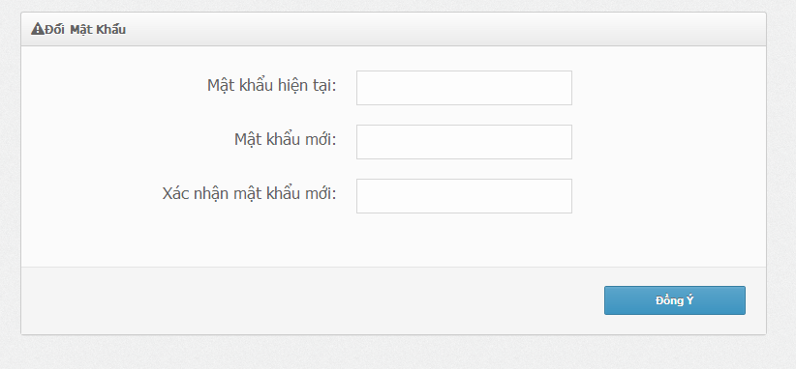

Figure 6-4 – Change Password Form

* This is User’s function.
* Triggers:

1. Click on User dropdown list. Choose “Thay đổi mật khẩu” link.
2. Input below information:

|  |  |
| --- | --- |
| “Mật khẩu hiện tại” | Input current password.  Required. |
| “Mật khẩu mới” | Input new password.  Required. |
| “Xác nhận lại mật khẩu mới” | Confirm new password.  Required. |

1. Click on “Đồng Ý” button.

##### Forget Password

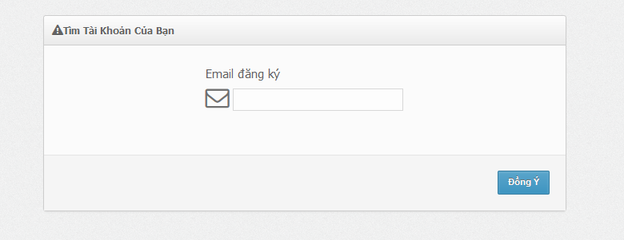

Figure 6-5 – Forget Password Form

* This feature is for all User of server.
* Triggers:

1. Click on “Đăng Nhập” link on header of page.
2. Click on “Quên mật khẩu” link.
3. Input email which user register:

|  |  |
| --- | --- |
| Email | Input register email.  Required. |

1. Click on "Đồng Ý" button.
2. Check email and click link to set a new password.

##### View User List

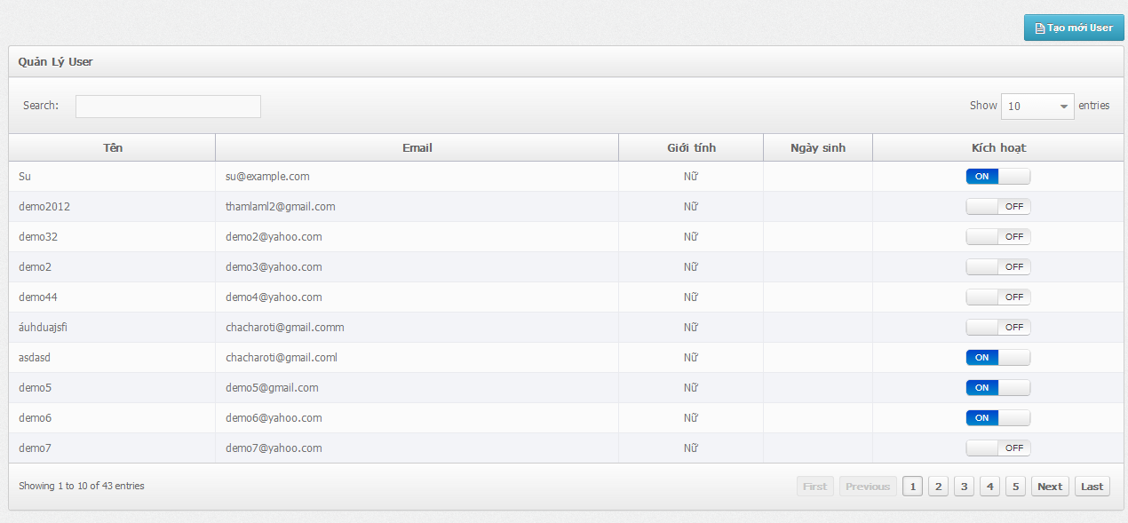

Figure 6-6 – View User List GUI

* This is Admin’s function.
* Triggers:

1. Click on “Thành Viên” link on header of page.

##### Create User

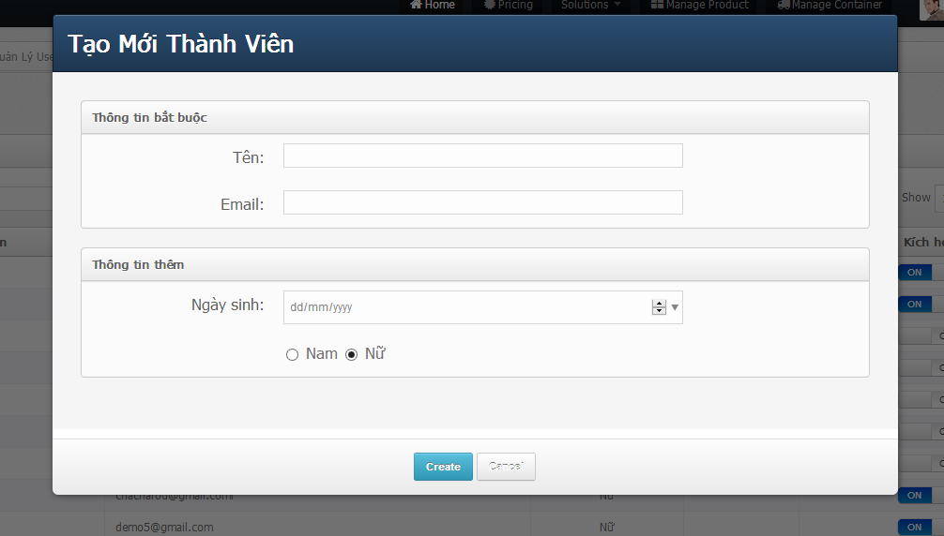

Figure 6-7 – Create User Form

* This is Admin’s function.
* Triggers:

1. Click on “Tạo Mới Thành Viên” on header of table.
2. Input user information:

|  |  |
| --- | --- |
| Tên | Input User’s name. |
| Email | Input User’s email.  Required. |
| Ngày sinh | Daytime picker. |
| Giới tính | Radio button.  Required. |

1. Click on “Create” button to finish.

##### Activate/Deactivate User

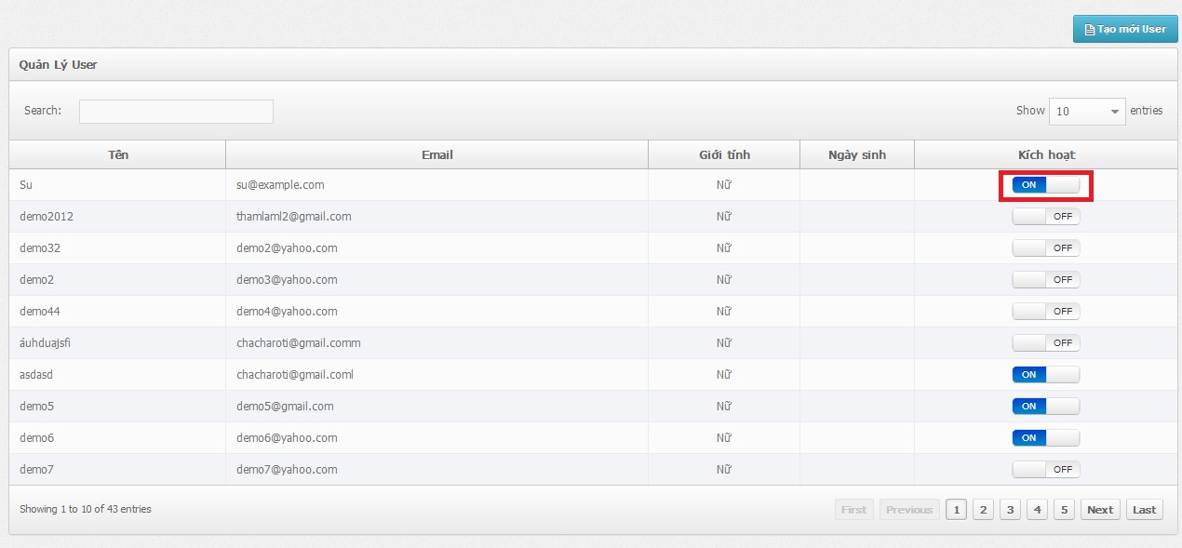

Figure 6-8 – Activate User

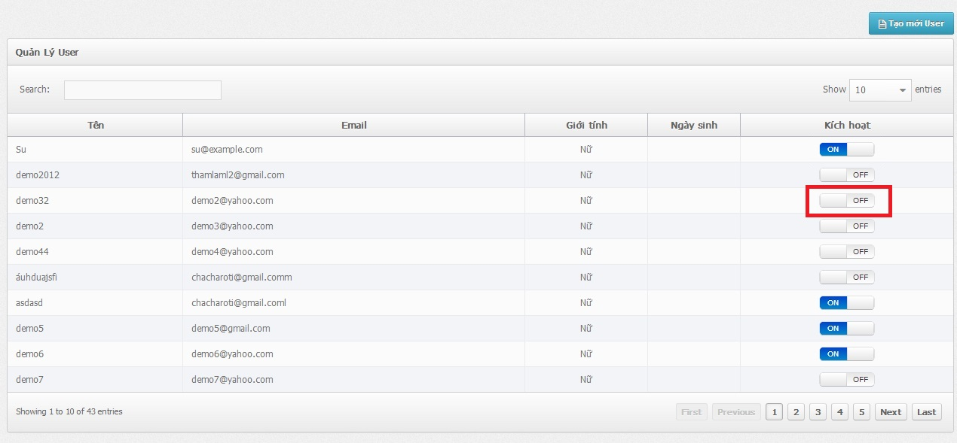

Figure 6-9 – Deactivate User

* This is Admin’s function.
* Triggers:

1. Click on “OFF” to change to “ON” or change “ON” to “OF”

#### Manage Product

##### View Product List



Figure 6-10 – Manage Product Page

* This is User’s function.
* Triggers:

1. Click on “Quản Lý Loại Hàng” link to open “Quản Lý Loại Hàng” page.

##### Create Product

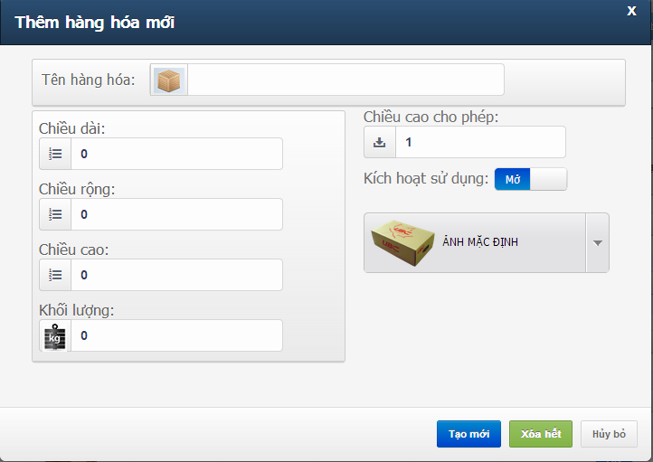

Figure 6-11 – Create Product Form

* This is User’s function.
* Triggers: Click on “Thêm Loại Hàng Mới” to open “Thêm Loại Hàng Mới” pop-up, then input Product information.

##### Update Product

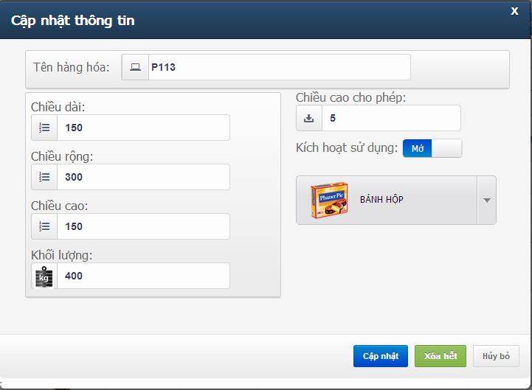

Figure 6-12 – Update Product Form

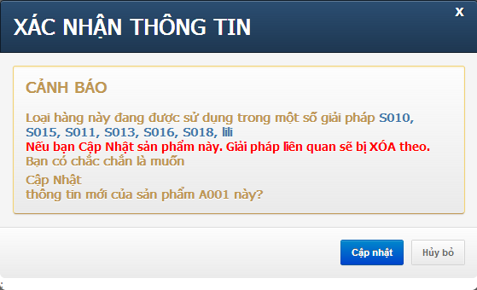

Figure 6-13 – Confirmation Form

* This is User’s function.
* Triggers:

1. Click on “Cập Nhật” button, then update information.
2. If that product has been used in any solution, “Xác nhận” pop-up will be show

##### Delete Product

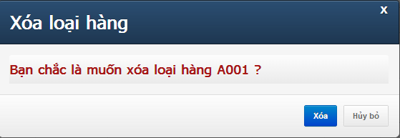

Figure 6-14 – Confirmation Form

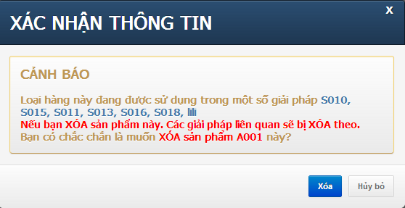

Figure 6-15 – Confirmation Form

* This is User’s function.
* Triggers:

1. Click on “Xóa”button to delete product. “Xóa loại hàng” pop-up will be show to cofirm.
2. If that product has been use. “Xác nhận xóa” pop-up will be show

##### Import Product from Excel file

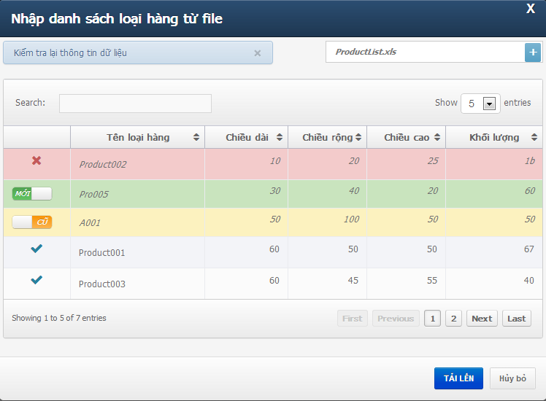

Figure 6-16 – Import Form

* This is User’s function.
* Triggers: Click on “Nhập danh sách loại hàng từ file” link, and choose excel file which contains product list to upload. After choose file, user can review data, choose new product or old product to use (if there is any duplicate product). Then, user click “Tải lên”.

#### Manage Solution

##### View Solution List

* This is function of “User”.
* For Viewing Solution List:

1. Click “Quản lý Giải Pháp” in menu.

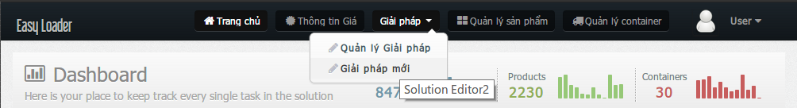

Figure 6-17 – Menu

##### Create Solution

* This is function of “User”.
* For Creating Solution:

1. Click “Giải pháp mới” in menu.



Figure 6-18 – Menu

1. Click “Lưu” button.

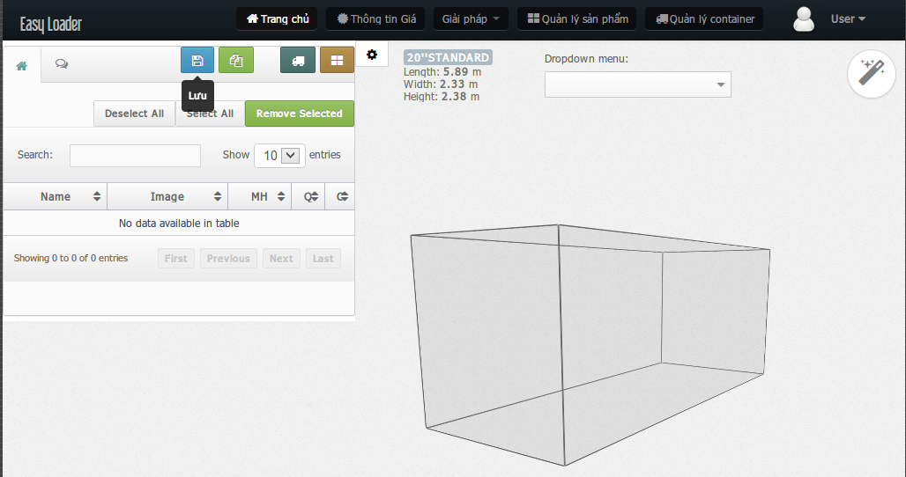

Figure 6-19 – Solution Editor Page

1. Input below information:

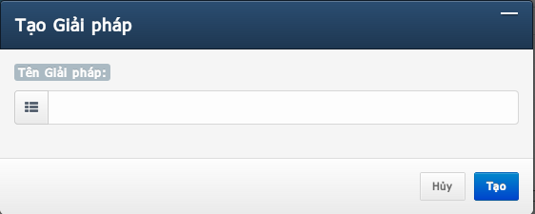

Figure 6-20 – Create Solution Form

1. Click “Tạo” button.

##### Update Solution

* This is function of “User”.
* For Updating Solution:

1. Click “Quản lý Giải Pháp” in menu.



Figure 6-21 – Menu

1. Click “Xem” button.

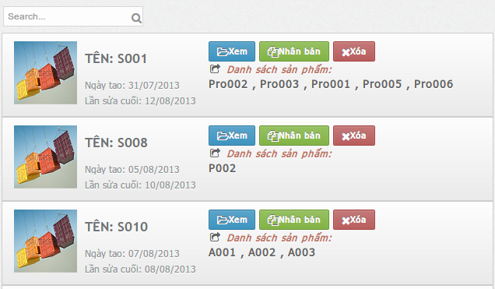

Figure 6-22 – Manage Solution

1. Click “Lưu” button.



Figure 6-23 – Solution Editor Page

##### Delete Solution

* This is function of “User”.
* For Deleting Solution:

1. Click “Quản lý Giải Pháp” in menu.



Figure 6-24 – Menu

1. Click “Xóa” button.



Figure 6-25 – Manage Solution

1. Click “Đồng ý” button

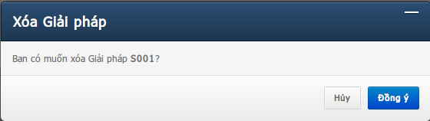

Figure 6-26 – Confirmation Form

##### Clone Solution

* This is function of “User”.
* For Deleting Solution:

1. Click “Quản lý Giải Pháp” in menu.



Figure 6-27 – Confirmation Form

1. Click “Nhân bản” button.



Figure 6-28 – Manage Solution

1. Input below information.

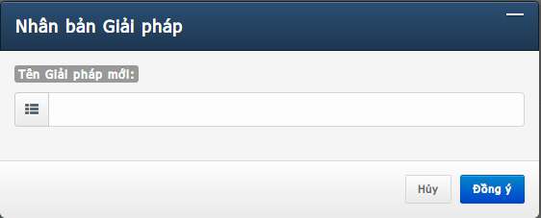

Figure 6-28 – Clone Solution Form

1. Click “Đồng ý” button.

##### View Solution Detail Result

* This is function of “User”.
* For Viewing Solution Detail Result Solution:

1. Click “Giải pháp mới” in menu.



Figure 6-29 – Menu

1. Click “Chọn sản phẩm” button.

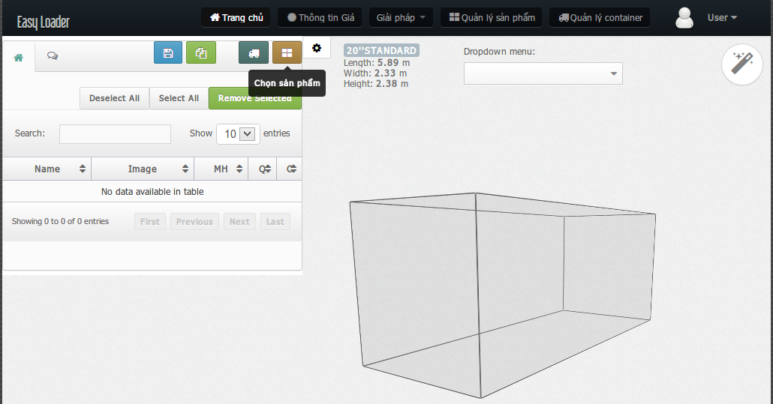

Figure 6-30 – Solution Editor Page

1. Select product from left table and click “Thêm sản phẩm”

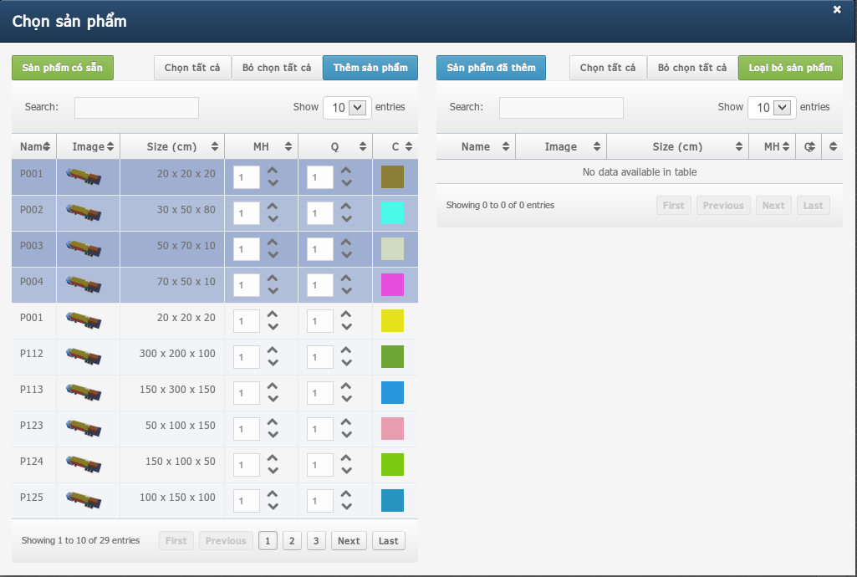

Figure 6-31 – Choose Products Form

1. Click “Chọn Container”

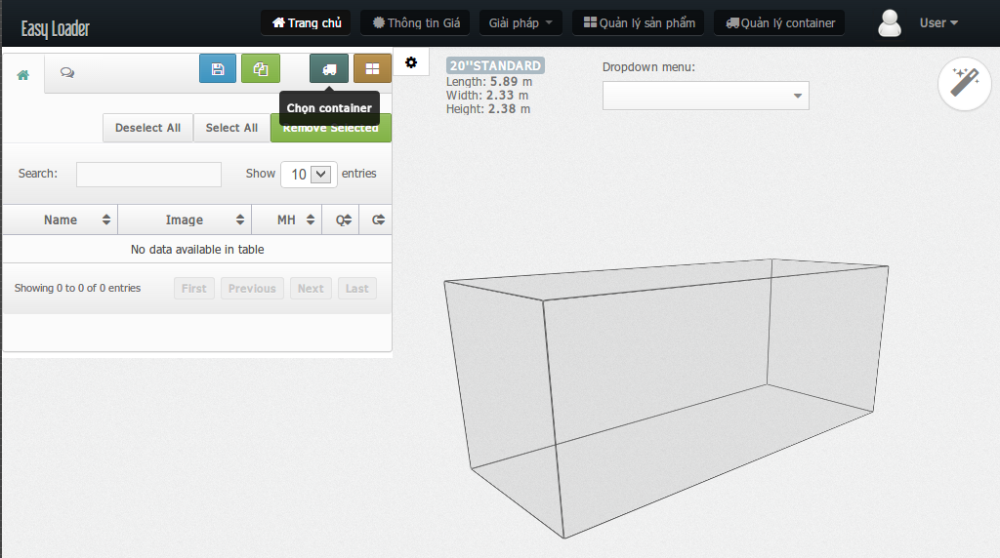

Figure 6-32 – Solution Editor Page

1. Select Container

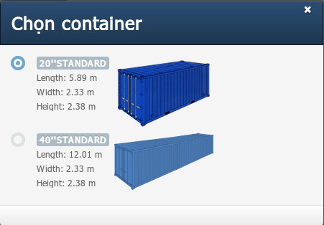

Figure 6-33 – Choose Container Form

1. Click “Sắp xếp”

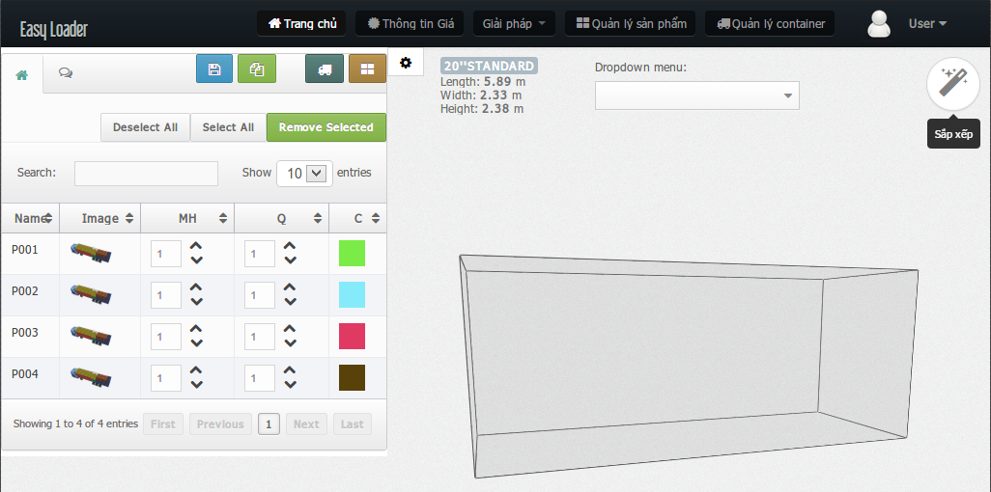

Figure 6-34 – Solution Editor Page

1. Result

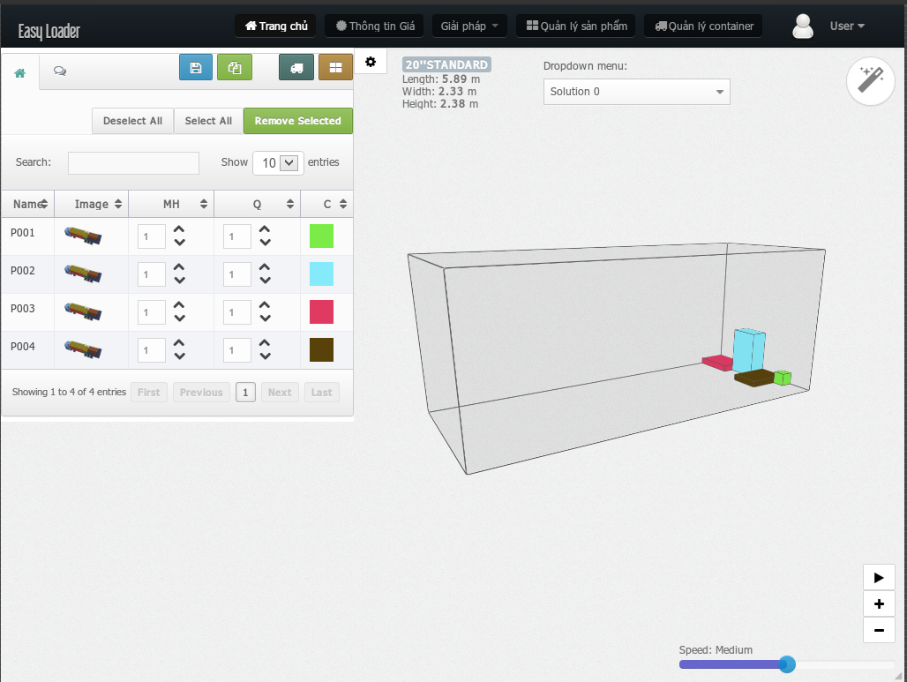

Figure 6-35 – Solution Editor Page

#### Manage Charge Usage

##### View Charge History

* This is function of “User”.
* For View Charge History List:

1. Click “Hiện trạng sử dụng” in menu.

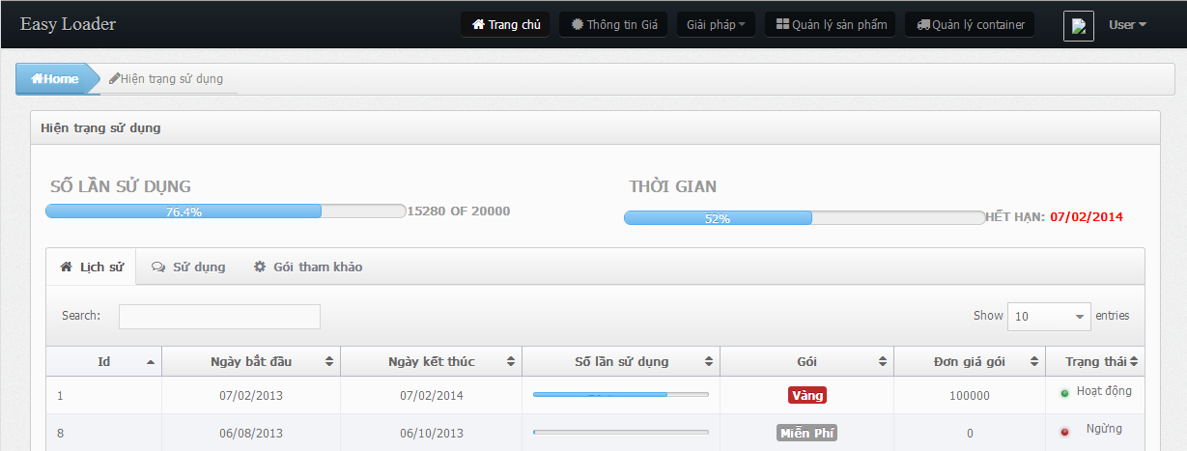

##### View Charge Usage

* This is function of “User”.
* For View Charge History List:

1. Click “Hiện trạng sử dụng” in menu.
2. Click “Sử dụng” on current tab.



##### Buy Main Charge Package via PayPal

* This is function of “User”.
* For View Charge History List:

1. Click “Hiện trạng sử dụng” in menu.
2. 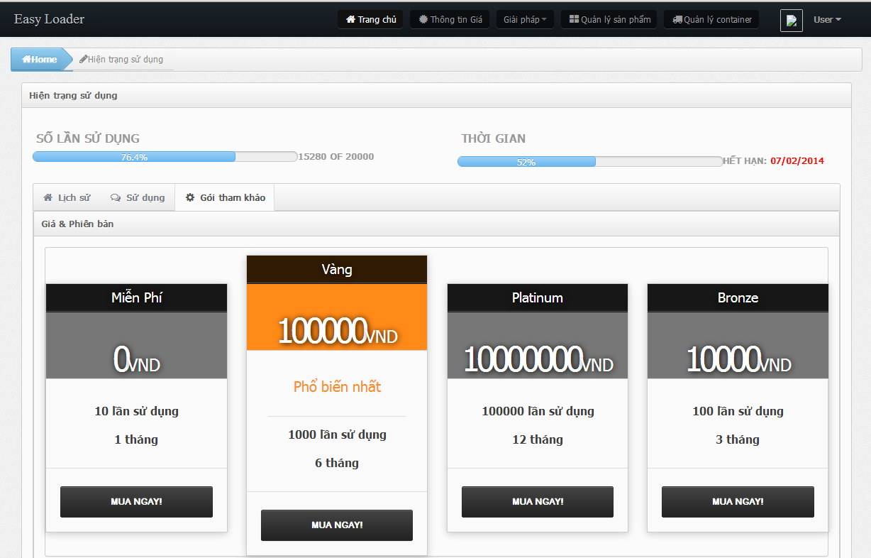Click “Gói tham khảo” on tab.
3. Click “Mua ngay”
4. Enter billing info in paypal form

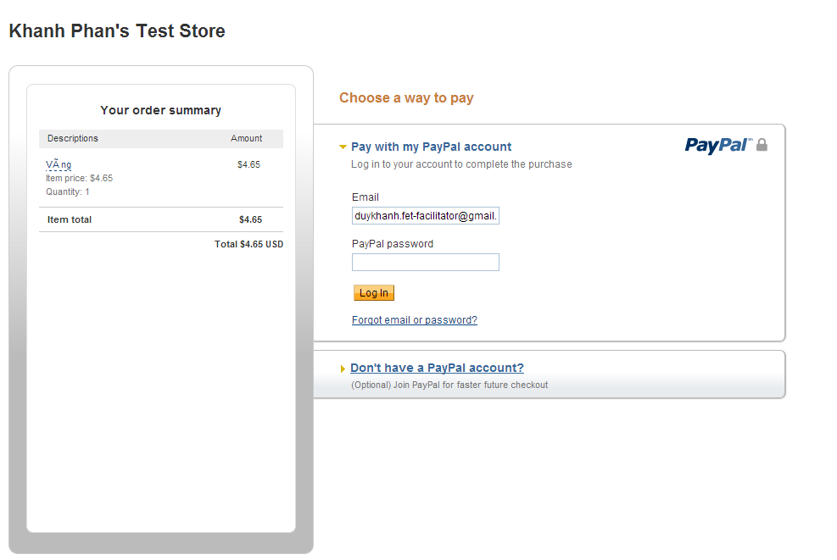

1. Review information and click “Pay now”

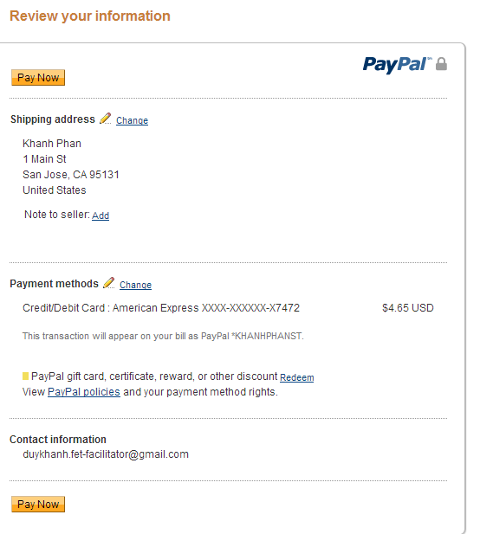

1. The Main charge Package is added for current user.

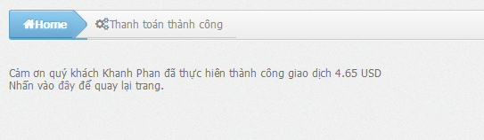

##### Buy Additional Charge Package via PayPal

Optional

#### Manage Charge Package

##### View Charge Package List

1. This is function of “User”.
2. For Viewing charge package List:
3. Click “Quản lý gói” in menu.

##### Create Charge Package

* This is Admin’s function.
* Triggers:

1. Click on “Thêm gói mới” on header of table.
2. Input user information:

|  |  |
| --- | --- |
| Tên gói | Input Charge Package’s name. Required. |
| Đơn giá | Input Price. Required. |
| Thời hạn sử dụng | Daytime picker. |
| Số lượng sử dụng | Input Number Of Request. Requried |
| Màu | Color Picker. Required. |
| Hoạt động | Checkbox. Required. |
| Được Recommend | Checkbox. Required. |
| Giới tính | Radio button. Required. |

1. Click on “Khởi tạo” button to finish.

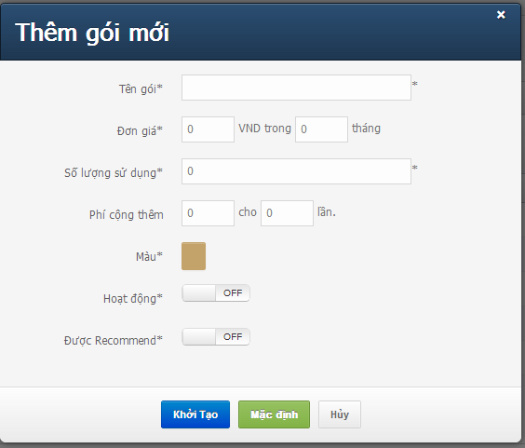

##### Update Charge Package

* This is Admin’s function.
* Triggers:

1. Click on “Cập nhật thông tin gói mới” on header of table.
2. Input user information:

|  |  |
| --- | --- |
| Tên gói | Input Charge Package’s name. Required. |
| Đơn giá | Input Price. Required. |
| Thời hạn sử dụng | Daytime picker. |
| Số lượng sử dụng | Input Number Of Request. Requried |
| Màu | Color Picker. Required. |
| Hoạt động | Checkbox. Required. |
| Được Recommend | Checkbox. Required. |
| Giới tính | Radio button. Required. |

1. Click on “Khởi tạo” button to finish.

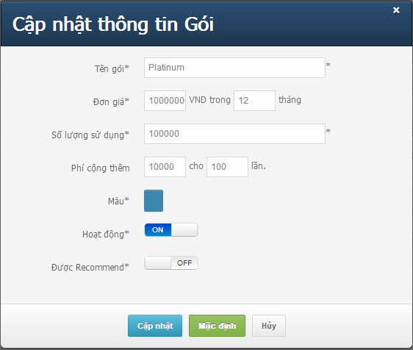

##### Activate/Deactivate Charge Package

* This is Admin’s function.
* Triggers:

1. Click on “ON” to change to “OFF”.

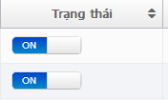

#### Manage Transaction

##### View Transaction

1. This is function of “Admin”.
2. For Viewing Charge transaction List:
3. 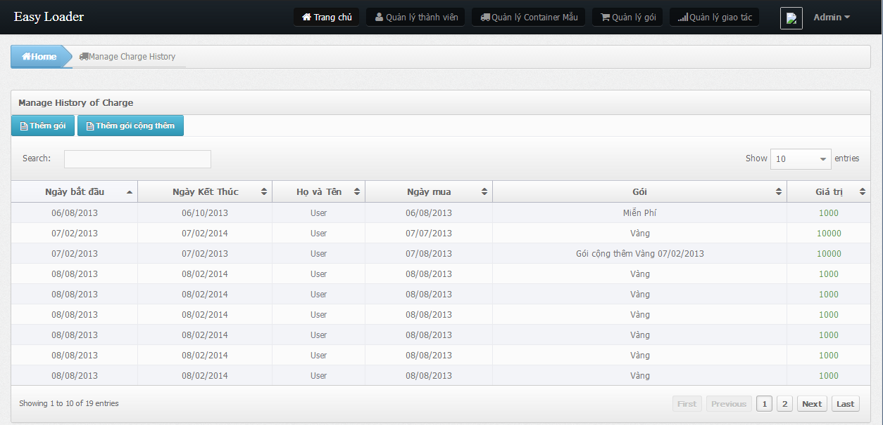Click “Quản lý giao tác” in menu.

##### View User Charge History

Optional

##### Create Main Charge Package

* This is Admin’s function.
* Triggers:

1. Click on “Thêm gói” on header of table.
2. Input user information:

|  |  |
| --- | --- |
| Khách hàng | Choose one customer from Search Dropdown list. Required. |
| Email | Disabled. Input Email |
| Gói | Choose Package. Dropdown List |
| Đơn giá | Input price |
| Ngày mua | Datetime picker. Required |
| Ngày bắt đầu | Datetime picker. Required |
| Thời hạn sử dụng | Input Duration |

1. 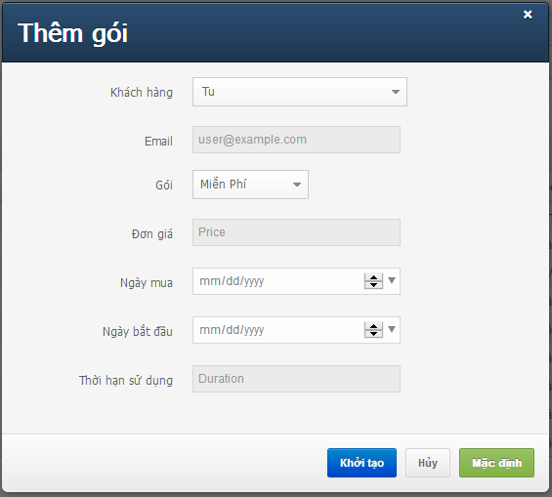Click on “Khởi tạo” button to finish.

##### Create Additional Charge Package

* This is Admin’s function.
* Triggers:

1. Click on “Thêm gói cộng thêm” on header of table.
2. Input user information:

|  |  |
| --- | --- |
| Khách hàng | Choose one customer from Search Dropdown list. Required. |
| Email | Disabled. Input Email |
| Ngày mua | Datetime picker. Required |
| Ngày bắt đầu | Datetime picker. Required |
| Ngày kết thúc | Datetime picker. Required |
| Gói hiện tại | Choose Package. Dropdown List |
| Số gói cộng thêm | Input number of Additional charge package. |

1. Click on “Khởi tạo” button to finish.

### Others

N/A